OTARI®
MX-5050 PROFESSIONAL RECORDER
MODELS MX-5050 2S, 4S, 2SD AND 4SD
MAINTENANCE MANUAL
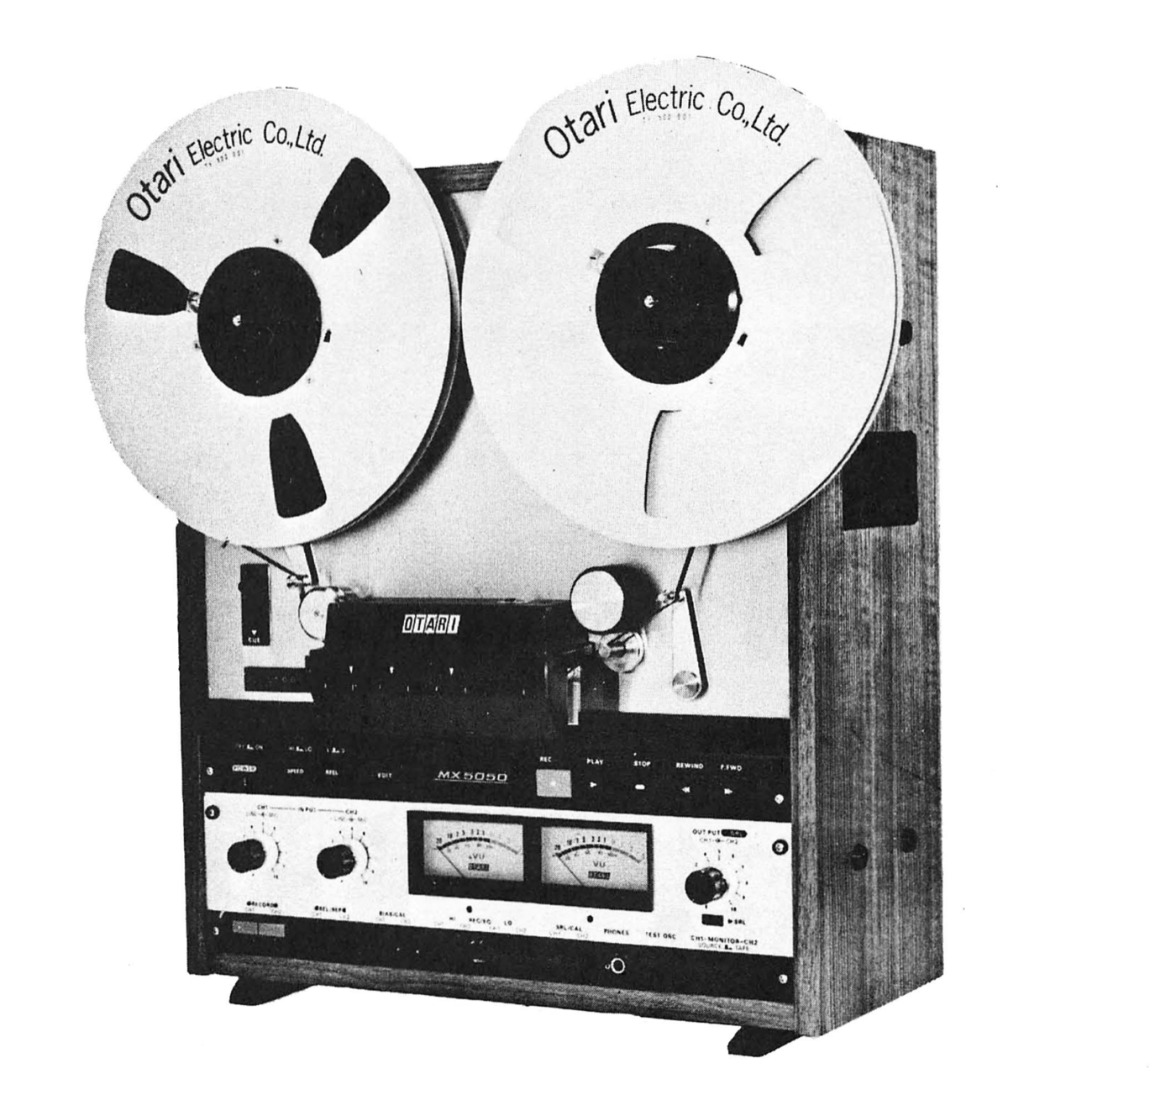
MX-5050 recorder loaded with two Otari Electric Co., Ltd. reels
Transcribed from the original scan — hosted, with all source material, at https://otarimx5050.com/

MX-5050 SERIES PROFESSIONAL RECORDER — INTRODUCTION
This manual supplement provides detailed maintenance information, schematics, and parts lists for the Otari MX-5050 Series Models 2S, 4S, 2SD and 4SD Professional Recorder. For descriptive information, installation and operating instructions, preventive maintenance and routine adjustment procedures, refer to Otari Instruction Manual Catalog No. OIM-1005E.
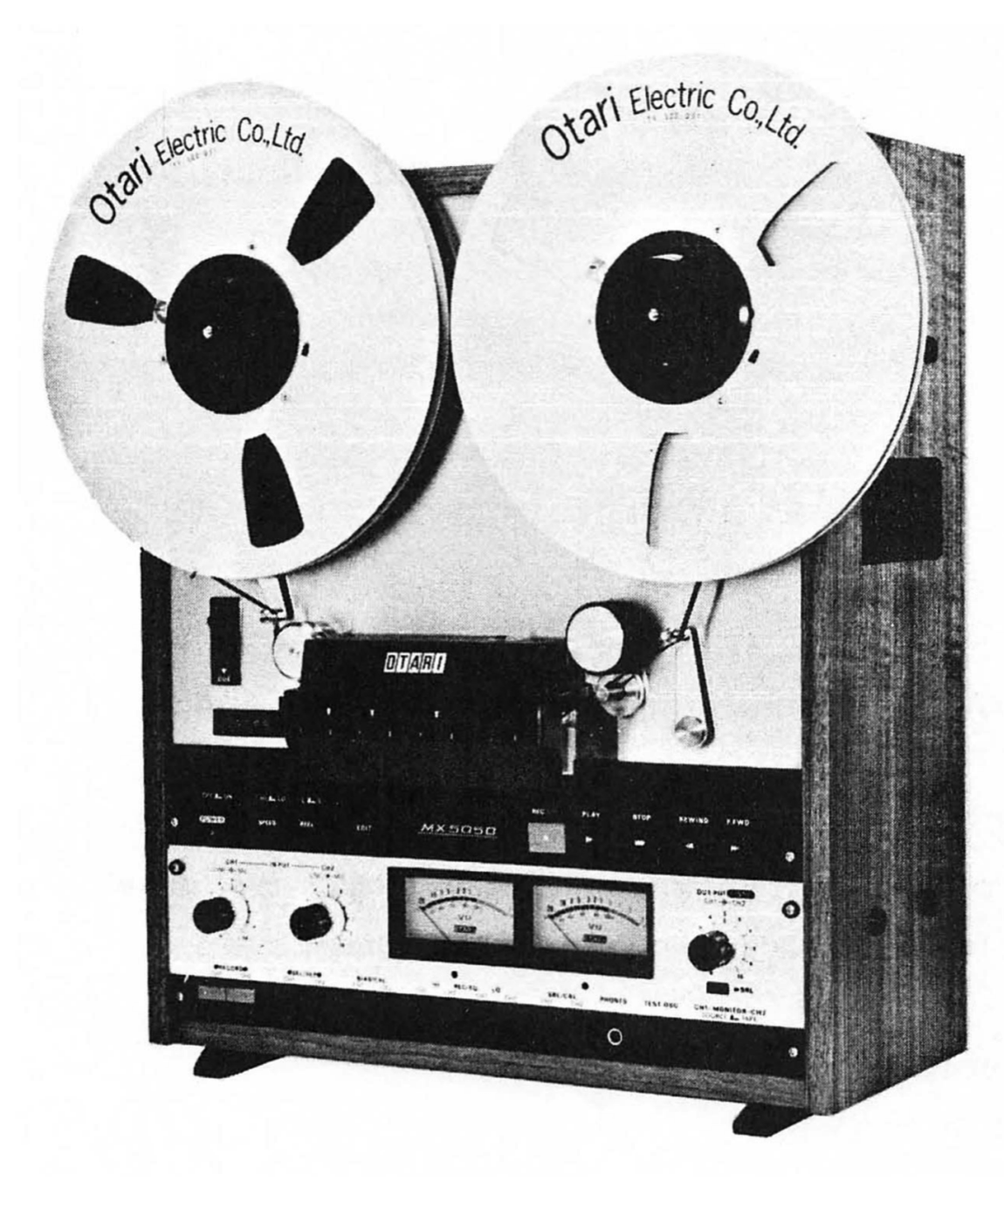
MX-5050 2SD Recorder

COMMUNICATION WITH OTARI — FOR SERVICE INFORMATION AND PARTS
The OTARI PRODUCTS are manufactured under strict quality control and each unit was carefully tested and inspected prior to shipment from our factory.
If, however, some adjustments or technical support become necessary, replacement parts are required, or technical questions arise, please contact your nearest Otari dealer or write to:
OTARI ELECTRIC CO., LTD. | OTARI CORPORATION
4-29-18, Minami Ogikubo, | 1559 Industrial Road, San Carlos,
Suginamiku, Tokyo, 167, Japan | California 94070, U. S. A.
Phone: (03) 333 - 9631 | Phone: (415) 592 - 8311
Telex No.: OTRDENKI J26604 | Telex No.: TWX 910-376-4890
Another part of Otari continuous technical support program for our products, is the continuous revision of manuals as the equipment is improved or modified.
In order for you to receive our information and service applicable to your requirement, and for the technical support to function properly, please include the following information, most of which can be obtained from the name plate on the equipment.
- Model Number
- Serial Number
- Date of purchase
- Name and address of dealer from whom machine was purchased.
- Power requirements (voltage and frequency)
- Manual number which you are referring

TABLE OF CONTENTS
Site note: The printed contents pages of the original had drifted from the manual body — they list procedures that appear nowhere inside, and parts of the 3-5/3-6 numbering don’t line up with the section headings. This contents list is generated from the actual headings of this edition, with page numbers for this printing. The original contents pages are transcribed verbatim at https://otarimx5050.com/library/manuals/digital/front-matter/.
In Word, right-click here and choose Update Field to fill in this table of contents.

List of Illustrations
Site note: Titles link to the figure in the manual body. Two more list-vs-body drifts here, both original: Fig. 3-5 is listed but printed nowhere in the manual (see the note in Section 3), and from 4-11 on the list runs one behind the body — the body’s Fig. 4-11 “P.C. Board Wiring” never made this list, so entries 4-11 through 4-15 are the body’s Figs. 4-12 through 4-16.
Figure | Title | Page
1-1 | Lifting Head Cover | 1-2-(1)
1-2 | Demagnetizing | 1-2-(2)
1-3 | Lubrication | 1-2-(3)
2-1 | Transport Access | 2-1
2-2 | Measurement | 2-2
2-3 | Adjusting Parts Location | 2-2
2-4 | Tape Tension Adjustment Resistors | 2-3
2-5 | Measurement | 2-4
2-6 | Adjusting Parts Location | 2-4
2-7 | Adjusting Parts Location | 2-5
3-1 | ASA “A” Weighted Filter | 3-4-(1)
3-2 | Using Test Tape | 3-4-(5)
3-3 | Access to Electronic Assembly | 3-5
3-4 | Adjusting Parts Location | 3-5, 3-6
3-5 | Bias Buffer Adjusting Parts | 3-6-(4)
4-1 | Reel Table and Motor | 4-1-(1)
4-2 | Capstan Motor Location (2S or 4S) | 4-1-(4)
4-3 | Capstan Motor Location (2S or 4SD) [sic] | 4-1-(4)
4-4 | Brake Assembly Location | 4-1-(5)
4-5 | Pinch Roller Removal | 4-1-(6)
4-6 | Top View of Head Assembly | 4-2-(1)
4-7 | Front View of Head Assembly | 4-2-(1)
4-8 | Bottom View of Head Assembly | 4-2-(1)
4-9 | Head Alignment | 4-2-(1)
4-10 | Input Circuity [sic] | 4-3-(1)
4-11 | Input Transformer Installation | 4-3-(1)
4-12 | Input Transformer Wiring | 4-3-(1)
4-13 | Output Circuitry | 4-3-(2)
4-14 | Output Transformer Installation | 4-3-(2)
4-15 | Output Transformer Wiring | 4-3-(2)

List of Table
Table | Title | Page
1-1 | Test and Maintenance Equipment | 1-1
1-2 | Alignment Test Tapes | 1-1
2-1 | Tension Specifications | 2-2
2-2 | Tape Tesnion Specifications [sic] | 2-3
3-1 | Signal-to-noise Specifications (ASA weighted) | 3-4-(1)
3-2 | Crosstalk Specifications (Between Adjacent Channels) | 3-4-(3)
3-3 | Flutter and Wow Specification | 3-4-(6)
5-1 | Troubleshooting Hints | 5-2

SECTION 1 — GENERAL INFORMATION
This manual is a maintenance supplement to the MX-5050 Series Models 2S, 4S, 2SD and 4SD Instruction Manual, Catalog No. OIM-1005E, and provides detailed maintenance information. This manual is intended for use by qualified maintenance or service personnel only. Prior to using this manual, it is suggested that the user become familiar with the information contained in the basic manual.
NOTE
AFTER MAINTENANCE OR COMPONENT REPLACEMENT, ALL SCREWS SHOULD BE LOCKED UP WITH FOLLOWING PAINT TO PREVENT POSSIBLE DAMAGE. USE ENAMEL PAINT FOR HEAD ALIGNMENT SCREWS (AZIMUTH, ZENITH, HEIGHT), AND USE LOCTITE-222 (VIOLET) FOR OTHER SCREWS.

1-1 TEST AND MAINTENANCE EQUIPMENT REQUIREMENTS
All maintenance, electronic, and mechanical test equipment required during maintenance, alignment, and adjustment of the recorder is listed in Table 1-1. In addition, recommended maintenance periods are shown by accumulative hours of usage and/or elapsed period of time, whichever occurs first. Equivalent equipment can be substituted for the equipment suggested in the table.
Table 1-1. Test and Maintenance Equipment
EQUIPMENT TYPE | SUGGESTED MODEL | USED FOR | PERIOD
Head cleaner | Ampex 087-007 | Cleaning heads and guides | 8 hours
Isopropyl or denatured alcohol | Any | Cleaning capstan pinch-roller | 8 hours
Q tips | Any | Cleaning heads and guides | 8 hours
Head demagnetizer | Ampex 4010820 | Demagnetizing heads and guides | 8 hours
Lubricating oil | Ampex 087-579 or Mobile [sic] DTE Medium | Oiling of capstan motor and pinch roller bearings | 1,000 hours or 6 months
Spring scales 0-16 oz, 0-32 oz and 0-10 lbs | Any | Mechanical adjustments | 1,000 hours or 6 months
Frequency Counter (Electronic Counter) | Hewlett-Packard 5300A + 5301A | Tape speed measurment [sic] | Same as above
Vacuum cleaner and brushes | Any | General cleaning | 1 month
Standard alignment test tapes | Refer to Table 1-2 and 1-3. | Reproduce amplifier alignment | 150 hours or 1 month
Audio oscillator | Hewlett Packard H20-200CD | Overall frequency response and signal-to-noise measurement | 150 hours or 1 month
AC Voltmeter (VTVM) | Hewlett Packard 400L or 400 FL | Same as above | Same as above
Bandpass filter | See text | Same as above | Same as above
Flutter bridge | Data Measurement Corp. 8100 | Flutter and wow measurement | Same as above
Wave analyzer | Hewlett Packard 3590A or 310A | Distortion and crosstalk measurement | Same as above
Test cables | See text
Technicians tools
Stroboscope | General Radio 1531-AB | Mechanical adjustments | 1,000 hours or 6 months
Volt-ohm meter | 20,000 ohms/volt any brank [sic] | Test and adjustments | -
Allen wrenches | Metric
ASA Noise Filter | See text and Fig. 3-1. | Signal-to-noise ratio measurement | 150 hours or 1 month
Table 1-2. Alignment Test Tape
SPEED (IN/S) | EQUALIZATION (TIME CONSTANTS) | STANDARD | TRACKS | AMPEX CATALOG NO.
3-3/4 | 90 μs & 3180 μs | NAB | Full | 4690037-01
7-1/2 | 50 μs & 3180 μs | NAB | Full | 01-31321-01
 | 50 μs & 3180 μs | NAB | 1 & 3 | 01-31321-04
 | 70 μs & ∞ | IEC | Full | 4690014-01
15 | 50 μs & 3180 μs | NAB | Full | 01-31311-01
 | 35 μs & ∞ | IEC | Full | 01-31313-01

1-2 ROUTINE MAINTENANCE
It is important that routine maintenance be performed at the recommended intervals. External cleaning and demagetization [sic] procedures should be performed after each eight hours of operation, and the interior of the transport should be cleaned once a month. The lubrication procedure should be performed after 1,000 hours of operation or after 6 months, whichever comes first.

1-2-(1) CLEANING
Oxide particles from the magnetic tape tend to collect on components in the tape path and degrade performance of the recorder. To clean the head assembly, proceed as follows:
- Lift the head cover as shown in Fig. 1-1.
CAUTION
WHEN CLEANING THE HEADS, USE ONLY THE RECOMMENDED SOLVENT (HEAD CLEANER) TO AVOID DAMAGING THE HEADS. KEEP THE HEAD CLEANER OFF PLASTIC FINISHES AND THE CAPSTAN PINCH ROLLER. DO NOT USE METAL TOOLS THAT CAN SCRATCH THE HEADS.
- Clean each head stack thoroughly with a cotton-tipped applicator (Q tip) dampened with head cleaner.
- Use isopropyl alcohol to clean all tape-guiding components, the capstan shaft, and the capstan pinch roller.
CAUTION
DO NOT USE HEAD CLEANER ON THE CAPSTAN PINCH ROLLER AS DAMAGE WILL RESULT AND TAPE WILL SLIP.
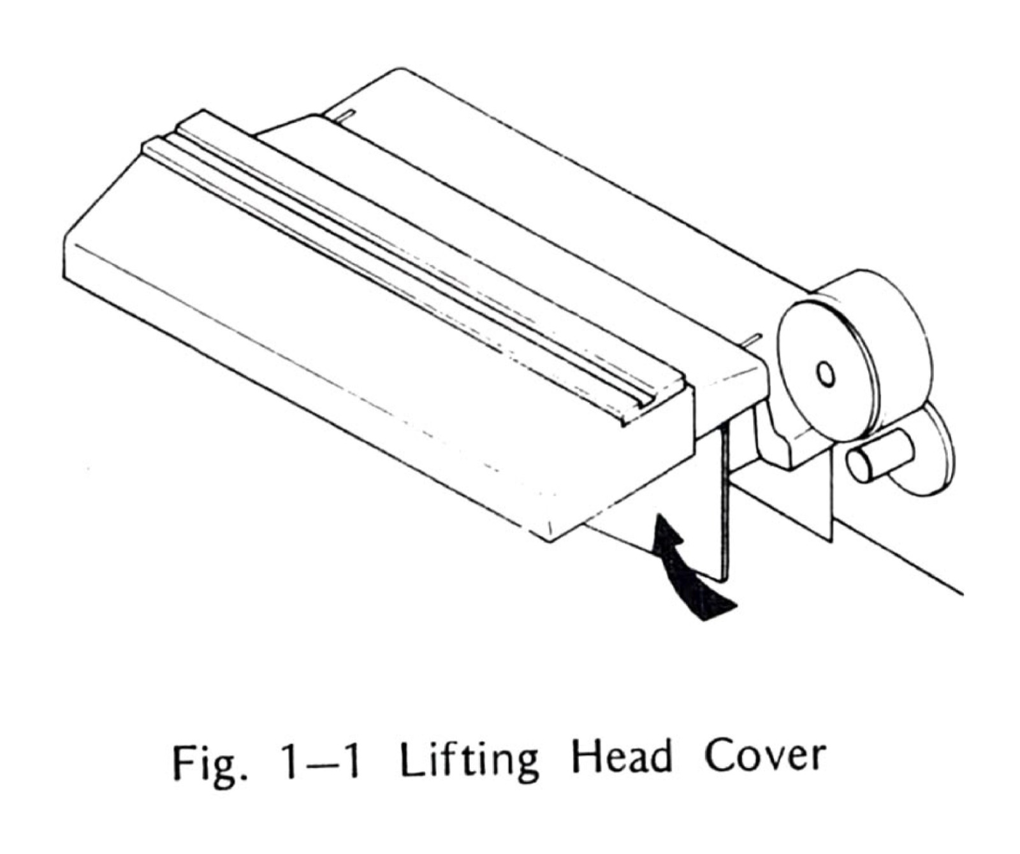
Fig. 1-1 Lifting Head Cover
- Remove rear cover of recorder (4 screws).
- Use a vacuum cleaner and a small brush to remove all dust or contamination from the interior of the transport. If necessary lightly moisten brush with isopropyl alcohol to clean parts.
- Reinstall rear cover.

1-2-(2) DEMAGNETIZING
The heads and tape guiding components in the tape path should be demagnetized after each eight hours of operation. These components can acquire permanent magnetization that increases signal noise and distortion and partially erase high frequencies on recorded tape. Use a hand-held head demagnetizer to demagnetize all components in the tape path as follows:
- Turn equipment power off and remove any recorded tape near the transport (tape could be partially erased by the demagnetizer).
- Lift head cover as shown in Figure 1-1.
- Cover the demagnetizer tips with adhesive tape to prevent scratching head stacks.
- With the demagnetizer held away from the transport, connect demagnetizer to power source.
- Move the demagnetizer tips slowly close to the head, lightly touch the demagnetizer tips to the face of one head stack and slowly move the tips up and down the stack several times. Then slowly withdraw the demagnetizer as shown in Fig. 1-2.
- Repeat step 5 for each head stack.
- Repeat the motions of step 5 for each guide and other metallic parts in the tape path.
- Move the demagnetizer slowly away from the transport for at least three feet and then disconnect power from the demagnetizer.
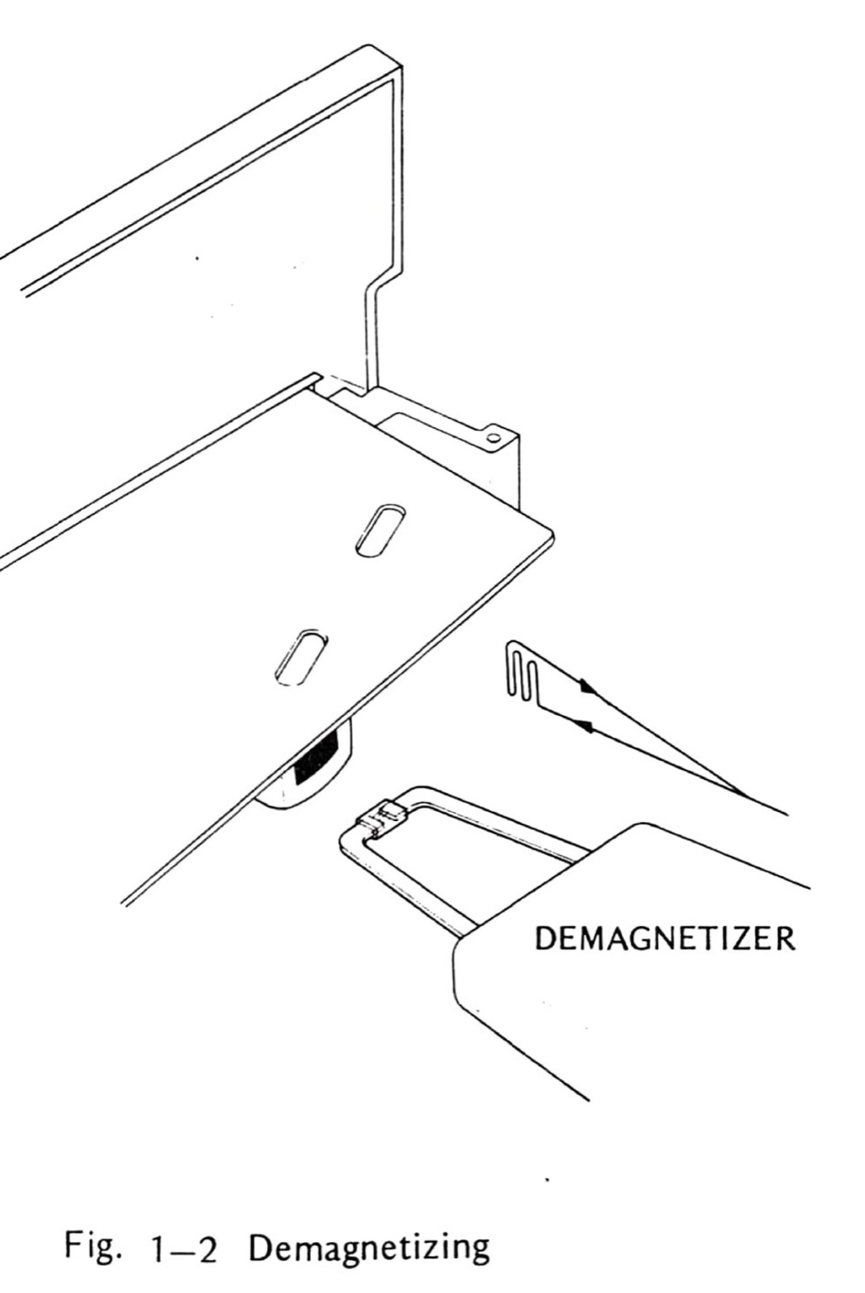
Fig. 1-2 Demagnetizing

1-2-(3) LUBRICATION
The only components requiring lubricaiton [sic] are the capstan sleeve bearing and the capstan pinch roller bearings. See Fig. 1-3 and proceed as follows:
CAUTION
BE CERTAIN TO CLEAN CAPSTAN SHAFT THOROUGHLY. THE LUBRICATING OIL CAN RUIN THE CAPSTAN PINCH ROLLER AND MAGNETIC TAPE. CLEAN THE CAPSTAN AND PINCH ROLLER WITH ISOPROYL [sic] ALCOHOL.
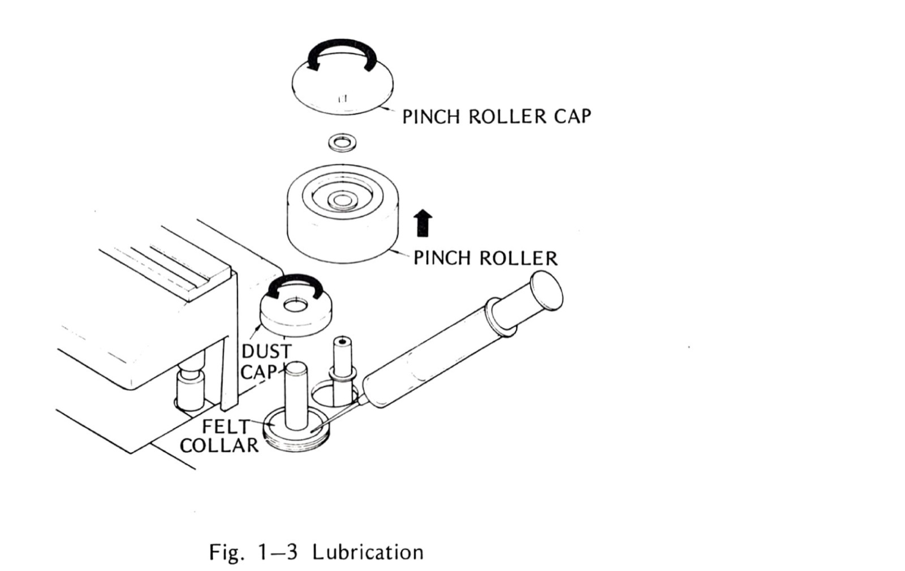
Fig. 1-3 Lubrication
- Unscrew pinch roller cap.
- Remove pinch roller from the pinch roller shaft.
- Remove metal dust cap from the capstan shaft by turning counterclockwise.
- Now the felt collar is visible. Apply 2 or 3 drops of oil onto this felt collar. Please do not over lubricate.
- Apply a few drops of oil to the pinch roller bearings.
- Wipe off any excess oil and reinstall the dust cap, pinch roller cap as they were.

SECTION 2 — TAPE TRANSPORT MAINTENANCE
Tape transport maintenance includes procedures for adjusting supply and takeup reel brakes, adjusting supply reel hold-back tension, and adjusting capstan pinch roller pressure.

2-1 TRANSPORT ACCESS
To gain access to recorder transport proceed as follows:
- Remove power cord and place recorder in an upright position.
- Use metric allen wrench and remove top panel, two side panels, and rear cover by removing four screws per panel (16 screws total).
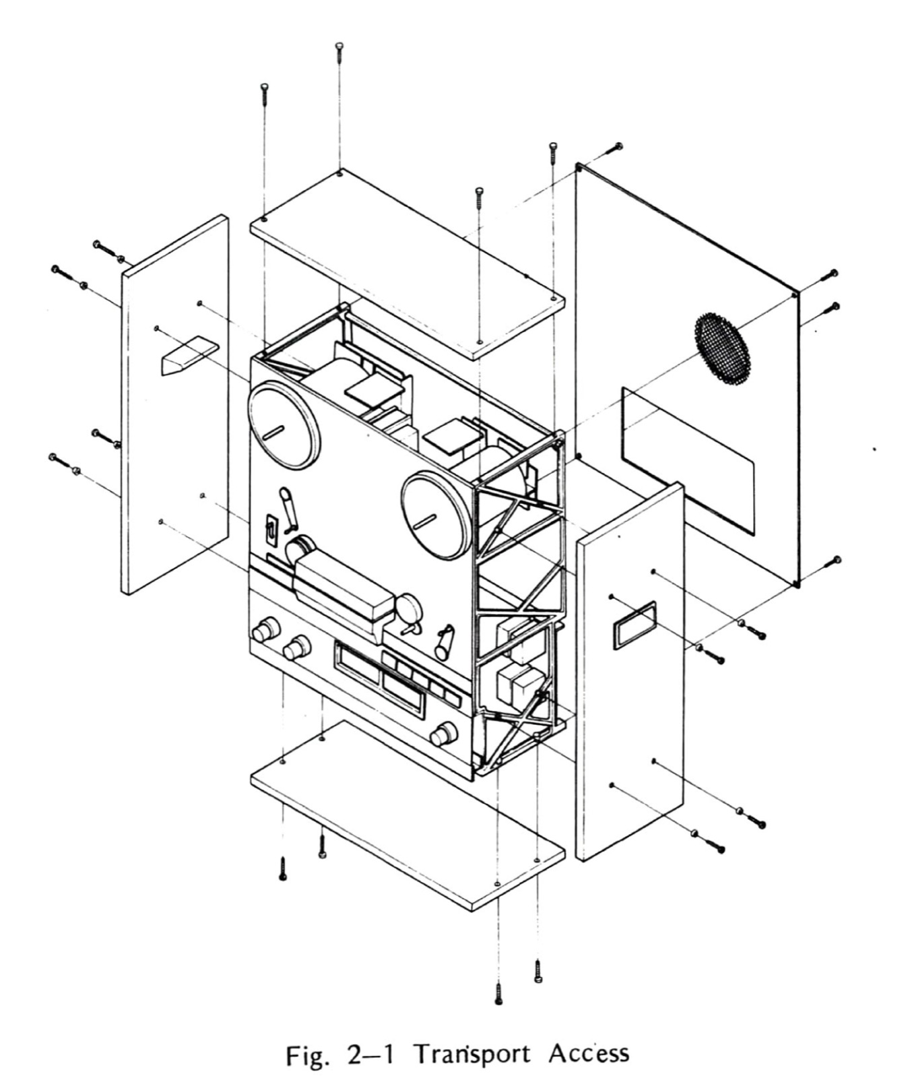
Fig. 2-1 Transport Access

2-2 BRAKE ADJUSTMENT
The brake system on each reel stops reel rotation when entering stop mode or when power is removed. The brakes are checked and adjusted with power removed. Since the brake force is different for each direction of rotation (brake differential), and there is a single adjustment, the force is checked and adjusted for the best compromise force in each direction.
In the following steps, an empty 10½ inch diameter NAB reel (4½ inch diameter hub) is used and a cord or twine is wrapped on the reel. A spring scale is attached to a small loop formed in the free end of the cord or twine.
If an [sic] 10½ inch diameter NAB reel (4½ inch diameter hub) is not available, a 7 inch diameter (2¼ inch diameter hub) may be used but all readings must be multiplied by a factor of 2. Proceed as follows: Refer to table 2-1 for the tension specifications on each Model.
- Place an empty 10½ inch diameter NAB reel on the supply reel turntable. Secure with a holddown knob.
- Wind a cord or twine a few turns counterclockwise on the hub. Tie a loop in the free end of the cord or twine.
- Insert the hook of a 0-16 ounce or 0-32 ounce spring scale through the loop and hold the spring scale upright as shown in Fig. 2-2.
- Pull on the scale slowly to make the reel rotate counterclockwise. While being sure the cord does not rub against either flange, note the scale reading. Reading should be “B” in Table 2-1.
- Wind the cord or twin [sic] in a clockwise direction on the supply reel.
- Repeat steps 3 and 4 to make the reel rotate clockwise. Reading should be “A” in Table 2-1.
- If the readings were low in both directions, remove the brake spring (shown in Fig. 2-3) from the existing anchor hole on the brake lever and install spring in the next hole located farther away from the brake solenoid.
- If the readings were high in both directions move the spring anchor point to a hole closer to the brake solenoid.
- If the brake spring was moved, repeat steps 2 through 6 to check results.
- Repeat the brake adjustment procedure on the takeup reel. Note that the high braking force is present when the takeup reel is rotated clockwise. The tension specifications are the same as for the supply reel.
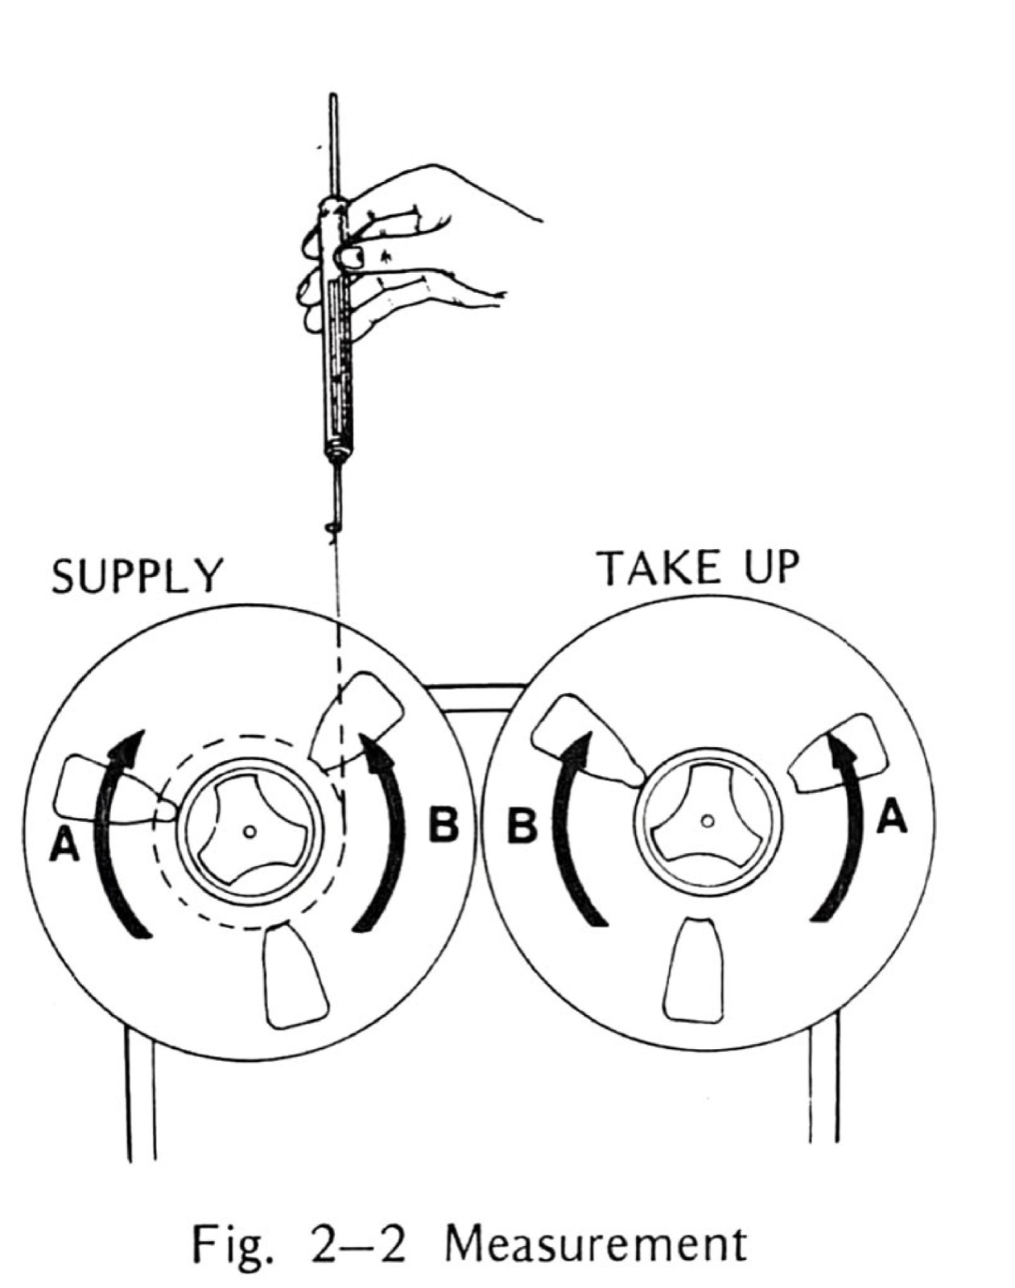
Fig. 2-2 Measurement
Table 2-1 Tension specifications
A | 3.6~4.5oz (100~125g)
B | 7.9~9.7oz (225~275g)
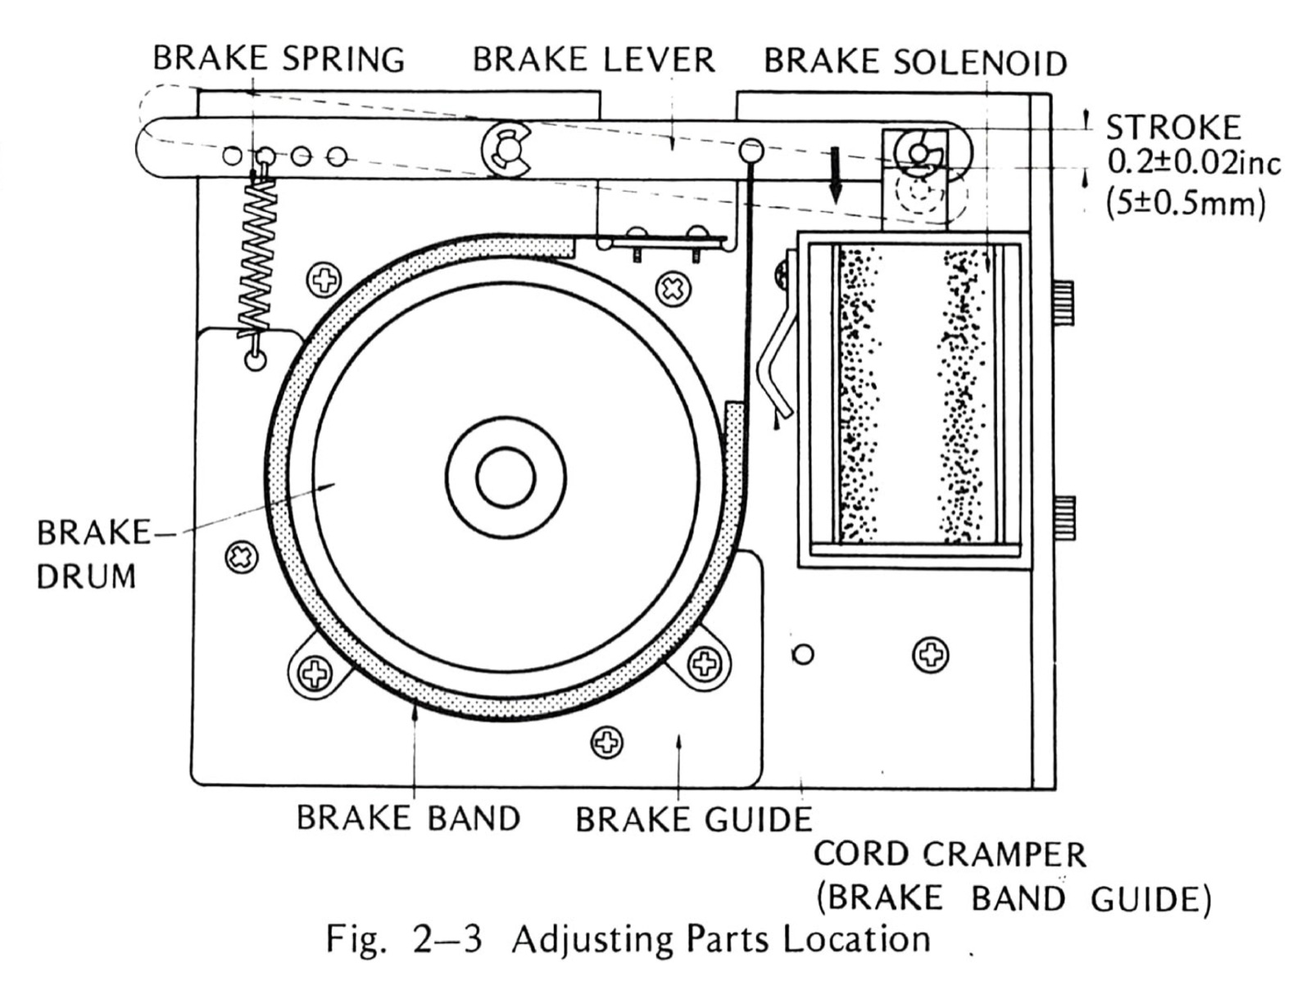
Fig. 2-3 Adjusting Parts Location

2-3 TAPE TENSION ADJUSTMENT
Tape tension is controlled by the amount of torque applied by the reel motors. Only the supply reel motor torque is adjustable. The tape tension is determined indirectly by measuring the supply motor holdback torque in play and fast forward modes. This tension is adjusted by positioning sliders on resistors located below the takeup motor (Fig. 2-4). When adjusting the sliders, loosen the contact screws just enough to slide the contact, then tighten the screw just enough to make good electrical contact.
WARNING
WHEN TRANSPORT POWER IS ON, LINE VOLTAGE IS PRESENT AT THE RESISTORS. TURN POWER OFF BEFORE MAKING AN ADJUSTMENT.
The supply reel tensions were adjusted at the factory with a local power line source. Since motor torque is affected by the source voltage, verify the source voltage is correct before making any adjustment.
In the following steps, an empty 10½ inch diameter NAB reel is used and a cord or twine is wrapped on the reel in the same direction as tape is pulled onto the reel. A spring scale is attached to a small loop formed in the free end of the cord or twine. If an [sic] 10½ diameter NAB reel (4½ inch diameter hub) is not available, a 7 inch diameter (2¼ inch diameter hub) may be used but all readings must be multiplied by a factor of 2. The spring scale is held stationary (Fig. 2-2) and with no slack in the cord. The scale indicates cord tension when in fast forward or play modes. Proceed as follows:
- Use adhesive tape to hold the takeup-tension-arm safety switch in an upright position so that the safety switch is not activated.
- Place an empty 10½ inch NAB reel on the supply turntable and secure reel with a holddown knob.
- Wind the cord or twine a few turns counterclockwise onto the reel hub. Fasten a spring scale to a loop formed on the free end of the cord or twine (Fig. 2-2).
- Apply power to the recorder.
- Press F.FWD pushbutton switch. The reading should be “C” in Table 2-2. If necessary adjust slider “C”. (Moving slider towards front of transport increases tension.)
- Set REEL switch to Large “out” position.
- Hold the scale upright and press PLAY pushbutton switch. After an initial surge, the reading should be “A” in Table 2-2. If necessary adjust slider “A”. (Moving slider towards front of transport increase [sic] tension.)
- Set REEL switch to Small “in” position.
- Press PLAY pushbutton. After an initial surge, the reading should be “B” in Table 2-2. If necessary adjust slider “B”. (Moving slider towards front of transport increases tension.)
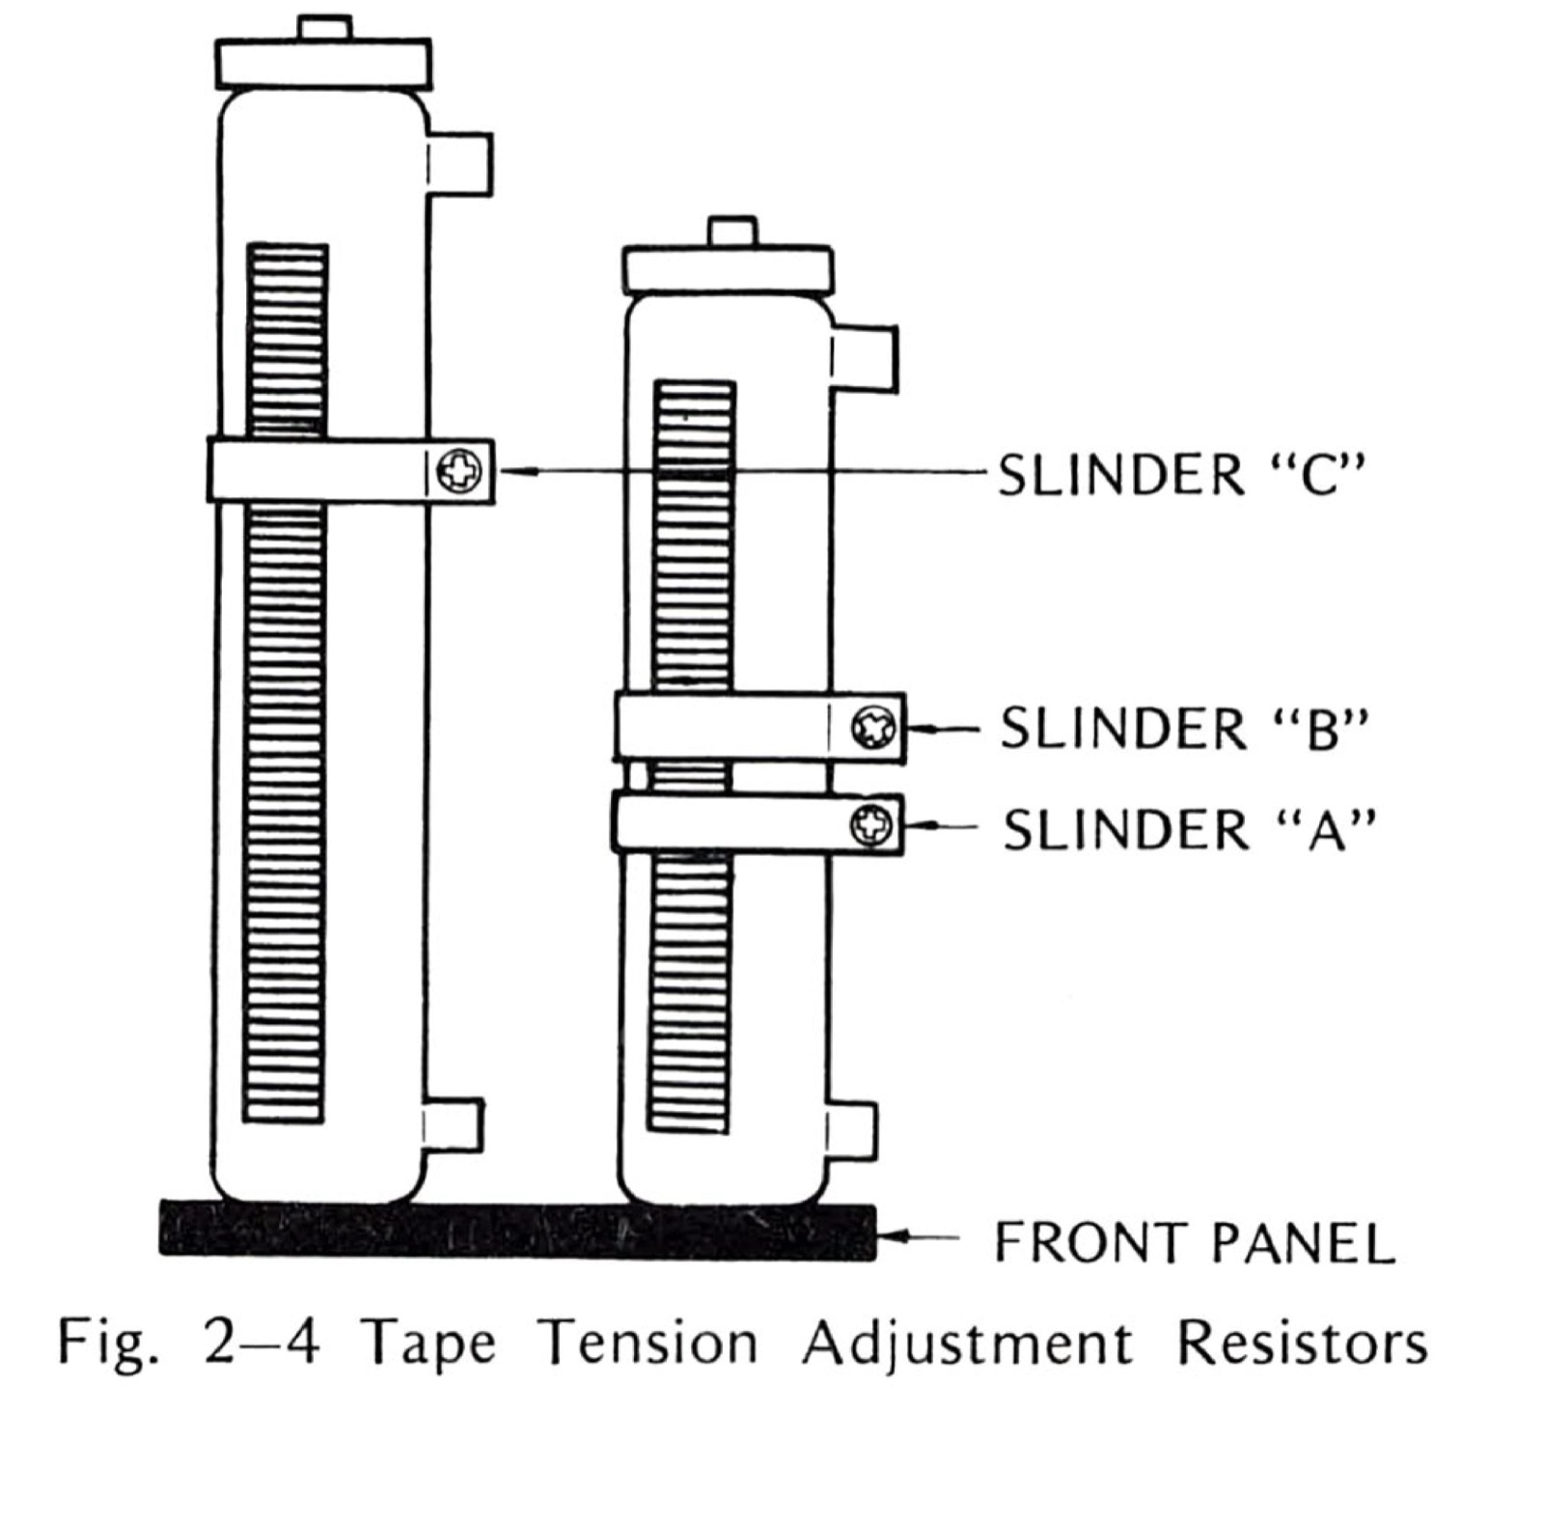
Fig. 2-4 Tape Tension Adjustment Resistors
Table 2-2 Tape Tension Specifications
SLIDER | MODE | Specification
A | PLAY LARGE | 2.2~2.7 oz (63~77 gram)
B | PLAY SMALL | 1.4~1.8 oz (40~50 gram)
C | F.FWD. | 1.4~1.8 oz (40~50 gram)

2-4 CAPSTAN PINCH ROLLER PRESSURE ADJUSTMENT
The capstan pinch roller pressure against the capstan is determined by the capstan solenoid spring. This force is adjusted by means of nut shown in Fig. 2-6. This force is adjusted by means of nut shown in Fig. 2-6. [sic] The nut is adjusted to obtain a force of 6.4~7.0 pounds. The resistance of the solenoid coil rises with temperature and causes the solenoid force to decrease. Therefore, do not adjust the pinch roller pressure until the recorder has been operated in play mode for at least 30 minutes prior to performing the following procedure.
- Use adhesive tape to hold the takeup-tension-arm safety switch in an upright position so that the safety switch is not activated.
- Tie a cord or twine together for [sic] form a continuous loop. Place one end of the loop around the capstan pinch roller shaft.
- Press the PLAY pushbutton. The pinch roller will move to contact the capstan and both will rotate.
- Hook a 0 to 10 pound spring scale to the other end of the cord and pull the cord taut straight to center of capstan as shown in Fig. 2-5. Do not let the cord contact the rotating pinch roller.
- Pull on the scale and note the scale reading when the pinch roller just loses contact with the capstan (the pinch roller stops rotating). The scale reading should be 6.4~7.0 pounds.
- If the proper scale reading was not obtained in step 5, loosen the locknut and adjust the pressure nut as required. (Turning the pressure nut towards the spring increases pinch roller pressure.) Tighten locknut.
- After adjustment is completed, check that the solenoid bottoms within the solenoid coil (pinch roller can easily be pushed away from the capstan). If the solenoid does not bottom, loosen locknut and turn pressure nut away from spring until solenoid bottoms. Recheck pressure adjustment and tighten locknut.
After the proceeding [sic] adjustments are completed, reinstall top panel, two side panels, and rear cover (16 screws total). For transport component replacement procedures, refer to Section 4 of this manual.
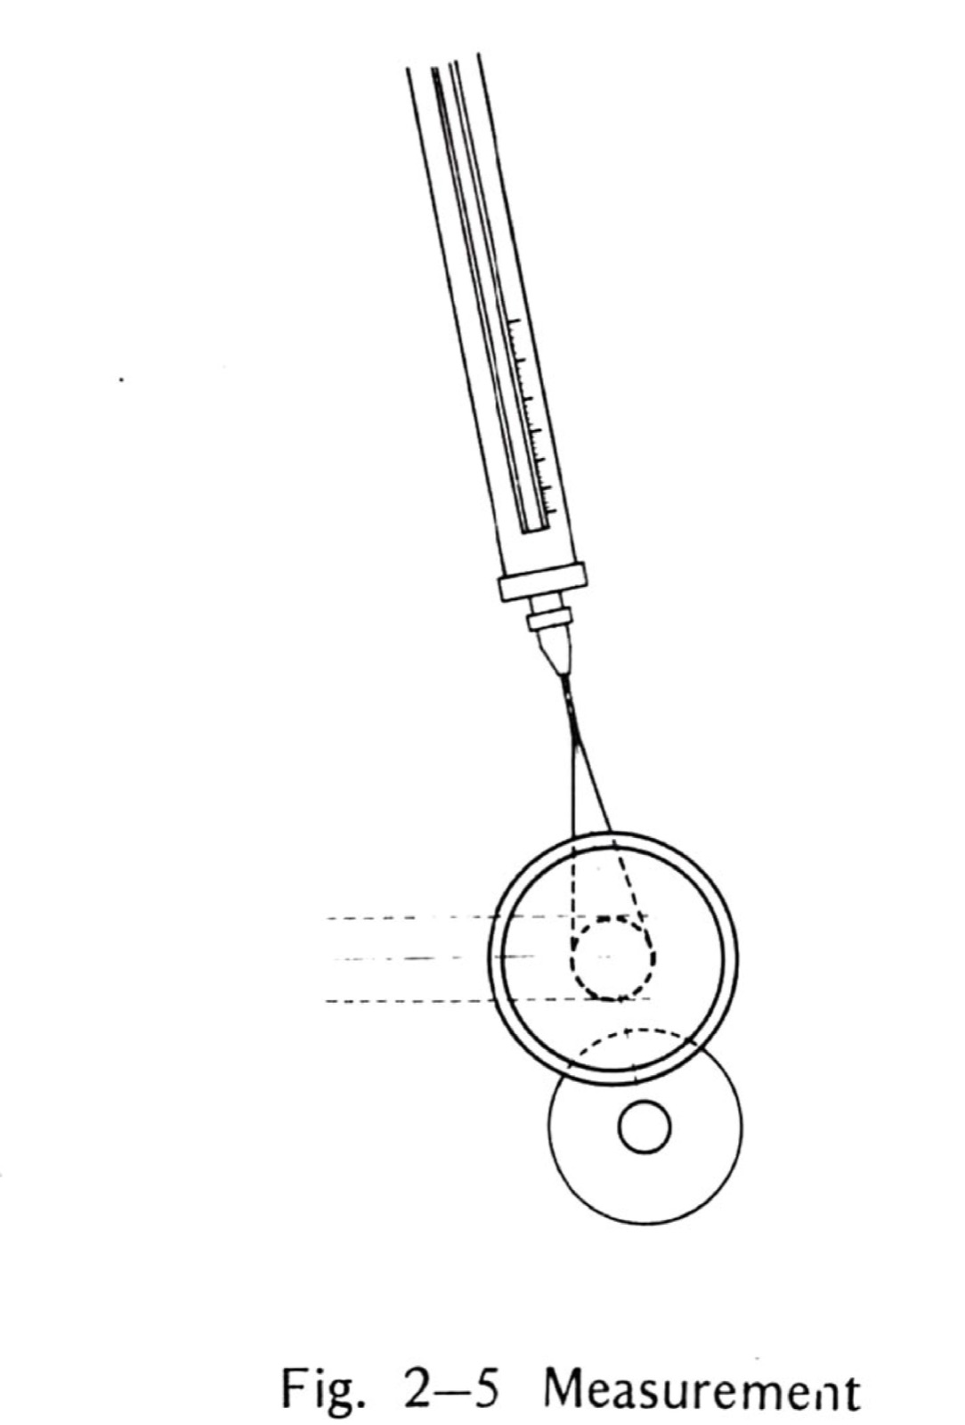
Fig. 2-5 Measurement
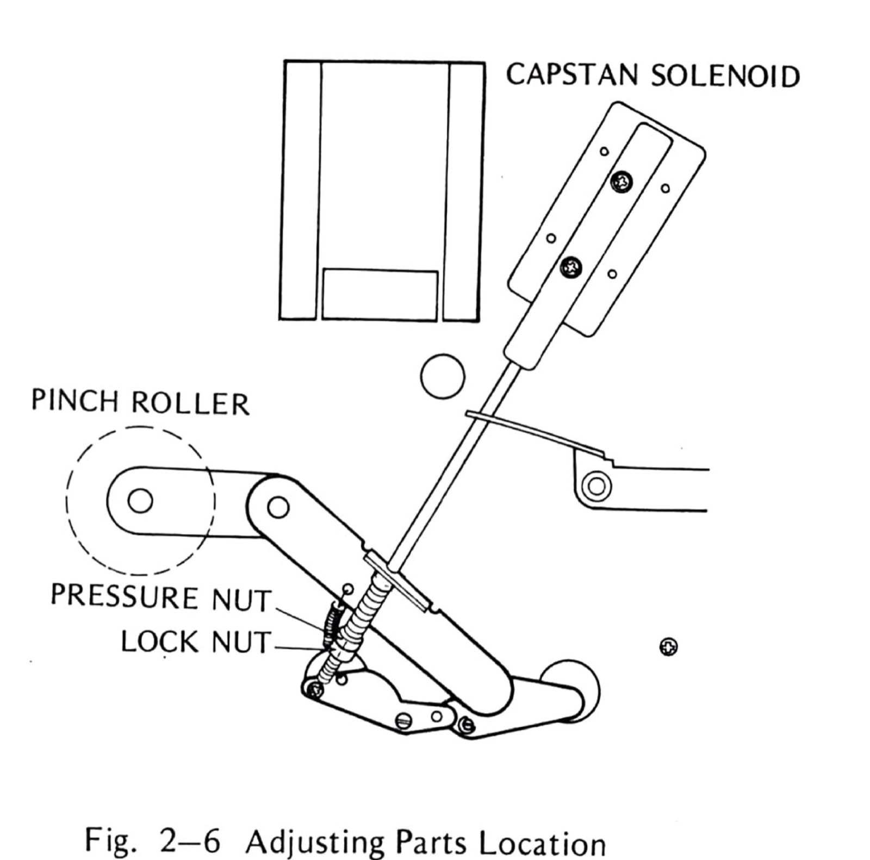
Fig. 2-6 Adjusting Parts Location

2-5 CAPSTAN SPEED ADJUSTMENT (D Type Only)
Capstan speed can be adjusted by speed control on servo control printed circuit board.
This adjustment follows tape speed measurement in Section 3 and adjust [sic] the speed control as shown in Fig. 2-7 as necessary.
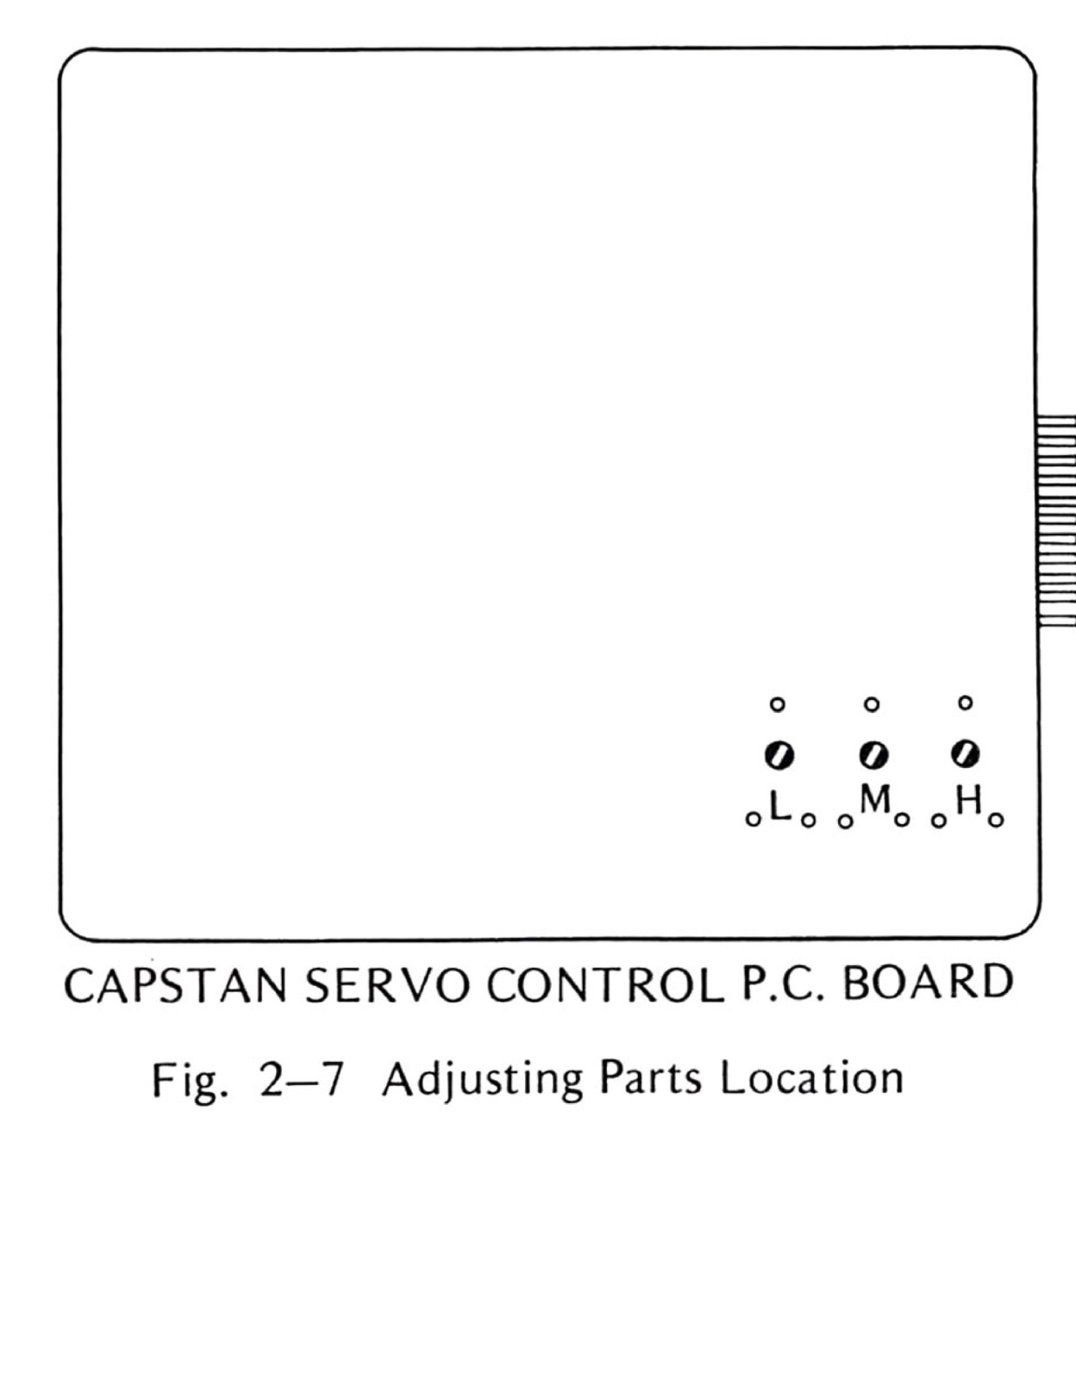
Fig. 2-7 Adjusting Parts Location
Site note: Speed on the first-gen AC transport is set by the mains-locked hysteresis-synchronous motor and the P-12 speed board's 50/60 Hz capacitor values — see Is it a Mini Pro? (https://otarimx5050.com/identify/) for photos of the board.

SECTION 3 — PERFORMANCE TESTS AND ELECTRONIC ALIGNMENT
Performance tests should be performed at regularly scheduled intervals (every 150 hours or 1 month periods) to ensure the recorder is performing within specifications. These tests should also be performed whenever the recorder appears to be malfunctioning and following repairs to the equipment that may affect performance. If the performance test is not successful, proceed to the applicable electronic alignment procedure. It is important that clean and demagnetize the head and tape guiding components before performing the following steps.
Site note: Period measured results for these tests exist: Audio magazine ran them on a 2SH in April 1976 — figures on the specs page (https://otarimx5050.com/specs/).

3-1 TEST EQUIPMENT
The test equipment listed in Table 1-1 is required for completion of the performance and alignment procedures.

3-2 TEST TAPES
The test tapes are precisely recorded under controlled conditions and must be correctly handled and stored to retain their accuracy. The following requirements should be followed:
- Clean and demagnetize the heads and tape guiding components before installing the test tape.
- Never store test tapes in areas where there are temperature or humidity extremes.
- Remove test tapes from equipment only after a normal play run (never after a fast-winding mode). This is further explained below.
During the alignment procedure, the rewind and fast forward modes should not be used. After alignment, wind the tape completely on the takeup reel, interchange reels, thread the tape, and place the equipment in the play mode to wind the tape back on its original reel.
All tones on an Ampex 15 in/s standard alignment tape are recorded at operating level. On slower speed tapes, all tones are recorded 10 dB below operating level except for the last tone. After extensive use, high frequency tones may drop as much as 2 dB. In addition, flutter indications may rise even though actual flutter remains unchanged. Flutter increase is caused by : demagnetization of the recorded signal from repeated plays; tape deformation due to tape tension, changes in temperature and humidity; and increased dropouts resulting from tape wear.

3-3 TEST CONDITIONS
The test conditions specified in the following steps are to be used prior to performing the tests. After these test conditions are set up, continue with the procedures that follow for checking overall signal-to-noise, overall distortion, crosstalk, and flutter.
- Clean and demagnetize the heads.
- Use high quality low-noise tape such as Ampex 406, 407, 456 or Scotch 206, 207, 250, or equivalent. Bulk erase the blank tape.
- Turn power on and allow unit to warm up for 20 minutes.
- Be sure head cover is installed for all tests.

3-4 PERFORMANCE TESTS
Before making performance test, SRL check, reproduce frequency response check, record level check, monitor level check, overall frequency response check, and SEL/REP level check are necessary. Refer to 3-5 ELECTRONIC ALIGNMENT in this section for checking procedures.
For performance tests, preliminary proceed as follows.
Demagnetize and clean heads and guiding compornents. [sic]
- Set REEL switch to appropriate position, and set EDIT switch to “out” non edit position.
- Set LINE OUT switch to H, set each RECORD switch to “in” record position, set each SEL/REP switch to “out” position, and set each MONITOR switch to “out” SOURCE position.
- Thread a reel of bulk-erased tape onto the transport, set SRL switch to SRL position, and push PITCH CONTROL knob to place fix position.

3-4-(1) OVERALL SIGNAL-TO-NOISE
The overall signal-to-noise test requires an ASA “A” weighted filter to attenuate noise outside of the audible frequency band. The filter is shown in Fig. 3-1 and may be built into a small alumimum box as shown in Fig. 3-1. [sic]
Signal-to-noise depends on SRL calibration, reproduce equalization, bias calibration, and record equalization. Proceed as follows:
- Connect filter to CH-1 LINE OUT and connect VTVM to the output of filter.
- Hold TEST OSC pushbutton depressed and adjust CH-1 INPUT LINE control for 0 VU indication on the VU meter.
- (On model MX-5050 2SD2, set reproduce head selector switch at the rear of the head assembly to 2T position.)
- Note VTVM indication, VTVM does not read +4 dBm due to insertion loss of filter.
- Depress CH-1 MONITOR switch to “in” TAPE position, set CH-1 INPUT LINE and CH-1 INPUT MIC controls to full counterclockwise position. Reset TAPE TIMER to “0000”.
- Start record mode and record for one minute. Rewind the tape to “0000” indication on the timer.
- Reproduce the recorded portion and read noise level on VTVM.
- Signal-to-noise retio [sic] is determined by calculating the difference in readings obtained in step 2 and step 5 plus 9 dB (peak recording level—520 nWb/m—is 9 dB above SRL—185 nWb/m)
- Repeat step 1 through 6 for the other channels as required, change tape speed to other and check signal-to-noise retio. [sic]
Table 3-1. Signal-to-noise specifications (ASA weighted)
Models | 2S or 2SD | 4S or 4SD
15 or 7½ | 68dB | 65dB
3¾ | 67dB | 64dB
If signal-to-noise specifications are not obtained, check and adjust following items.
- SRL caliblation [sic] is incorrect.
- BIAS/CAL adjustment is incorrect.
- Reproduce equalization is incorrect.
- Record equalization is incorrect.
- Bias buffer adjustment is incorrect.
- Record and/or reproduce electronics is defective.
- Head is magnetized
- Affected with magnetic flux of a motor, a soldering iron or a transformer near the recorder.
Site note: The manual’s own List of Illustrations promises a “Fig. 3-5 Bias Buffer Adjusting Parts” that appears nowhere in the scan — a stale entry, likely from an earlier revision. No figure is missing from this transcription.
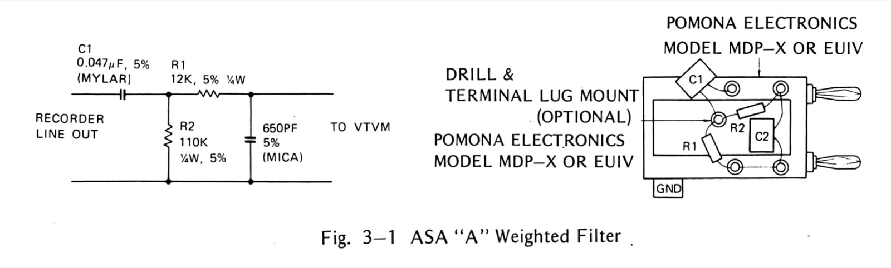
Fig. 3-1 ASA “A” Weighted Filter

3-4-(2) OVERALL DISTORTION TEST
For accurately checking distortion it is necessary to use an audio oscillator with less than 0.1% distortion and a wave analyzer with an adjustable bandwidth capability. A wave analyzer with too narrow a bandwidth may make it difficult to measure harmonics due to flutter components within the transport. Instruments that measure total harmonic distortion will be affected by tape and modulation noise in addition to harmonic distortion. To measure overall harmonic distortion proceed as follows:
- Connect wave analyzer to CH-1 LINE OUTPUT and connect audio oscillator to CH-1 LINE INPUT.
- Set MONITOR switches to “in” TAPE position, set audio oscillator frequency to 1000 Hz.
- Set wave analyzer frequency to 1000 Hz, bandwidth to 100 Hz, and mode selector switch to AFC.
- Start Record mode and adjust CH-1 INPUT LINE control for O VU [sic] on the VU meter.
- Adjust fine tuning control on the wave analyzer and adjust analyzer input level control for full scale reading of 100%.
- Change wave analyzer tuning control to 2000 Hz and measure second harmonic content. The second harmonic content should not exceed 0.5%.
- Change wave analyzer tuning control to 3000 Hz and measure third harmonic content. The third harmonic distortion is dependent upon the type of tape used, accuracy of the BIAS/CAL setting. Typical reading for low noise high output tape is 0.5%: Typical reading for standard output professional grade tape is 0.8%.
- Repeat step 1 through 7 for channel 2.
If distortion specification is not obtained, check and adjust the following items.
- SRL caliblation [sic] is incorrect.
- BIAS/CAL adjustment is incorrect.
- Head is magnetized.
- Record and/or reproduce electronics is defective.

3-4-(3) CROSSTALK TEST
It is important that blank bulk-erased tape is used for crosstalk test. To measure crosstalk between channels proceed as follows:
- Follow the procedure for Overall Distortion Test, steps 1 through 5.
- Connect wave analyzer from the output of CH-1 to CH-2 LINE OUTPUT.
- Measure the crosstalk in dB.
- Crosstalk should not exceed Table 3-2. If crosstalk specification is not obtained, record and/or reproduce head alignment (height and tape contact) is incorrect or record or reproduce head is detective. [sic]
Table 3-2. Crosstalk specifications (Between adjacent channels)
2S or 2SD | 4S or 4SD
60 dB | 55 dB

3-4-(4) ERASURE TEST
It is important that blank bulk-erased tape is used in erasure test. To measure erasing effect proceed as follows.
- Follow the procedure for Overall Distortion Test step 1 through 5. A 1000 Hz signal is being recorded at SRL.
- Set SRL switch to off position and adjust OUTPUT control for -10 VU on VU meter.
- Adjust INPUT LINE control for O VU [sic] on VU meter and 1000 Hz signal is being recorded at 10 dB above SRL. Continue recording for a few minutes.
- Remove the audio oscillator.
- Rewind and reproduce the recorded position.
- VU meter reading should be O VU. [sic]
- Check wave analyzer and readjust as necessary.
- Press RECORD pushbutton to place recorder in record mode.
- As the tape is being erased, adjust the percent scale on the wave analyzer to read the residual 1000 Hz tone.
- Repeat the same procedure for other channels.
- Erasure effect should be more than 65 dB.
If erasure specification is not obtained, check and adjust following items.
- Erase and/or record head alignment is incorrect. (height, tape contact)
- Erase head is worn.
- Erase head surface is dirty.
- Bias oscillator is detective. [sic]

3-4-(5) TAPE SPEED MEASUREMENT
A flutter test tape is used for measuring tape speed.
Since tape tension affects the tape speed, it is important for accurate measurement that flutter test tape is used to be attached to end of full winded blank tape as Fig. 3-2 and is used with REEL pushbutton to appropriate reel size to be used.
Proceed as follows:
- Place PITCH CONTROL to fix position and set all RECORD switch to off “out” position.
- Connect frequency counter to LINE OUT and set MONITOR switch to TAPE position.
- Set SPEED switch to HI and use test tape to appropriate tape speed.
- Attach test tape to 10½ inch NAB reel as Fig. 3-2, place test tape onto supply reel table, thread the tape, and set REEL switch to L position.
- Place recorder in play mode and note reading on frequency counter.
- Reading should be 2994 ~ 3006 Hz (3000Hz ± 0.2%).
- Repeat procedure for at a point towards the end of the reel, for at 7 inch EIA reel and for at low tape speed.
If speed accuracy is not within ± 0.2%, check and adjust following items.
- Capstan servo control is incorrect (on 2SD or 4SD).
- Capstan belt is dirty or worn (on 2S or 4S).
- Capstan motor is defective.
- Pinch roller tire is worn, or has insufficient pressure.
- Brakeshoe is contacting brake drum.
- Tape tensions are incorrect.
- Power requirement is incorrect.
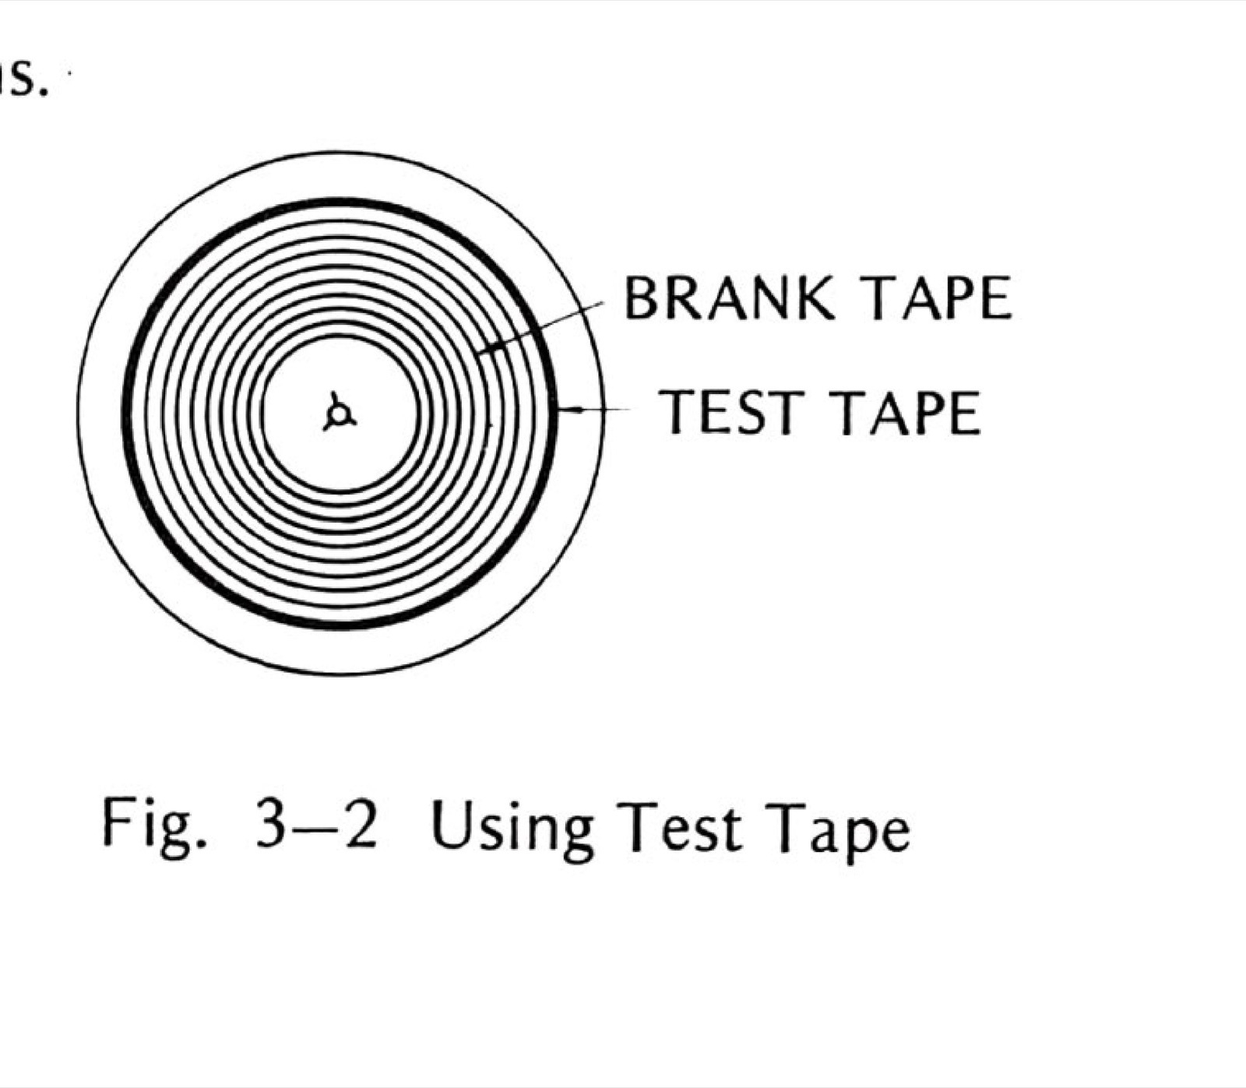
Fig. 3-2 Using Test Tape

3-4-(6) FLUTTER AND WOW TEST
It is recommended that these checks be made with standard flutter test tapes (See Table 1-2) which are recorded on pricise [sic] equipment to produce less than 0.03% rms flutter. If flutter tapes are not available it is possible to record a 3000 Hz or 3150 Hz signal to be used for a flutter measurement. After recording a section of tape, rewind to the begining [sic] and start the tape in the reproduce mode. Since it is possible for the record mode flutter to either add or subtract from the reproduce mode flutter depending upon the phase relationship, it is necessary to make several passes over the recorded section of tape and average the flutter meter readings.
Flutter meters are sensitive to amplitude modulation that results from poor head-to-tape contact or from signal dropouts. Therefore, clean the heads before making flutter tests.
Test tape method is as follows:
It is important that flutter test tape is used to be attached to end of full winded blank tape as Fig. 3-2, and is used with REEL pushbutton to appropriate reel size to be used.
- Set all RECORD switch to off “out” position, and on 2SD or 4SD, place PITCH CONTROL to fix psition. [sic]
- Connect flutter meter to LINE OUT of CH-2 and set the channel MONITOR switch to TAPE position.
- Set selector switch of flutter meter to NAB weighted position, set SPEED switch to HI and use test tape of appropriate tape speeds.
- Attach test tape to 10½ inch NAB reel as Fig. 3-2, place test tape onto supply reel table, thread the tape, and set REEL switch to L position.
- Place recorder in play mode and note reading on flutter meter. Reading should be Table 3-3.
- Repeat procedure for at a point towards the end of the reel, for at 7 inch EIA reel and for at low tape speed.
Record-playback method is as follows:
- Connect oscillator signal output of the flutter meter to CH-2 LINE INPUT of the recorder.
- Connect the LINE OUTPUT of the recorder to the signal input of the flutter meter
- Set SPEED switch to HI, set SRL switch to SRL position set MONITOR switch to TAPE position, start record mode, and adjust appropriate INPUT LINE control
- Rewind and reproduce recorded portion, note the flutter and wow on the flutter meter.
- Check flutter and wow at low tape speed and check at a point towards the end of the reel.
Table 3-3 Flutter and wow specifications
Tape speed | Flutter and wow
15 ips | 0.05 %
7.5 ips | 0.06 %
3¾ ips | 0.15 %
Flutter and wow can be caused by any element in the tape path. Excessive flutter and wow may be traced by observing the flutter component on an oscilloscope screen connected to the demodulator output of the flutter meter. If the fluctuation rate observed on the oscilloscope coincides with the rotation elements, such as the supply or takeup reel, capstan or pinch roller, the problem source may be easily traced. Other sources of excessive flutter and wow are:
- Capstan servo control is defective (on D type).
- Capstan motor is damaged.
- Capstan needs lubrication (dry bearing).
- Tape tensions are incorrect.
- Brakeshoe is contacting brake drum.
- Tape reels or tape is defective.
- Pinch roller tire is worn, has insufficient pressure, or pinch roller solenoid is not bottomed.
- Pinch roller and capstan are dirty.

3-5 ELECTRONIC ALIGNMENT
If the previous performance tests were not successful, perform the following applicable reproduce and record alignment procedure.
Access to electromic [sic] assembly is as follows: The record/reproduce electronic circuitry is contained on three printed circuit board assemblies (PCB). Access to these PCB may be obtained by removing the base of the cabinet (four screws). Fig. 3-4 shows the location of the various circuits contained on the PCBs.
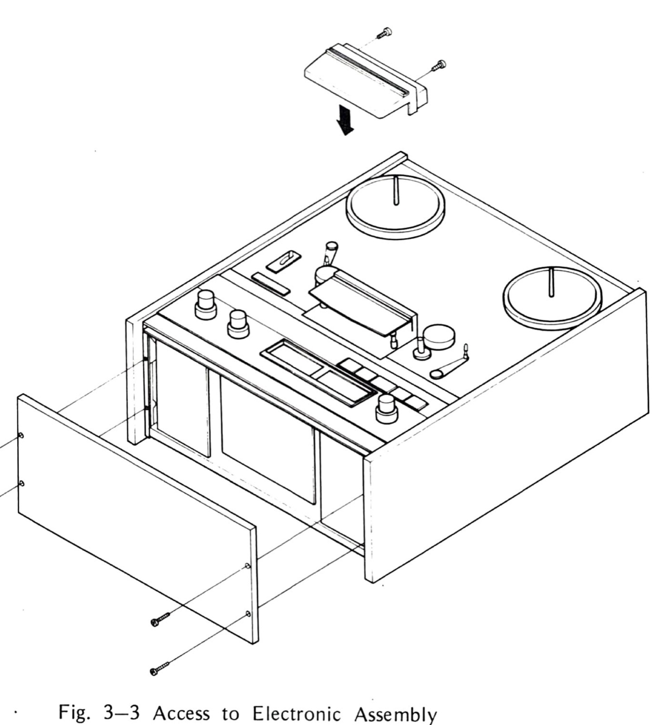
Fig. 3-3 Access to Electronic Assembly

3-5-(1) REPRODUCE ALIGNMENT
Reproduce adjustment consists of reproduce head azimuth adjustment, reproduce equalization adjustment, maximum reproduce level caliblation [sic] (MRL), and standard reference level (SRL) calibration. Location of each calibration potentiometer control is shown in Fig. 3-4. To adjust the reproduce system, proceed as follows:
- Lift head cover and demagnetize and clean heads and guides.
- Set LINE OUT switch to HIGH, set SRL switch to “off” variable position. Set REEL switch to appropriate position, and set EDIT switch to “out” (non edit) position. Set reproduce head selector switch to 2T position for models 2S or 2SD, to 4T position for mosels [sic] 4S or 4SD.
- Set each RECORD switch to “out” (non record) position, set SEL/REP switches to “out” position, and set MONITOR switches to “out” SOURCE position.
- Connect VTVM to LINE OUT.
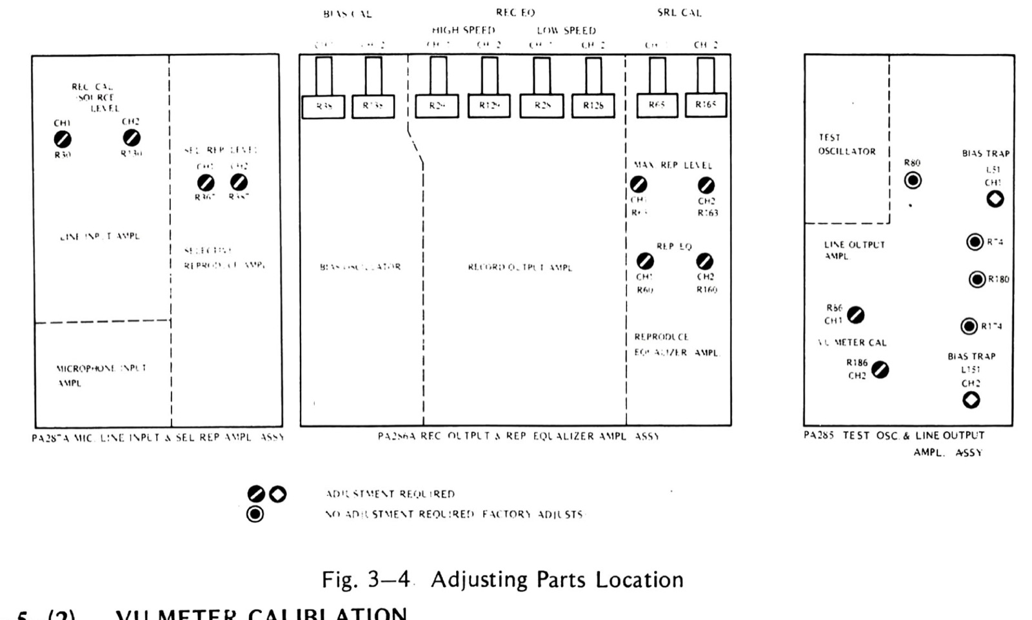
Fig. 3-4 Adjusting Parts Location

3-5-(2) VU METER CALIBLATION [sic]
- Depress TEST OSC switch and adjust INPUT LINE CONTROL to obtain +4dBm reading on VTVM.
- Adjust R86 (CH-1) and R186 (CH-2) to obtain OVU [sic] reading on VU meter.

3-5-(3) REPRODUCE HEAD AZIMUTH ADJUSTMENT
It is recommended that reproduce head azimuth adjustment is made at 7½ ips tape speed.
- Set SPEED switch to appropriate position for 7½ ips and set MONITOR switches to “in” TAPE position.
- Thread 7½ alignment test tape on the equipment.
- Place equipment in play mode, first tone on test tape is refference [sic] level of 700 Hz. Adjust OUTPUT level control to obtain O dBm on the VTVM. Next tone is for azimuth adjustment (15 kHz).
- Adjust the head azimuth screw (appropriate screw “A” in Fig.4-6) to obtain a maximum reading on the VTVM.
CAUTION
DO NOT ADJUST ANY OTHER SCREWS EXCEPT AZIMUTH ADJUSTMENT SCREW (LABELED “A” IN FIG. 4-6).
If a maximum reading cannot be achieved within one full turn of the azimuth screw, or a maximum reading on the VTVM is way below O dBm, a full head alignment may be required. Refer to section 4 of this manual.

3-5-(4) REPRODUCE EQUALIZATION ADJUSTMENT
This adjustment is performed at 7½ ips tape speed for both High speed models and Low speed models.
- Reproduce the 10 kHz tone and adjust REP EQ potentiometer R60 (CH-1) and R161 [sic] (CH-2) so that VTVM indicate O dBm. If adjustment was required, recheck the 15 kHz tone and note if reading is O dBm ±2 dB.
- Check response for the other tones on the alignment tape. Frequency response should be O dBm ± 2 dB.
- Check frequency response for the other tape speed. Frequency response should be O dBm ±2 dB. It is unnecessary to readjust equalization for 15 ips or 3¾ ips, since adjustment has been done at the same time of 7½ ips.
NOTE
Many test tapes are recorded full track. When reproduced by a half-track or multi–track head, the fringing effect produces invalid response at frequencies below 700 Hz. This effect, which results in high indications in the lower frequencies, does not occur when tapes are recorded and reproduced with heads of the same configuration. Do not adjust the low frequency reproduce equalizers for flat response from a full track standard tape.

3-5-(5) MAXIMUM REPRODUCE LEVEL (MRL) CALIBLATION [sic]
This adjustment is performed at 7½ ips tape speed.
- Set both OUTPUT controls to full clockwise position.
- Reproduce a 7½ ips alignment test tape. When the first 700Hz tone is reached, adjust maximum reproduce level caliblation [sic] potentiometers R63 (CH-1) and R163 (CH-2) so that each VU meter indicates O VU.
NOTE
The first tone is a reference level which is recorded at 10 dB below operating level (185nWb/m).

3-5-(6) SRL ADJUSTMENT
This adjustment is made with the operating level 700 Hz signal of the standard alignment tape. It is important that this adjustment is accurate since it affects signal to noise ratio, distortion, and tape saturation level. On Ampex standard alignment tapes this level is 185 nWb/m and is the first tone for 15 ips the last tone for 7½ ips and 3¾ ips tapes. It is suggested that SRL be set at the speed at which the equipment will usually run. If used equally, set at 15 ips for high speed models, 7½ ips for low speed models.
Set SRL switch to SRL position. Reproduce the operating level tone and adjust SRL/CAL potentiometers R65 (CH-1) and R165 (CH-2) so that each VU meter indicates O VU or a +4 dBm or -10 dBm reading on the VTVM depending upon the LINE OUTPUT LEVEL selector.
NOTE
If high output extended dynamic range tapes are to be used exclusively such as Scotch 206, 207 or 250 or Ampex 406, 407 or 456 (or equivalent), the SRL/CAL and SEL/REP levels may be set lower than O VU. Consult Otari representative. Nominal setting for these tapes is -3 VU.

3-6 RECORD AND BIAS SYSTEM ADJUSTMENT
Record and bias system adjustment consists of bias calibration, record level calibration, record head azimuth adjustment, record equalization adjustment, and SEL/REP LEVEL adjustment. The record and bias system adjustment should be made after reproduce system adjustments are completed.
- Connect VTVM to LINE OUT, connect audio oscillator to LINE IN, and thread blank bulk-erased tape onto the transport.
- Push POWER switch to on, set SPEED switch to HI position, and set MONITOR switch to TAPE position, set LINE OUT LEVEL switch to HIGH position, and SRL switch to SRL position.
Fig. 3-4 Adjusting Parts Location

3-6-(1) BIAS CALIBRATION
Bias adjustment should be made at 15 ips for high speed models and 7½ ips for low speed models. Record bias current affect signal-to-noise ratio, frequency response, distortion, and recording level. Then it is important to adjust bias current for the using tape in order to make perfect recording.
- Connect 1 kHz tone of audio oscillator to LINE INPUT. (Built in TEST oscillator is also available.) Set MONITOR switch to TAPE position.
- Start Record mode and adjust INPUT LINE control for O VU on the VU meter.
- Adjust the BIAS/CAL potentiometers R38(CH-1) and R138(CH-2) so that each VU meter indicates maximum record output.

3-6-(2) RECORD HEAD AZIMUTH ADJUSTMENT
This adjustment should be made at 7½ ips tape speed and at least 10 dB below SRL.
- Set audio oscillator frequency to 15 kHz.
- Start record mode and adjust INPUT LINE control for -10 dBm on VTVM (14 dB below SRL).
- Adjust record head azimuth adjustment screw (labeled “A” in Fig. 4-6) for maximum reading on VTVM.
- If a peak reading cannot be achieved within one full turn of the azimuth screw, a full head alizument [sic] may be required. Refer to Section 4 of this manual.

3-6-(3) RECORD LEVEL CALIBLATION [sic]
This adjustment should be made at 15 ips for high speed models and 7½ ips for low speed models.
- Set audio oscillator frequency to 1 kHz, set SRL switch to SRL position, and set MONITOR switches to TAPE position.
- Start record mode and adjust input LINE controls so that each VU meter indicates O VU.
- Set MONITOR switches to SOURCE position and adjust REC. CAL. potentiometers R30 (CH-1) and R130 (CH-2) so that each VU meter indicates 0 VU.

3-6-(4) RECORD EQUALIZATION ADJUSTMENT
This adjustment should be performed at SRL position for 15 ips tape speed and at least 10 dB below SRL for 7½ ips or 3 ¾ ips tape speed. Since overall frequency response is affected with bias current, bias calibration may be performed before making this adjustment.
ADJUSTMENT FOR 15 ips
- Set SRL switch to SRL position, and set MONITOR switches to TAPE position.
- Place recorder in record mode, set audio oscillator frequency to 1 kHz and adjust INPUT LINE controls for O VU on VU meters.
- Change frequency to 18 kHz and adjust REC/EQ potentiometers R29 (CH-1) and R129 (CH-2) so that each VU meter indicates O VU.
- Sweep oscillator frequency from 35 to 22 kHz. Check that the overall frequency response is within ±2 dB. Readjust REC/EQ potentiometers R29 (CH-1) and R129 (CH-2) as necessary.
ADJUSTMENT FOR 7½ ips
- Set SRL switch to “off” or “variable” position and set OUTPUT controls to full clockwise position.
- Place recorder in record mode. Set audio oscillator frequency to 1 kHz and adjust INPU [sic] LINE controls for O VU on VU meters (recording is made at 10 dB below SRL).
- Change frequency to 15 kHz and adjust REC/EQ potentiometers R28 (CH-1) and R128 (CH-2) on high speed models or R29 (CH-1) and R129 (CH-2) on low speed models, so that each VU meter indicates O VU.
- Sweep oscillator frequency from 30 to 18 kHz and check that the over all frequency response is within ±2 dB. Readjust appropriate REC/EQ potentiometer as necessary.
ADJUSTMENT FOR 3 ¾ ips
- Set SRL switch to “off” or “variable” position and set OUTPUT controls to full clockwise position.
- Place recorder in record mode. Set audio oscillator frequency to 1 kHz and adjust INPUT LINE controls for O VU on VU meter (recording is made at 10 dB below SRL).
- Change frequency to 10 kHz and adjust REC/EQ potentiometers R28 (CH-1) and R128 (CH-2) so that each VU meter indicates O VU.
- Sweep oscillator frequency from 30 to 12 kHz and check that the over all frequency responce [sic] is within ±2 dB. Readjust appropriate REC/EQ potentiometer as necessary.

3-6-(5) SEL/REP LEVEL ADJUSTMENT
- Record 1 kHz signal at SRL for about one minute for both channels.
- Rewind and reproduce the recorded position in the step, and check both VU meters should indicate O VU.
- Depress SEL/REP switch and adjust SEL. REP LEVEL potentiometers R367 (CH-1) and R387 (CH-2) so that each VU meter indicates O VU.
NOTE
If this adjustment is made by using standard alignment test tapes which are full track recorded, there will be a little error on acount [sic] of fringing effect.

SECTION 4 — MAJOR COMPONENT REPLACEMENT PROCEDURES

4-1 TAPE TRANSPORT
In order to gain access to the tape transport components, place the recorder in an upright position and remove rear cover, two side panels, and top panel (16 screws total).
Refer to Section 6 for parts lists and exploded views of the transport assembly to aid in the identification of the various components.

4-1-(1) REEL TABLE REPLACEMENT AND HEIGHT ADJUSTMENT
The reel table may be removed by removing three cross head screws accessible from the front of the transport. To adjust the reel table height, loosen two hexagonal socket head screws shown in Fig. 4-1, adjust height and retighten screws.
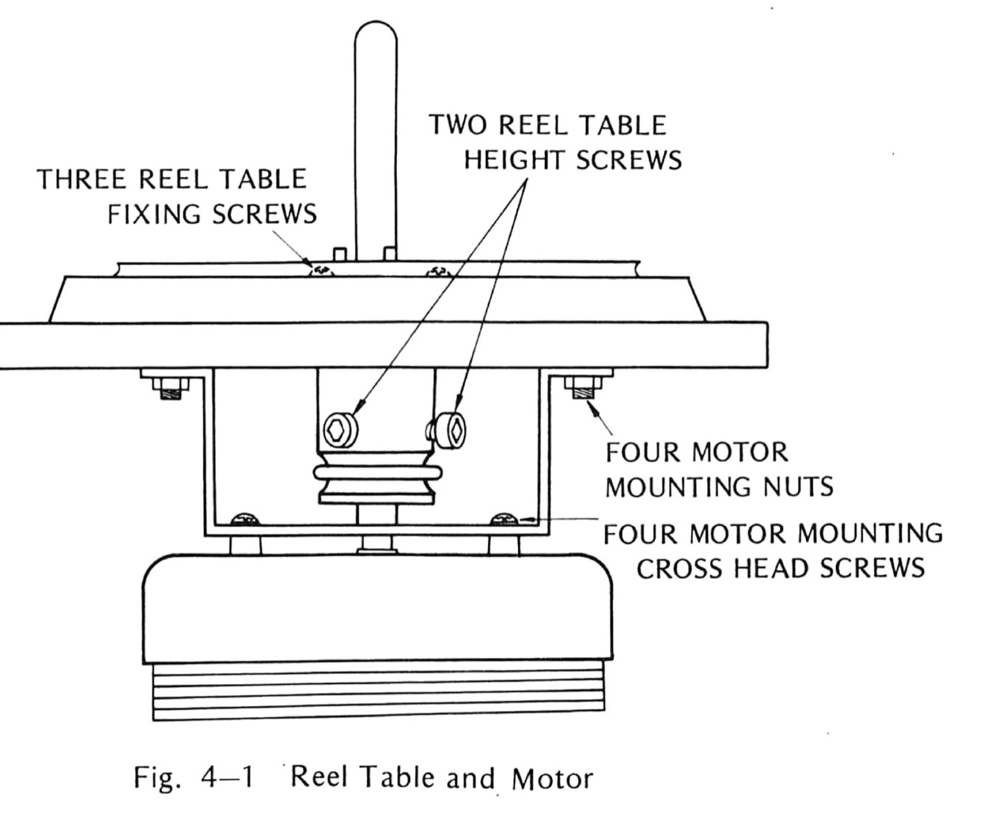
Fig. 4-1 Reel Table and Motor

4-1-(2) SUPPLY OR TAKEUP REEL MOTOR REPLACEMENT
To replace the supply or takeup motor proceed as follows:
- Loosen two hexagonal socket head screws on the reel shaft holder (Fig. 4-1) and remove reel table and holder.
- Tag and unsolder motor leads from the attached printed circuit board.
- Remove four motor mounting M4 nuts.
- Remove four motor mounting crosshead screws.
- Install new motor in the reverse order of removal and adjust reel table height.

4-1-(3) POWER TRANSFORMER REPLACEMENT
To replace the power transformer (refer to EXPLODED VIEW 2), proceed as follows:
- Tag and unsolder all transformer leads from the terminal.
- Remove four M4 nuts that secures [sic] the transformer to the transport. (Ref. No. 2-18)
- Install new transformer in the reverse order of removal and resolder leads to the terminal of the transformer.

4-1-(4) CAPSTAN MOTOR REPLACEMENT
On models 2S or 4S (Hysteresis synchronous motor machines).
To place [sic] the capstan motor (Fig. 4-1 and refer to Exploded View 4), proceed as follows:
- Tag and unsolder all motor leads from the printed circuit board.
- Remove entire motor assembly and mounting bracket by removing four cross head screws accessible from the rear of the transport.
- Remove motor pully [sic] from motor shaft by loosening an allen head screw.
- Remove motor from mounting bracket and replace with new motor.
- Reinstll [sic] motor assembly and mounting bracket in the reverse order of removal. Adjust bracket position to tighten drive belt before cross head mounting screws are tightened.
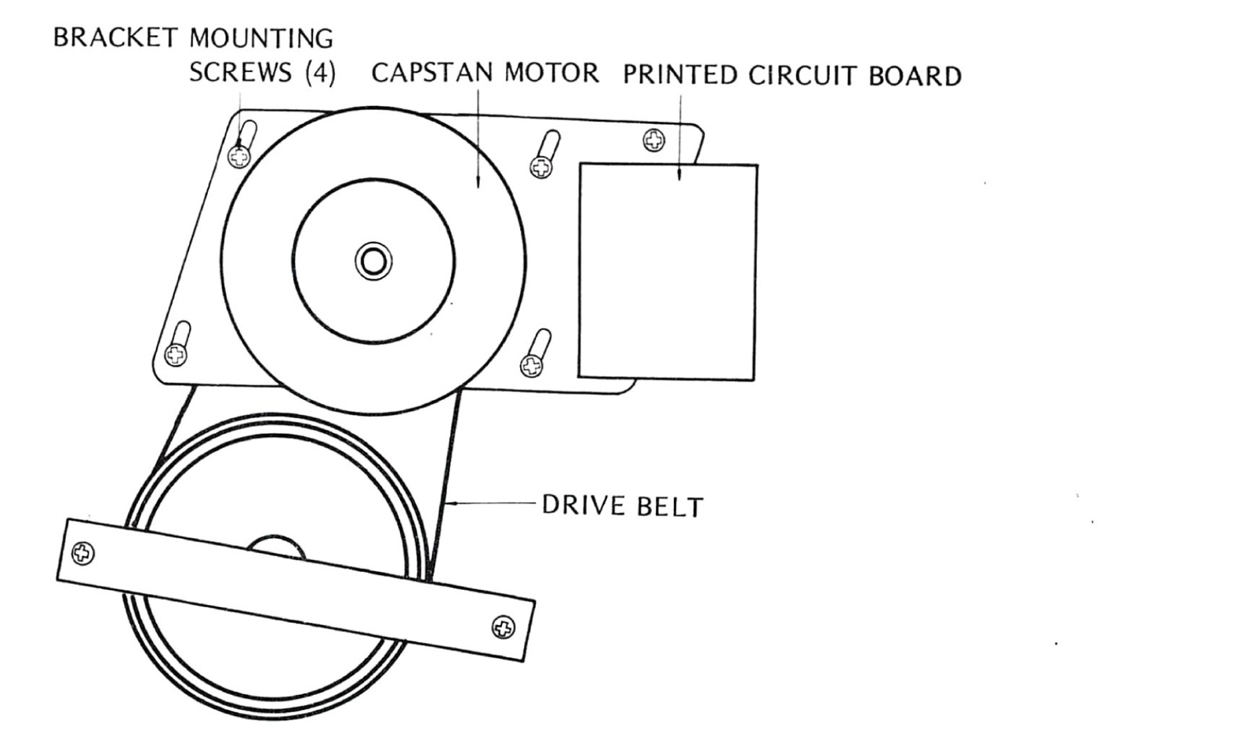
Fig. 4-2 Capstar Motor Location (2S or 4S)
On models 2SD or 4SD (DC servo controlled motor machines)
The capstan motor should be replaced with servo control printed circuit board assembly, to replace the capstan motor proceed as follows: (Refer to EXPLODED VIEW 4-2)
- Remove connector on servo control printed circuit board assembly located above capstan.
- Remove servo control printed circuit board assembly with mounting plate by turning four M3 crosshead screws “B” on mounting plate.
- Remove capstan dust cap from face of transport. (Ref. No. 4-102)
- Remove capstan mounting plate with capstan motor by removing four M4 crosshead screws “A” on the mounting plate.
- Remove the capstan motor by removing three M4 crosshead screws “C” on the mounting plate and install new capstan assembly in the reverse order.
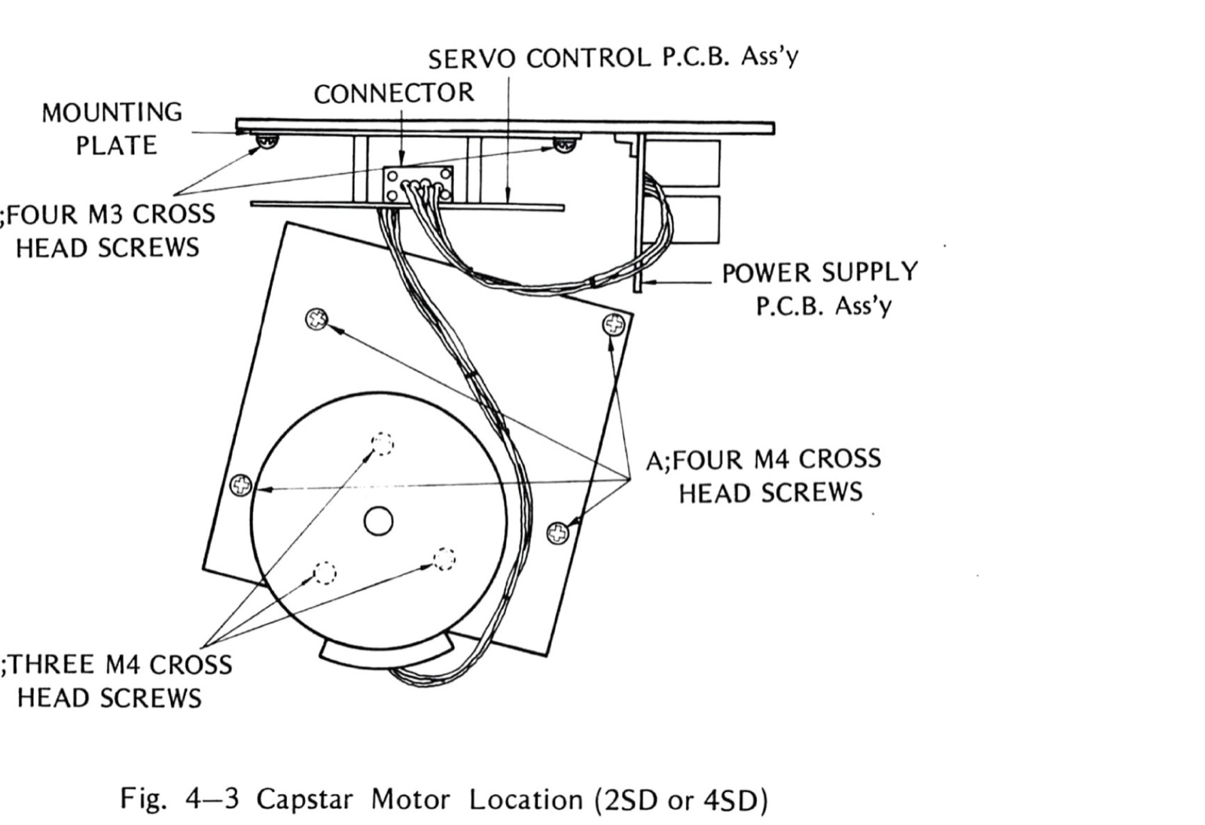
Fig. 4-3 Capstar Motor Location (2SD or 4SD)
Site note: Exploded view 4-1 is the AC belt-drive capstan with its run cap; 4-2 is the DC-servo capstan of the 2SD/4SD variants — the detail that settled which machines the DC sections of this manual describe. Replacing the run caps is written up in Re-capping the motor run caps (https://otarimx5050.com/log/recapping-motor-run-caps/).

4-1-(5) BRAKE BAND OR BRAKE SOLENOID REPLACEMENT
When a new brake band or new brake solenoid is installed (Fig. 2-2), it is necessary to position the brake guide and/or brake solenoid to ensure that there is uniform brake band clearance around the brake drum when the solenoid is energized. Also the brake solenoid plunger must bottom in the solenoid housing when the solenoid is energized. When the solenoid is deenergized, the brake band should uniformally [sic] contact the drum surface. After installation, perform the Brake Adjustment procedure given in Section 2 of this manual. After completion of the adjustments place the recorder in play mode for 30 minutes. Then press STOPand [sic] PLAY pushbuttons to ensure that the solenoid bottoms when it is hot.
Site note: The transport push-buttons and their microswitches are documented with part numbers and photos in Inside the transport buttons (https://otarimx5050.com/log/transport-buttons/).
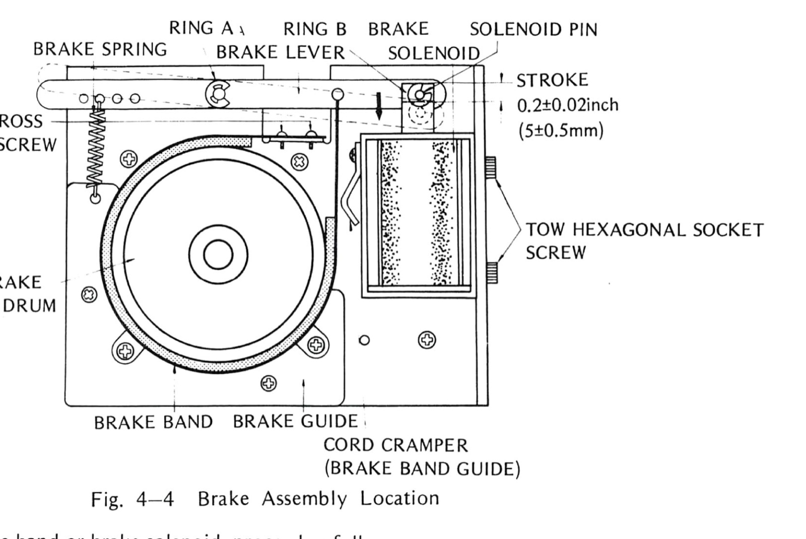
Fig. 4-4 Brake Assembly Location
To replace the brake band or brake solenoid, proceed as follows:
- Remove brake spring and retaining ring “A”.
- Remove retaining ring “B” of solenoid pin. [sic] and remove solenoid pin.
- Remove solenoid housing with plunger by removing two hexagonal socket head screws.
- Install new solenioid [sic] housing with plunger and set solenoid housing so that plunger stroke is 0.2 ± 0.02 inch (5 ± 0.5 mm).
- Remove spring pin of brake lever and remove brake band by removing two cross head screws.
- Install new brake band in the reverse order.

4-1-(6) PINCH ROLLER REPLACEMENT
To replace the pinch roller assembly proceed as follows:
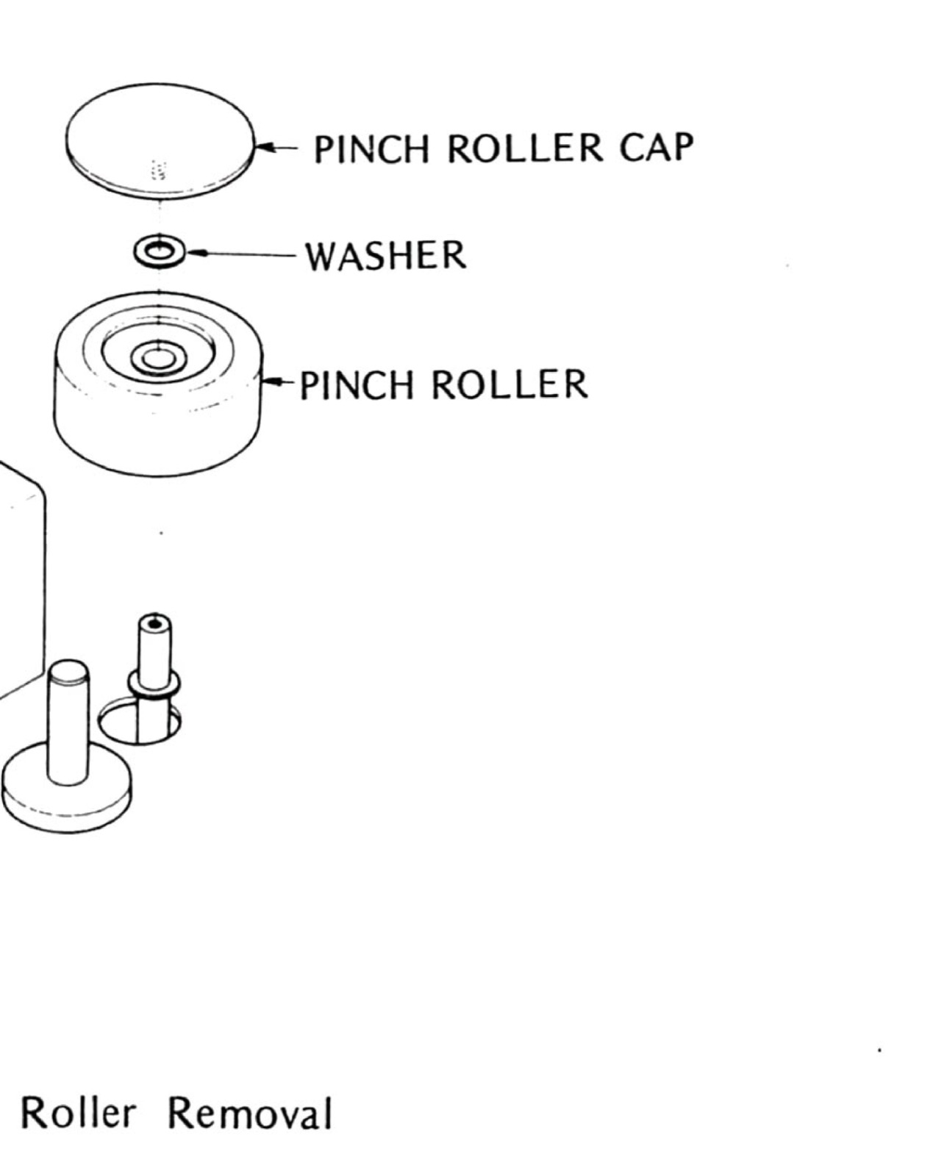
Fig. 4-5 Pinch Roller Removal
- Remove pinch roller cap by turning counterclock wise [sic].
- Install new pinch roller.
- Reinstall nylon washer and pinch roller cap in the reverse order.

4-2 HEAD ASSEMBLY REPLACEMENT
This section provide [sic] a description of the head assembly, procedures for changing head stacks and adjustment procedures for adjusting head azimuth (tilt), head height, head zenith (perpendicularity) and tape wrap (racking). These adjustments are required whenever a head stack is replaced.
NOTE
AFTER HEAD ALIGNMENT, ALIGNMENT SCREWS (AZIMUTH, ZENITH, HEIGHT) SHOULD BE LOCKED UP WITH ENAMEL PAINT.
DESCRIPTION
The head assembly is mounted on three tape-guide posts and secured in place by three screws labled [sic] “M” in Fig. 4-6.
The insulating shield for the head assembly printed circuit board is secured by screws labled [sic] “S”. Each head stack is secured to a bracket by screws labled [sic] “W” with a spacer between the bracket and head stack. Each bracket is suspended from the head base by three spring-loaded screws labled [sic] “H”, “A”, and “Z”. Screws labeled “W” are used to adjust tape wrap. Screws labeled “H”, “A”, and “Z” are used to adjust height, azimuth, and zenith.
A head stack may be removed and re-lapped (face resurfaced) if the amount of wear is small and only an indication of poor head-to-tape contact is evident. Poor contact is a result of improper adjustment and is evidenced by loss of high frequency response of the record or reproduce head stack, difficulty in achieving bias peak (record stack), or insufficient erase stack erasure.
HEAD STACK REPLACEMENT
To change a head stack, proceed as follows:
- Lift head cover, remove AC power cord.
- Remove three screws labeled “M” and pull out the head assembly from head connector.
- Tag and unsolder (use low wattage pencil type iron to prevent damage) leads at rear terminal of the head stack.
- Remove head stack by removing two screws labeled “W”.
- Install new head stack and resolder leads.
- As a preliminary adjustment, measure the distance between the head base and the bracket at a point near spring-loaded screws “A”, “Z”, and “H”. If necessary adjust screws for equal spacing.
- Lay a piece of ¼-inch tape over the spacers and head stacks as shown in Fig. 4-7. Note if the leading and trailing wrap angle around the head stack is equal. If not equal, correct by loosening screw “W”, adjusting head stack, and retightening screws. Remove the three screws and spacers installed in step 7.
- Remount the head assembly. Perform the appropriate head alignment procedure given below.
Following adjustment are [sic] necessary whenever head is replaced.
- In case of reproduce head replacement. A. Reproduce Equalization Adjustment (See 3-5-([illegible]) ) B. SRL Calibration (See 3-5-(6) )
- In case of record head replacement. A. Bias Calibration (See 3-6-(1) ) B. Record Level Calibration (See 3-6-(3) ) C. Record Equalization Adjustment (See 3-6-(4) ) D. SEL/REP Level Adjustment (See 3-6-(5) )
- In case of erase head replacement A. Bias Calibration (See 3-6-(1) )
Site note: The cross-reference digit is unreadable in the scan; Section 3’s own numbering shows Reproduce Equalization Adjustment as 3-5-(3).

RECORD OR REPRODUCE HEAD ADJUSTEMNT [sic]
Follow the procedure for Reproduce Amplifier Alignment given in Section 3 of this manual. For the final adjustment of a record stack, the height and azimuth adjustment may be accomplished in the same manner as for a reproduce head stack by playing back an alignment tape with the recorder in the selective reproduction mode (SEL/REP switches “in”). Use the 10 kHz tone for azimuth adjustment.

ERASE HEAD ALIGNMENT
Erase head azimuth is not critical, however wrap angle and head height relative to the record head is important to achieve maximum efficiency. Poor erasure is often caused by misalignment of the erase head. Before making any attempt to adjust the erase head stack, an entire electronic alignment procedure (reproduce, record, and bias amplifier alignment) should be performed so that the record and reproduce head heights are correct, SRL/CAL setting is correct, and bias and record levels are properly calibrated. If [sic] should be also noted that in some cases, high coercivity tape can be the cause of poor erasure.
An approximate erase head adjustment can be accomplished using headset or a speaker/amplifier. However, for precise alignment, a wave analyzer should be used. Proceed as follows:
- Follow the procedure for Erasure Test steps 1 through 6 given in Section 3 of this manual.
- Observe reading on wave analyzer and turn screw “H” (Fig.4-5) ¼ turn clockwise. If the reading decreased, turn screw “A” and “Z” ¼ turn clockwise. If the reading increased when “H” was turned ¼ turn clockwise, turn “H” counterclockwise past the original setting to ¼ turn counterclockwise. If the reading decreased, turn screw “A” and “Z” counterclockwise by the same amount.
- Repeat step 2 in small increments to achieve a minimum reading on the wave analyzer. Typical amount of erasure should be 65 dB or better. Note: After “H” is turned, be sure to turn “A” and “Z” the same amount.
- If the adjustment of erase head height alone cannot achieve satisfactory erasure, set screw “H”, “A”, and “Z” for minimum reading on the wave analyzer. Note that there are two vertical gaps on the face of the erase head. The trailing gap has the most effect on erasure and must be in good contact with the tape. Loosen screws “W” slightly and rotate the erase head stack for a minimum reading on the wave analyzer. Tighten screws “W”.
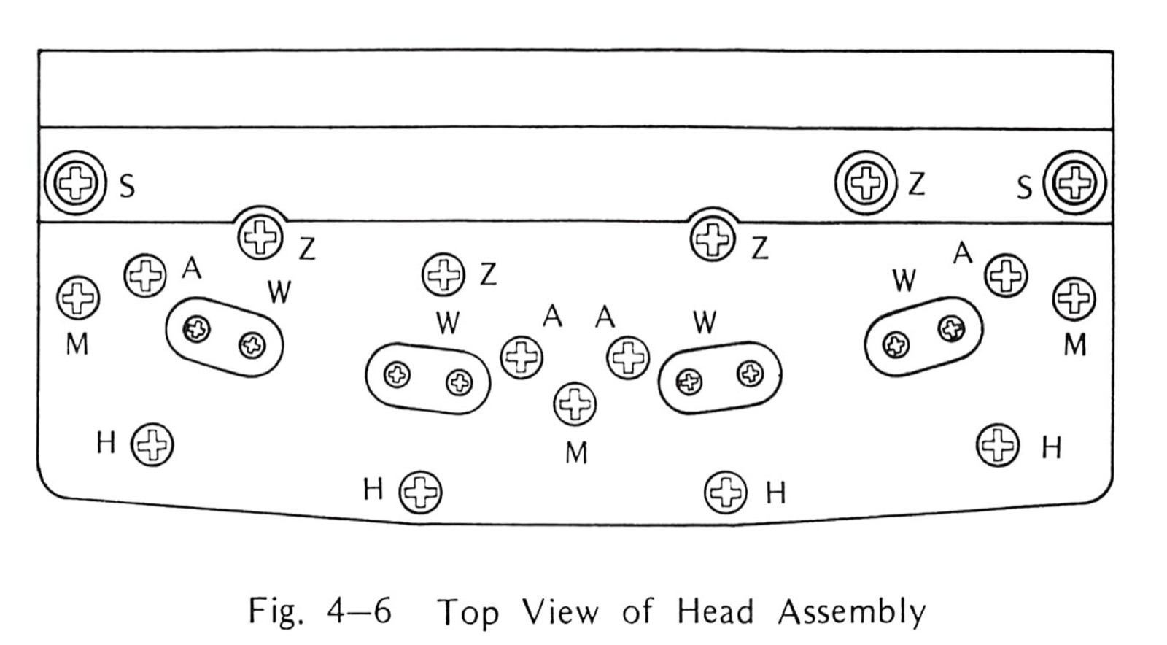
Fig. 4-6 Top View of Head Assembly
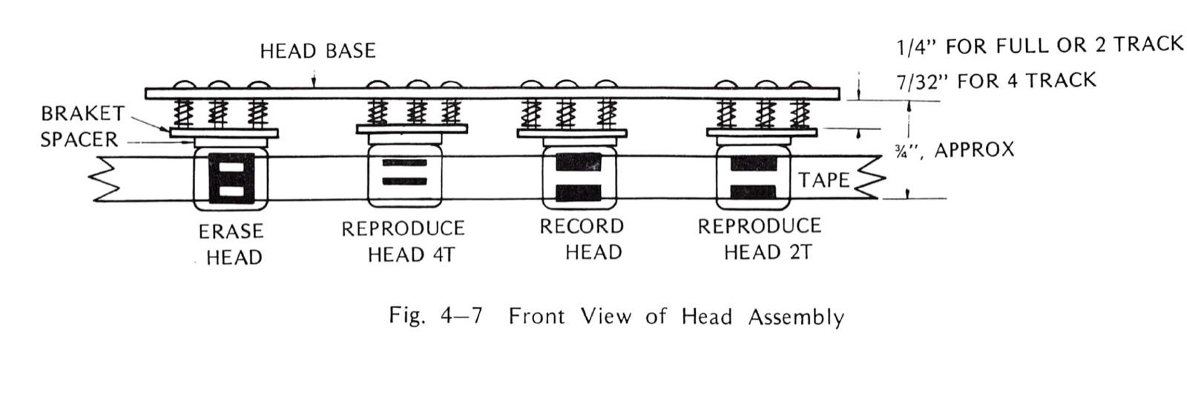
Fig. 4-7 Front View of Head Assembly
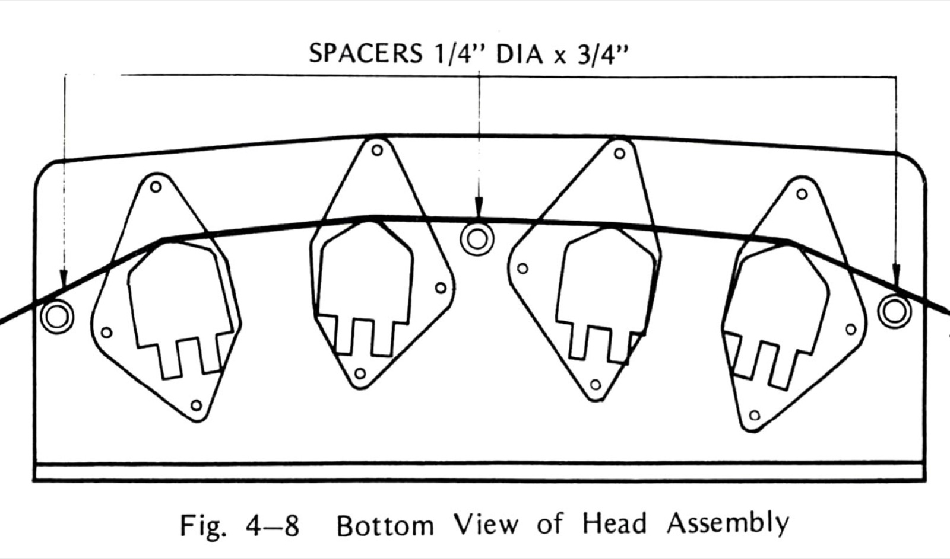
Fig. 4-8 Bottom View of Head Assembly
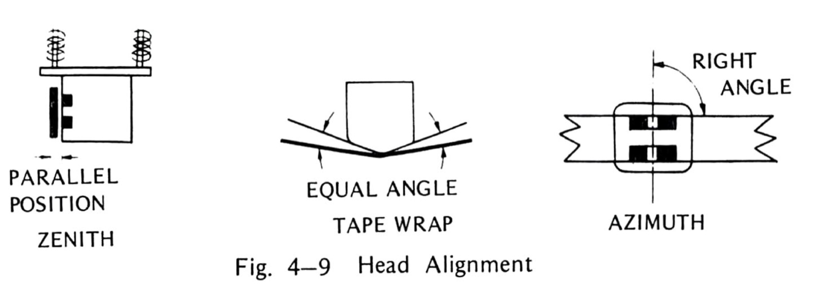
Fig. 4-9 Head Alignment

4-3 INSTALLATION OF OPTIONAL TRANSFORMER

4-3-(1) INSTRUCTION OF INPUT TRANSFORMER
Follow the instruction to install the input transformer.
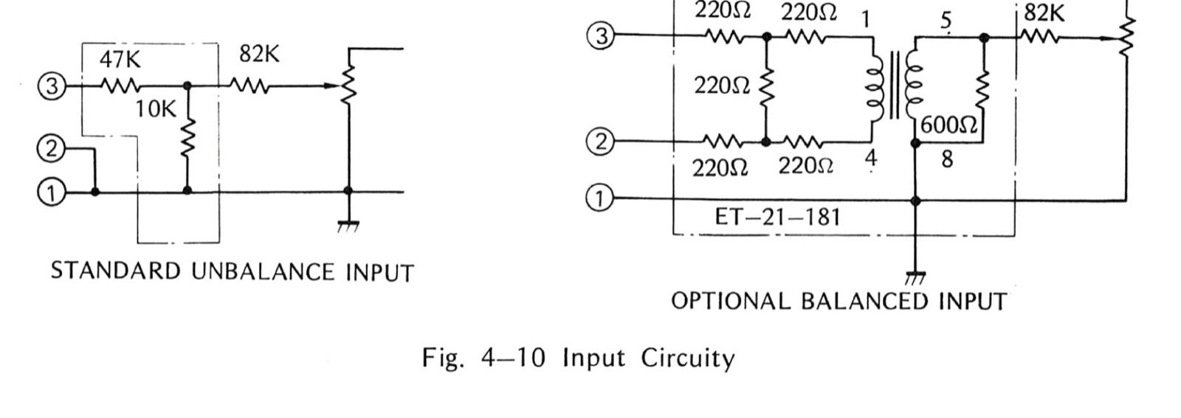
Fig. 4-10 Input Circuity
Input transformer has terminals as shown above surrounded by broken line.
- Take out case rear board as shown in Fig. 2-1, and out Rear Panel [sic]. Then mount the transformer with two screws. (See Fig. 4-12)
- Remove wires from XLR connector. Solder Hot Line (Orange) to transformer output side number 5, Solder Cold Line & Shied [sic] to terminal number 8.
- Solder Hot Line (Orange) premounted on the transformer to XLR connector number 3, Cold Line (White) to XLR connector number 2, and Shield to XLR connector l [sic]. (See Fig. 4-13)
- Take out the bottom board and re-wire the PCB as shown below.
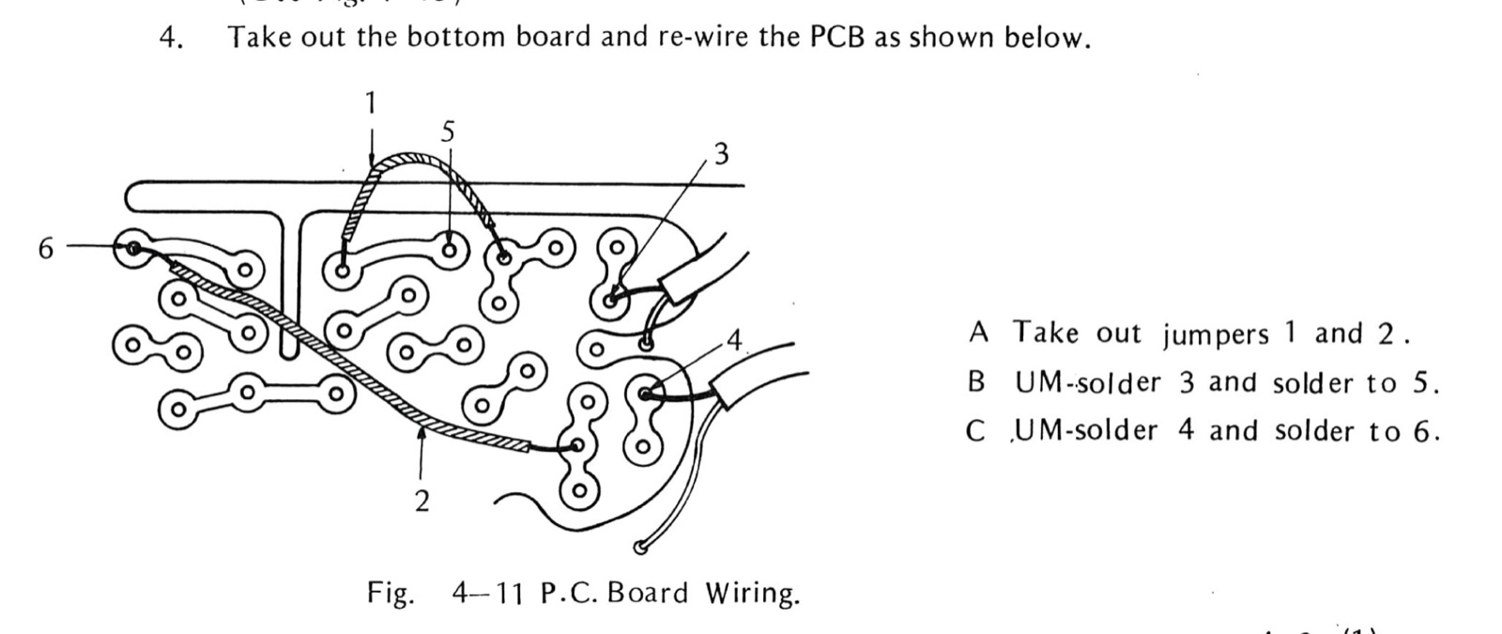
Fig. 4-11 P.C. Board Wiring
A Take out jumpers 1 and 2 . B UM-solder [sic] 3 and solder to 5. C UM-solder [sic] 4 and solder to 6.
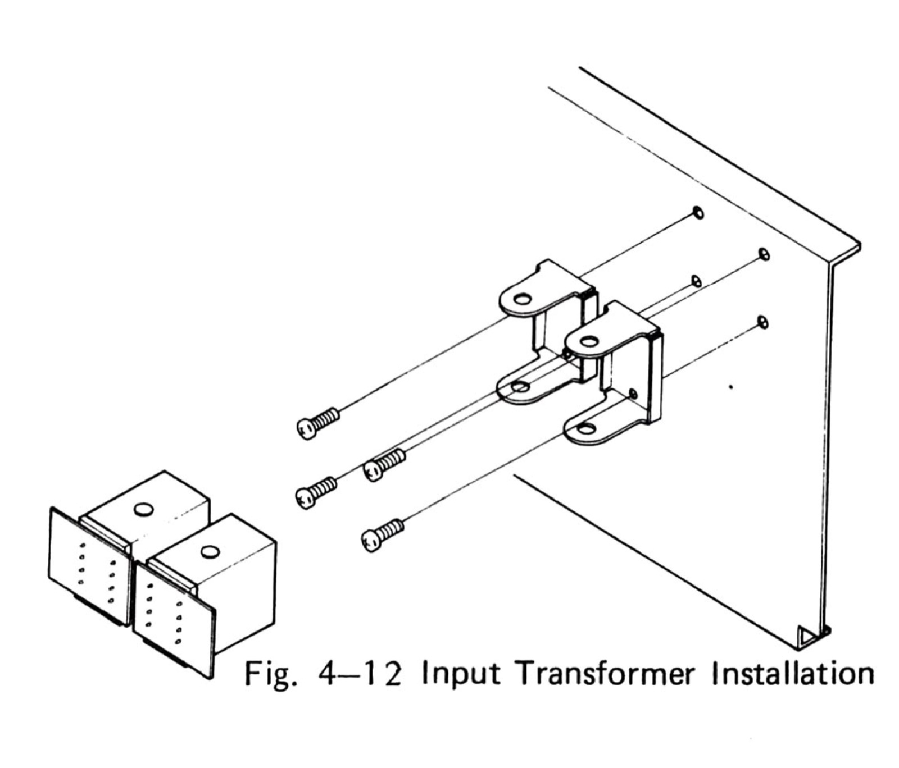
Fig. 4-12 Input Transformer Installation
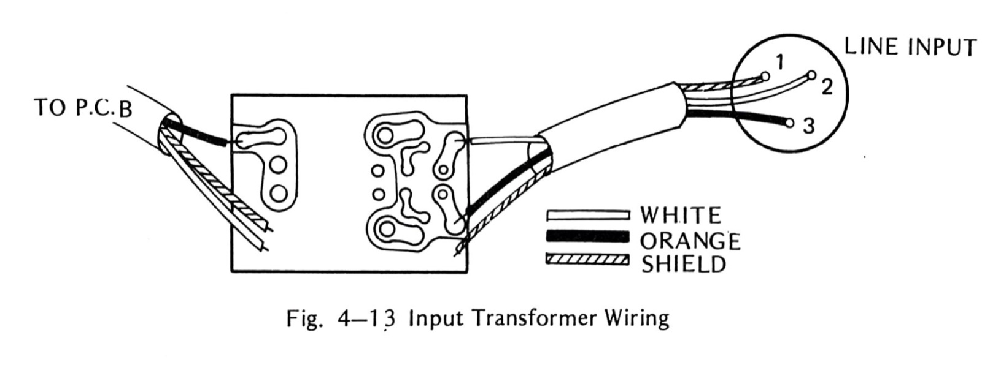
Fig. 4-13 Input Transformer Wiring
- After all of above modification, please test record.

4-3-(2) INSTALLATION OF OUTPUT TRANSFORMER
Fig. 4-15 [sic] shows circuity of unbalanced output and balanced output. To install input transformer [sic], proceed as follows:
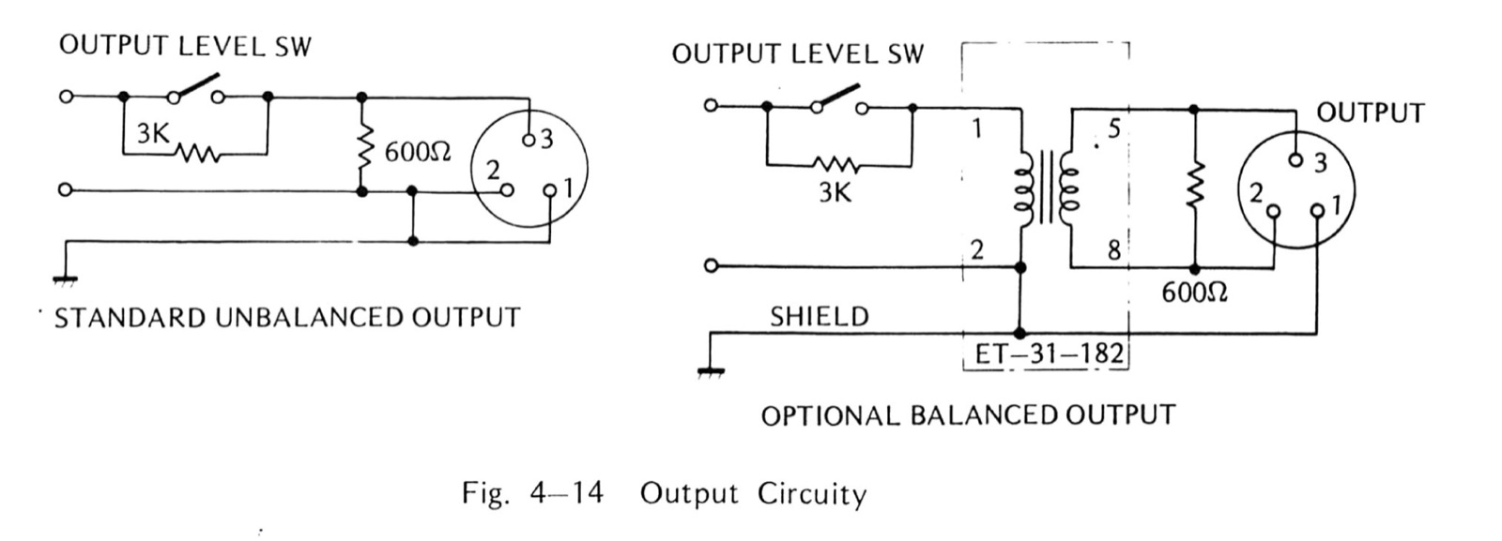
Fig. 4-14 Output Circuity
Transformer has terminals as shown above surrounded by broken line.
- Take out case rear board in the Fig. 11-1 [sic], and then take off rear panel. Mount the transtormer [sic] with two screws.
- Remove wires from XLR connectors. Solder Hot Line (Orange) to transformer terminal 1, and Solder Cold Line (White) and Shield to terminal 2.
- Solder Orange Wire coming out of terminal 5 to XLR connector number 3, Solder White Wires coming out of terminal 8 to XLR connector number 2, Solder Shield Wire to XLR connector number 1.
- After above wiring, put test tape and adjust reproduce level.
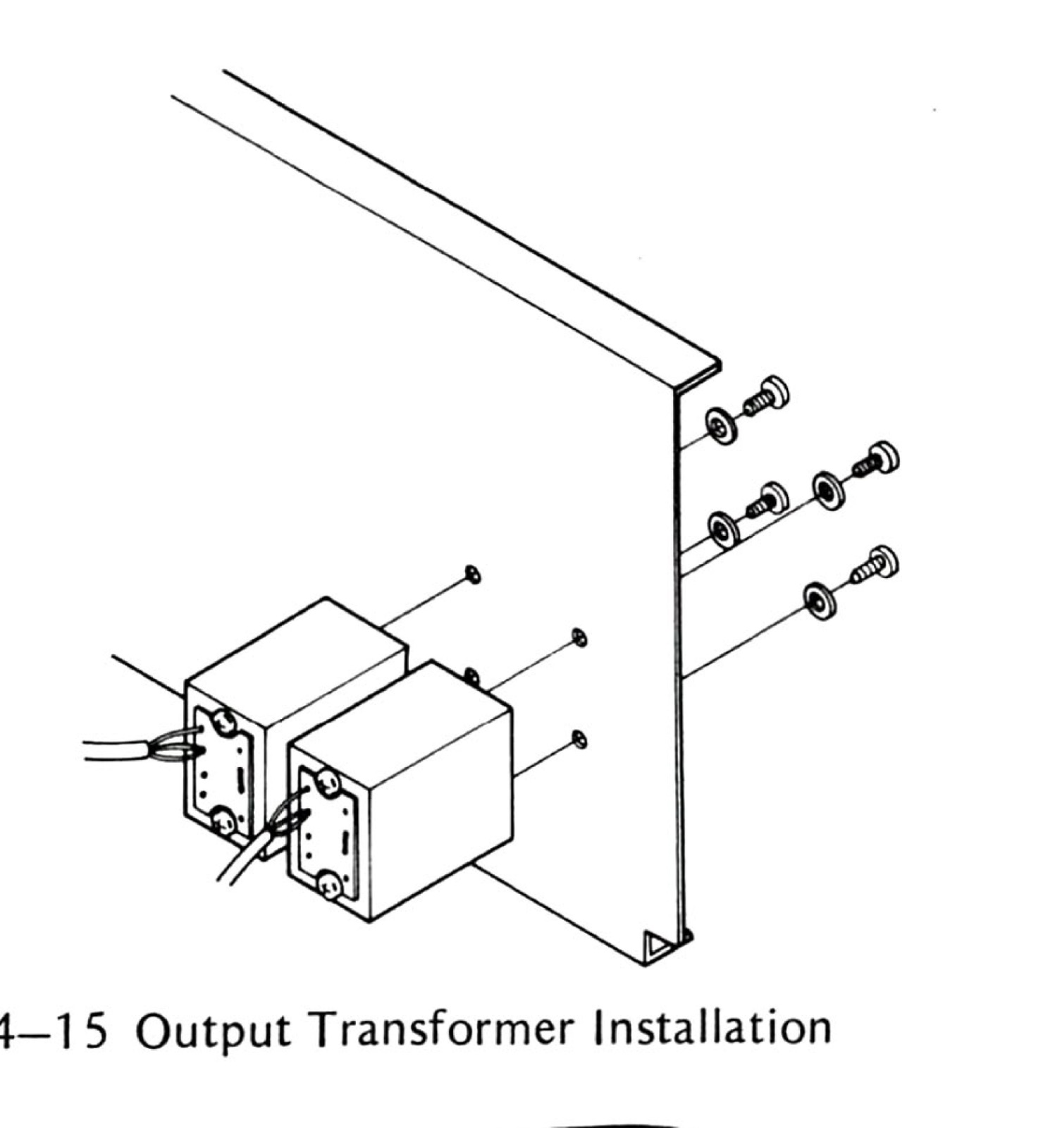
Fig. 4-15 Output Transformer Installation
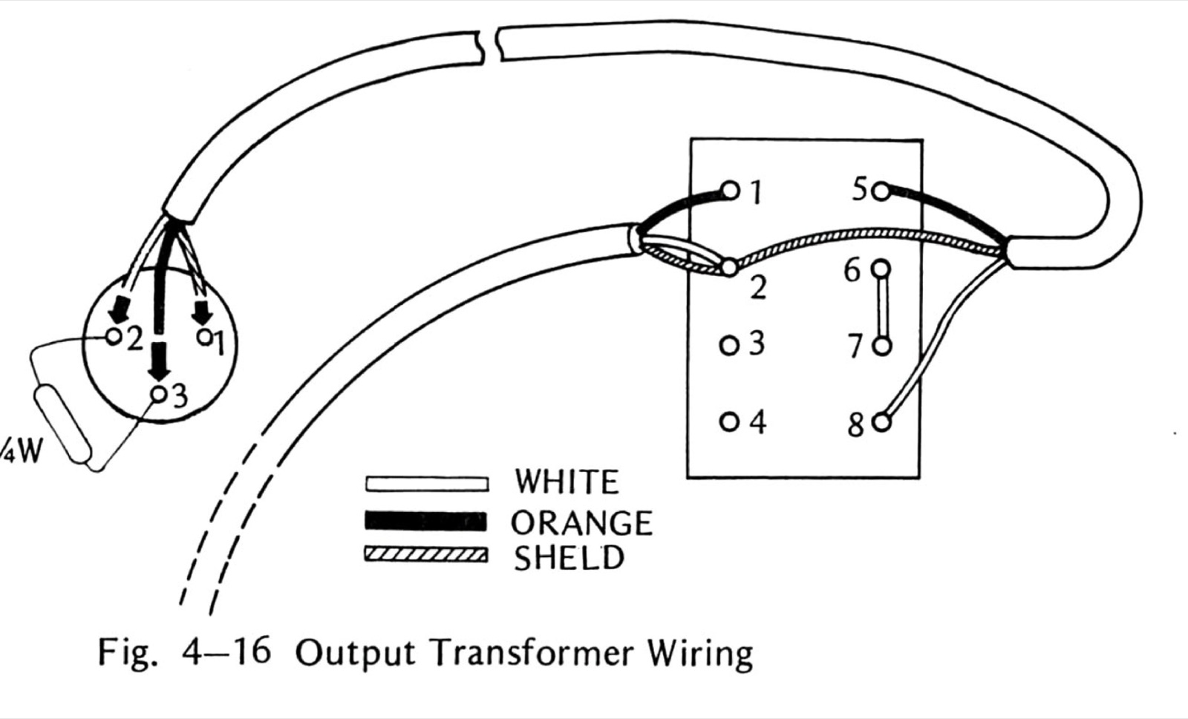
Fig. 4-16 Output Transformer Wiring

SECTION 5 — TROUBLESHOOTING

5-1 PRELIMINARY PROCEDURES
If a problem should occur with the recorder, check that the following items are correct before proceeding with troubleshooting procedures. As an aid in troubleshooting, refer to the schematic diagram and parts lists included in this manual.
- Head stacks are cleaned and demagnetized.
- Head azimuth and height are correct.
- Record bias has been adjusted properly.
- Recommended tape has been used.
- Input and/or output connectors are correctly wired.
- Ac line voltage is within ± 10% of indicated power requirement.
- All operational switches have been correctly set.
- Adjustment procedures have been correctly made using accurate test equipment.

5-2 TROUBLESHOOTING HINTS
Some of the more common problems and possible causes are listed in Table 5-1.
Site note: Before chasing anything in this table: if the transport is completely dead, check the rear REMOTE socket — the machine needs a remote or a dummy plug there. Mine was “broken” for exactly this reason: No dummy plug — no problem! (https://otarimx5050.com/log/building-a-dummy-plug/).
Table 5-1 Troubleshooting Hints
SYMPTOM | POSSIBLE CAUSE
Power switch is on but meters do not illuminate and transport does not function. | Fuse is blown, ac power cord is defective, or power switch is defective.
Transport function and meters illuminate but no recording and reproducing | Power source for amplifier (+29Vdc)’ [sic] is defective.
Transport does not function. | Power source for control (+24Vdc) is defective.
Capstan shaft does not rotate | Tension arm safety switch is defective. On models 2S or 4S, capstan motor is defective or capstan belt come off[sic]. On Models 2SD or 4SD, power source for capstan motor (+24Vdc or +5Vdc) is defective, or fuse of the power supply is blown.
No PLAY mode function | Control circuit (PA-284) is defective (Tr8,9,SCR2,3))[sic], or pinch roller solenoid is defective.
No FAST FORWARD mode function | Control circuit (PA-284) is defective (Tr 3,4, SCR 1).
No REWIND mode function | Control circuit (PA-284) is defective (Tr2).
Record lamp of transport does not illuminate and no RECORD mode function | Control circuit (PA-284) is defective (Tr10, SCR4)
Brake solenoide[sic] does not move. | Control circuit (PA-284) is defective (Tr5), or brake solenoi–lenoide[sic] is defective, or brake adjustment is incorrect (strok)[sic].
Tape speed is incorrect | Pinch roller adjustment is incorrect (not bottomed), or dirty pinch roller, dirty capstan shaft. On models 2S or 4S, loose or dirty capstan belt slips, or capstan motor is defective. On models 2SD or 4SD; capstan servo control circuit is defective, or adjusted incorrectly. Pitch control nob[sic] is at wrong position.
Output level is wrong | Reproduce head switch is at wrong position, or output level switch is wrong position.

SECTION 6 — PARTS LISTS AND SCHEMATICS
Site note: The New No. column on the parts lists below is not in the scan this transcription was made from — its column is blank there. The numbers come from my own paper copy, scanned at 1200 dpi and available on the manuals page (https://otarimx5050.com/library/manuals/): a later factory revision that fills the column with Otari’s old-to-new part renumbering. Each cell was transcribed and verified against that scan.

PARTS LIST 1
Ref. No. | Description | Parts No. | New No.
1-1 | Left Side Board | CS-245-004 | K100603
1-1 | Right Side Board | CS-245-004 | K100603
1-3 | Case Top Board | CS-245-002 | K100601
1-4 | Cooling Cover | CS-232-007 | K100602
1-5 | Case Bottom Board | CS-245-007 | K100604
1-6 | Case Rear Board | CS-245-009 | K1006-D
1-7 | Rubber Pad | NB-91-032 | CY4006
1-8 | Catcher | CS-245-005 | CY1004
1-9 | Display Washer | TY-800-014 | KZ6C016
1-10 | Sheet | TY-800-017 | K6C011
1-11 | Display Washer | TY-800-021 | KZ6C010
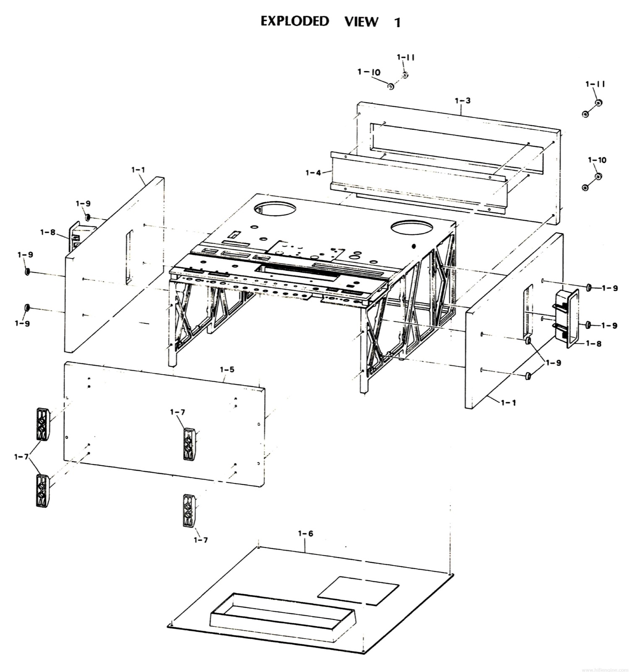
EXPLODED VIEW 1

PARTS LIST 2
Ref. No. | Description | Parts No. | New No.
2-1 | Display washer | TY-800-021 | KZ6C010
2-2 | Sheet | TY-800-017 | KZ6C011
2-3 | Control Display Panel | TD-5050-004 | T505003
2-4 | Plain Washer | TY-800-024 | KZ6C009
2-5 | Display Panel | TD-5050D-001(2SD,4SD)TD-5050-001(2S,4S) | T506006T505002
2-6 | Amplifier Display Panel | AF-230-003 | A101601
2-7 | Amplifier Mounting Base | AF-230-004 | A101602
2-8 | Mounting Base | TD-5010-001 | T505001
2-9 | Frame | TD-5010-006 | T505004
2-10 | Frame Stud | TD-5010-008 | KZ7B202
2-11 | Stud | ST-107 | KZ7A217
2-12 | Control PCB Assembly | PA-284 | PB-41D
2-13 | Power Transfomer [sic] | ET-11-194 | TF11012
2-14 | W-W Resistor | RS-39-40HAAC-600ohm | RV5J6011
2-15 | W-W Resistor | RS-39-30HAAC-200ohm | R55J2011
2-16 | Rear Panel | AF-230-007 | A101609
2-17 | Rear Name Plate | AF-230-009 | A101610
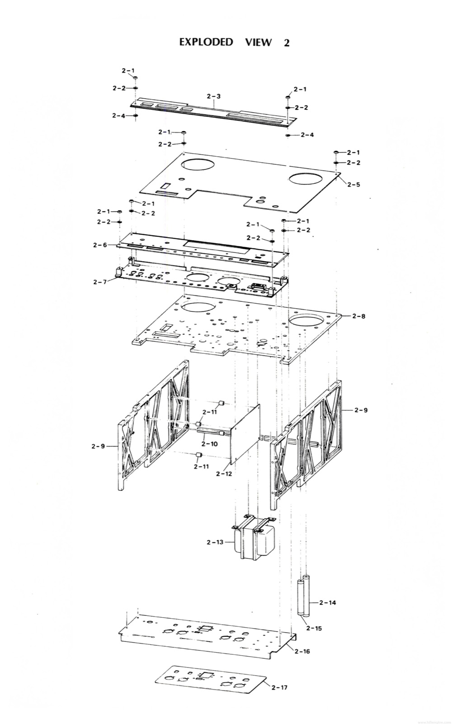
EXPLODED VIEW 2

PARTS LIST 3
Site note: The revision’s Parts No. column prints two slash-joined values for 3-2 and 3-3 — “TW-424-001/KW4J002” and “TW-424-002/KWOB017S” — and draws a bracket on the right joining those two lines into one assembly. Read literally: 3-2 (Reel Table) is now sold only as part of that assembly (its New No. cell prints “Assy.#”), and 3-3 (Reel Shaft Holder) carries the assembly’s own new number, KW4J001. Transcribed as printed, not reinterpreted.
Ref. No. | Description | Parts No. | New No.
3-1 | Reel Clamper | TW-661 | TW-670
3-2 | Reel Table | TW-424-001 | Assy.#
3-3 | Reel Shaft Holder | TW-424-002 | KW4J001
3-4 | Reel Protector | TW-424-009 | KW0H007
3-5 | Counter Grille | TD-5500-005 | SR8B003
3-6 | Display Panel | TD-5050D-001(2sD,4SD)TD-5050-001(2S,4S) | T505006T505003
3-7 | Mounting Base | TD-5010-001 | T505001
3-8 | Spacer | TZ-131-001 | SR8B002
3-9 | Tape Counter | CT-09-T4A SPEC | SR-8B
3-10 | Counter Supporter | TZ-126-001 | SR8B001
3-11 | Switch Bracket | PA-282-003 | T505005
3-12 | Rotary Switch(With Pulley) | SW-99-HZR0036-01-010 | WH91005
3-13 | Endless Belt | TB-5147-20 | BE1B147
3-14 | Reel Motor Supporter | TW-421-018 | KW0G016
3-15 | Reel Motor | EW-506-019 | MR1C005
3-16 | Relaying PCB | PM-678 | PB9A027
3-17 | Electrolytic Capacitor | CD-99-MPL-5.5µ | CZ10014W
3-18 | Capacitor Holder | TW-421-017L | KW4B003
3-19 | Capacitor Holder | TW-421-017R | KW4B004
3-20 | Brake Base | TW-421-009 | KW0G013
3-21 | Brake Base | TW-421-007 | KW0G012
3-22 | Switch Supporter | TW-421-006 | KW4B002
3-23 | Spacer | TW-421-019 | KW4B005
3-24 | Micro Switch | SW-59-SS5GL | WH51002
3-25 | Brake Guide | TW-421-004 | KW4B001
3-26 | Spring | SG-100-052 | GS1024
3-27 | Brake Arm | TW-424-008 | KW0D014
3-28 | Retaining Ring | EZ-09-E-15 | F74TE15
3-29 | Brake Band Assembly(With Sheet) | …… | KW-4E-A
3-30 | Pin | EZ-09-316 | F63316
3-31 | Brake Drum | TH-424-007 | KW0A012
3-32 | Retaning Ring [sic] | EZ-09-E-9 | F74TE09
3-33 | Solenoid Pin | TY-400-015 | MR5A003
3-34 | Solenoid | SO-334 DC24V | GP1F01
3-35 | Cord Clamper | …………. | KZ3A047
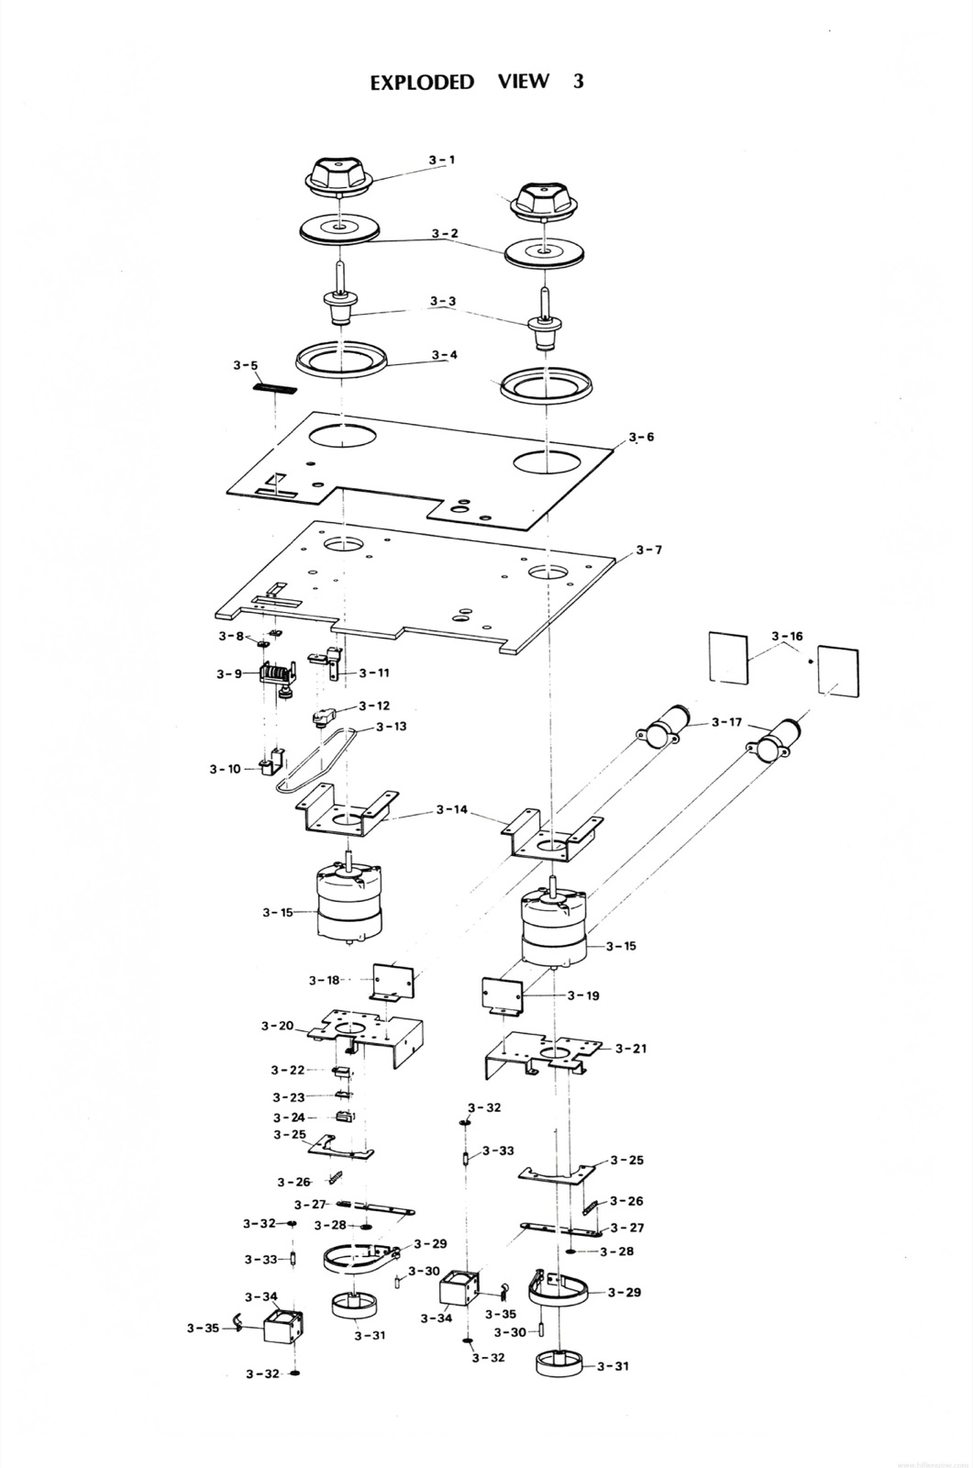
EXPLODED VIEW 3

PARTS LIST 4-1
Ref. No. | Description | Parts No. | New No.
4-1 | Dust Cap | TC-423-007 | KC0B008
4-2 | Felt Collar | TC-419-004 | PZ1B007
4-3 | Display Panel | TD-5050-001 | T505002
4-4 | Mounting Base | TD-5010-001 | T505001
4-5 | Metal Holder Assembly | TC-423-004 | KC4B001
4-6 | Slide Washer | TY-800-026C | KZ6C014
4-7 | Capstan-Flywheel | TC-423-001 | KC0A020
4-8 | Endless Belt | TB-9140-10-High speedTB-9137-10-Low speed | BE2M140BE2M137
4-9 | Stud | ST-076 | KZ9I755A
4-10 | Flywheel Holder | TC-419-007 | KC4B004
4-11 | Motor Pulley A | TC-423-008A 50HZ High speedTC-426-001A 50HZ Low speed | KC0D010KC0D016
4-12 | Motor Pulley B | TC-423-008B 60HZ High speedTC-426-001B 60HZ Low speed | KC0D011KC0D017
4-13 | Motor Stud | ST-054 | KZ9I570A
4-14 | Shielding Plate | TC-419-012 | KC4B006
4-15 | Motor Suppoter [sic] | TC-423-009 | KC4B005
4-16 | Motor | EM-408-011 | MR2F010
4-17 | Electrolytic Capacitor | CD-99-MPL-2.0+0.5 | CZ10011W
4-18 | Relaying PCB | PM-669 | PB9A026
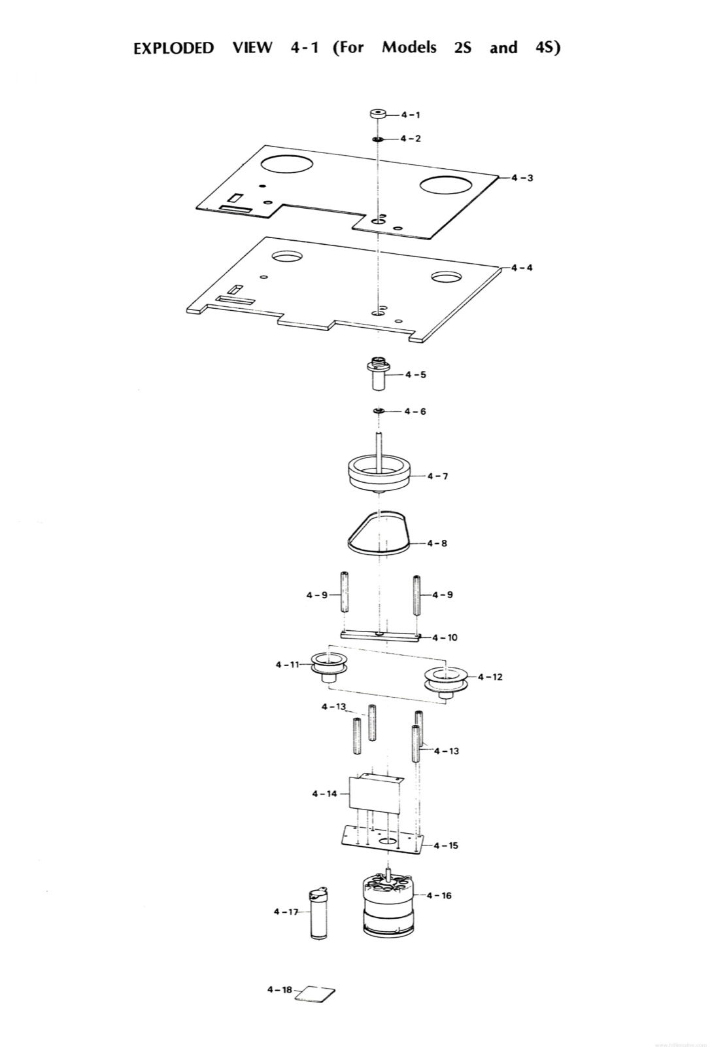
EXPLODED VIEW 4-1 (For Models 2S and 4S)

PARTS LIST 4-2
Ref. No. | Description | Parts No. | New No.
4-101 | Knob | NB-31-037 | KN1013
4-102 | Dust Cap | TC-423-007 | KC0B008
4-103 | Display Panel | TD-5050D-001 | T505006
4-104 | Mounting Base | TD-5010-001 | T505001
4-105 | Variable Resistor Supporter | TC-427-003 | KZ2A030
4-106 | Variable Resistor | VR-29-EVH-Y03R25B52 | RV252009
4-107 | +5Volt Dc Power Supply PCB Assembly | PA-426 | PB-61D
4-108 | PCB Supporter | TY-200-082 | KZ3A027
4-109 | Stud | ST-086 | KZ7B220
4-110 | Motor Supporter | TC-212-001 | KC2B001
4-111 | Capstan Drive Motor | EM-710-007A | MR5A001
4-112 | Radiator | TC-212-002 | KZ1A012
4-113 | PCB Supporter | TC-427-004 | KZ3A028
4-114 | Power Supply PCB Assembly | PA-377 | PB-61E
4-115 | Fuse Holder | FS-89-F-3294 | FH1-022
4-116 | Fuse | FS-19-2A | FH7A020
Site note: The revision adds this note beneath the table, verbatim, including what reads as a factory typo — “OF” where “IF” is meant: “THERE ARE VERY FEW OF THIS VERSION IN THE U.S. PLEASE CONFIRM THESE PART NUMBERS WITH THE CUSTOMER OF [sic] THEY ARE ORDERED.” (This crop is pulled from the later-revision 1200 dpi scan, p. 69 — not the 34 MB mirror pagination used for every other correction crop in this file.)
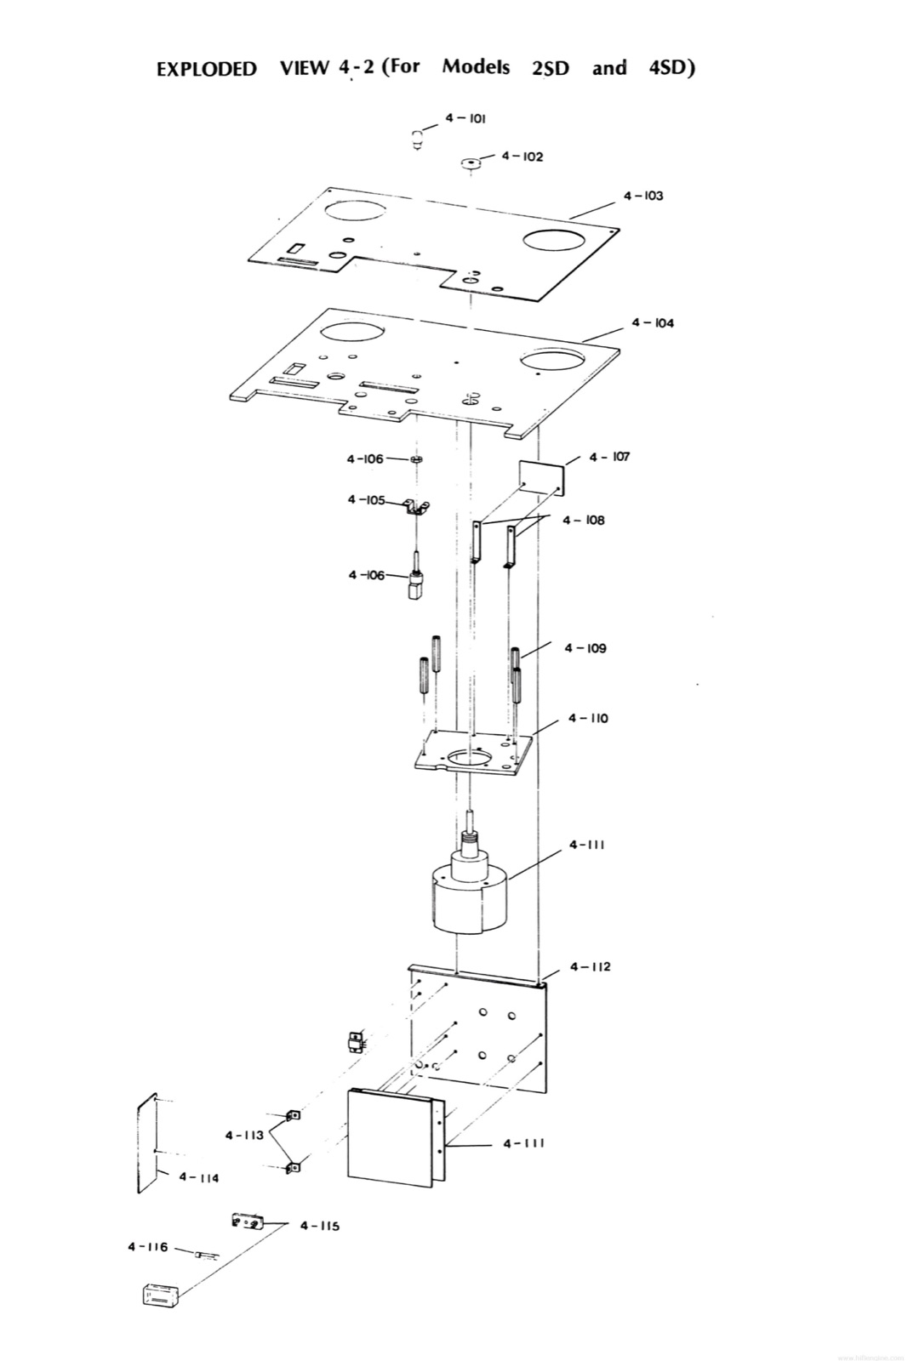
EXPLODED VIEW 4-2 (For Models 2SD and 4SD)

PARTS LIST 5
Ref. No. | Description | Parts No. | New No.
5-1 | Pinch Roller Cap | TP-416-001 | KP0C005
5-2 | Polyslider Washer | EZ-09-5TW-FT-6 0.25 | 6x0.25 polyslide washer
5-3 | Pinch Roller | TP-416-001 | KP0A007
5-4 | Retaining Ring | EZ-09-E-20 | F74TE20
5-5 | Pinch Roller Shaft | TP-416-002 | KP0B010
5-6 | Cue Lever | TR-416-001 | KP0C005
5-7 | CUE Lever Escutcheon | TR-416-002 | KR4B006
5-8 | Display Panel | TD-5050D-001(2SD,4SD)TD-5050-001(2S,4S) | T505006T505002
5-9 | Mounting Base | TD-5010-001 | T505001
5-10 | Arm Shaft | TR-413-002 | KR4B001
5-11 | Shifter Arm A | TR-413-003 | KR0B005
5-12 | Polyslider Washer | EZ-09-STW-FT-4 0.25 | 4x0.25 polyslide washer
5-13 | Shifter Arm B | TR-413-007 | KR0B006
5-14 | Retaining Ring | EZ-09-E-15 | F74TE15
5-15 | Spring | SG-100-050 | GS1028-A
5-16 | Arm Shaft | TR-414-003 | KR4B007
5-17 | Cue Arm | TR-416-003 | KR4B008
5-18 | Arm Shaft | TE-416-002 | KR4B006
5-19 | Pinch Roller Arm | TP-420-002 | KR4E001
5-20 | Arm Guide | TR-414-007 | KR4B011
5-21 | Roller Catch | EZ-09-C-51-2 | CY3001
5-22 | Retaining Ring | EZ-09-E-9 | F74TE09
5-23 | Solenoid Pin | TY-400-015 | KZ5A003
5-24 | Solenoid | SO-317 | GP1B02
5-25 | Adjusting Rod | TP-416-009 | KZ6A022
5-26 | Stopper | TY-200-013 | KZ2A015
5-27 | Plain Washer | EZ-09-M4 | M4 Washer
5-28 | Retaining Ring | EZ-09-E-15 | F74TE15
5-29 | Spherical Washer | TP-401-007 | KP0G004
5-30 | Pressure Spring | SG-500-031 | GS2003
5-31 | Double Nuts | EZ-09-M4 | M4 Double Nut
5-32 | Spring Holder | TY-900-019 | KZ3A023
5-33 | Spring | SG-100-048 | GS1011
5-34 | Switch Braket [sic] | TD-500-095 | KZ3A026
5-35 | Leaf Spring Switch | SW-09-PU-3024 | WH91004
Site note: Ref. 5-7’s row carries an asterisk in the revision, tied to a footnote below the table, transcribed verbatim: “* Old Part Number is incorrect, new number is correct.”
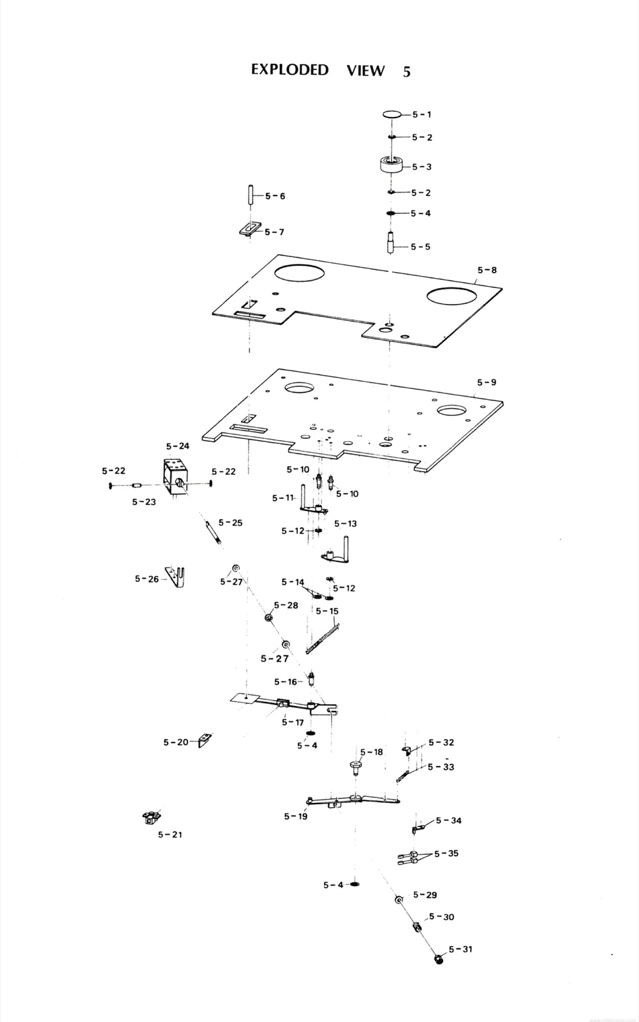
EXPLODED VIEW 5

PARTS LIST 6
Ref. No. | Description | Parts No. | New No.
6-1 | Name Plate | TH-446-005 | PT1004
6-2 | Splicing Block | TH-446-004 | KH4C003
6-3 | Head Housing Assy | TH-446-00B | KH-4C-A
6-4 | Switch Name Plate | TH-446-006 | PT4124
6-5 | Protector Sheet | TH-438-009 | KH4C002
6-6 | Head Cord PCB Assembly | PA-274 | PB-71B
6-7 | Blind | TY-900-009 | PZ1B010
6-8 | Head Base | TH-446-001 | KH0C011
6-9 | Head Adjusting Spring | SG-500-063 | GS2007
6-10 | Head Supporter B | TH-422-002 | KH0D005
6-11 | Head Supporter A | TH-422-001 | KH0D004
6-12 | Record Head(2T 2C)Record Head(4T 2C) | SH-6202-11-001 (2s typs)SH-6204-11-001 (4s typs) | GH4R005GH4R003
6-13 | Reproduce Head(2T 2C)Reproduce Head(4T 2C) | SH-7202-11-001 (2s typs)SH-7204-11-002 (4s typs) | GH4P006GH4P069
6-14 | Erase Head(2T 2C)Erase Head(4T 2C) | SH-5202-11-001 (2s typs)SH-5204-11-001 (4s typs) | GH4E004GH4E009
6-15 | Reproduce Head(4T 2C) [sic]Reproduce Head(2S 2C) | SH-7204-11-001 (2s typs)SH-7204-11-001 (4s typs) | GH4P069GH4P006
6-16 | Tape Guide | TH-438-004 | KG4C002
6-17 | Housing Base | TH-438-005 | KH4C001
6-18 | Push Button A | CR-824-001A | KN2020
6-19 | Push Button C | CR-824-001C | KN2022
6-20 | Push Button B | CR-824-001B | KN2021
6-21 | Push Button E | CR-824-001E | KN2024
6-22 | Push Button C | CR-823-001C | KN2018
6-23 | Push Button B | CR-823-001B | KN2017
6-24 | Push Button D | CR-823-001D | KN2019
6-25 | Push Button A | CR-823-001A | KN2016
6-26 | Control Display Panel | TD-5050-004 | T505003
6-27 | Lamp Cover | TY-900-024 (A:Red,B:Green) | LU9002
6-28 | Display Panel | TD-5050D-001(2SD,4SD)TD-5050-001(2S,4S) | T505006T505002
6-29 | Mounting Base | TD-5010-001 | T505001
6-30 | Plain Washer | EZ-09-M4 | M4 Washer
6-31 | Lamp Supporter | TY-900-025 | KZ2A029
6-32 | Lamp Assembly | PL-19-005 | LU2003
6-33 | Guide | CR-823-010 | CB20602
6-34 | Switch Base | CR-823-008 | CB20601
6-35 | Micro Switch | SW-59-V-1A | WH11007
6-36 | 2P Terminal | LP-09-1L2P | CN902002
6-37 | Guide | CR-824-006 | CB20701
6-38 | Switch Base | CR-824-005 | PB41E01
6-39 | POwer Switch PCB Assembly [sic] | PA-288 | PB-41E
6-40 | Micro Switch Supporter | CR-824-007R | PB41E02
6-41 | Micro Switch | SW-59-SS5GL | WH51002
6-42 | Switch Supporter | CR-824-008 | PB41E04
Site note: Ref. 6-27’s row is asterisked in the revision; the New No. cell above (LU9002) is only for the “A:Red” variant already printed in the Parts No. cell. A footnote below the table, keyed by the same asterisk, gives the “B:Green” variant’s new number, transcribed verbatim: “* B:Green … LU9003”
Site note: The transport-button microswitches turn up as Omron V-series parts — V-10-1A8 and V-15-1A5 — and the V-15-1A5 is still in production; marking photos in Inside the transport buttons (https://otarimx5050.com/log/transport-buttons/).
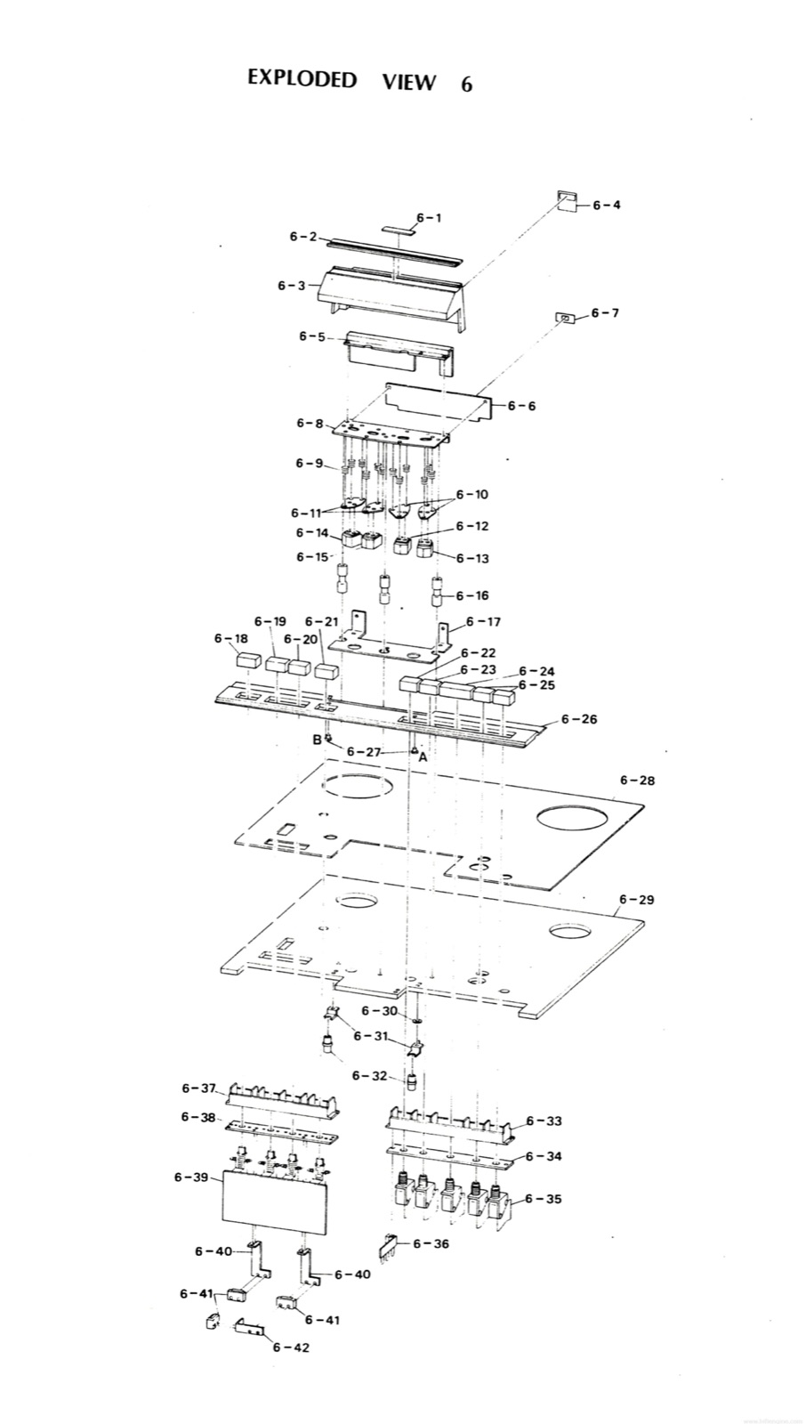
EXPLODED VIEW 6

PARTS LIST 7
Ref. No. | Description | Parts No. | New No.
7-1 | Display Screw | TA-420-005 | KA0C002
7-2 | Tape Guide | TA-420-004 | KG4D006
7-3 | Tension Arm | TA-420003 | KA0A005
7-4 | Arm Shaft | TA-429-001 | KA0A004
7-5 | Polyslider Washer | EZ-09-STW-FT-5 0.5t | 5x.5t polyslide washer
7-6 | Arm Holder | TA-420-002 | KA0B003
7-7 | Roller Cap | TG-424-01 | GR0A005
7-8 | Polyslider Washer | EZ-09-STW-FT-8 0.25t | 8x.25t polyslide washer
7-9 | Roller Shaft | TG-424-02 | GR4H001
7-10 | Sleeve | TG-424-03 | Assy. #
7-11 | Roller | TG-424-04 | GR4H002
7-12 | Roller Base | TG-424-05 | GR4B004
7-13 | Display Panel | TD-5050D-001(2SD, 4SD)TD-5050-001(2S,4S) | T505006T505002
7-14 | Mounting Base | TD-5010-001 | T505001
7-15 | Micro Switch | SW-59-1V-3H-2A | WH51004
7-16 | Magnetic Supporter | TY-900-023 | KZ3A025
7-17 | Spring Holder | TY-900-020 | KZ3A024
7-18 | Nut | TA-420-007 | KZ6D004
7-19 | Polyslider Washer | EZ-09-STW-FT-5 0.5t | 5x.5t polyslide washer
7-20 | Arm Boss B | TA-427-001 | KA0E005
7-21 | Spring | SG-100-047B | GS1027
7-22 | Switch Arm | TA-423-002 | KA4B001
7-23 | Arm Boss A | TA-429-002 | KA0E004
7-24 | Spring | SG-100-046 | GS1025
7-25 | Stopper Arm | TA-420-010 | KA0H004
Site note: As with Ref. 3-2/3-3, Ref. 7-10 and 7-11’s old numbers are bracketed together in the revision; Ref. 7-10 (Sleeve)’s New No. cell reads “Assy. #” and Ref. 7-11 (Roller) carries the assembly’s own new number.
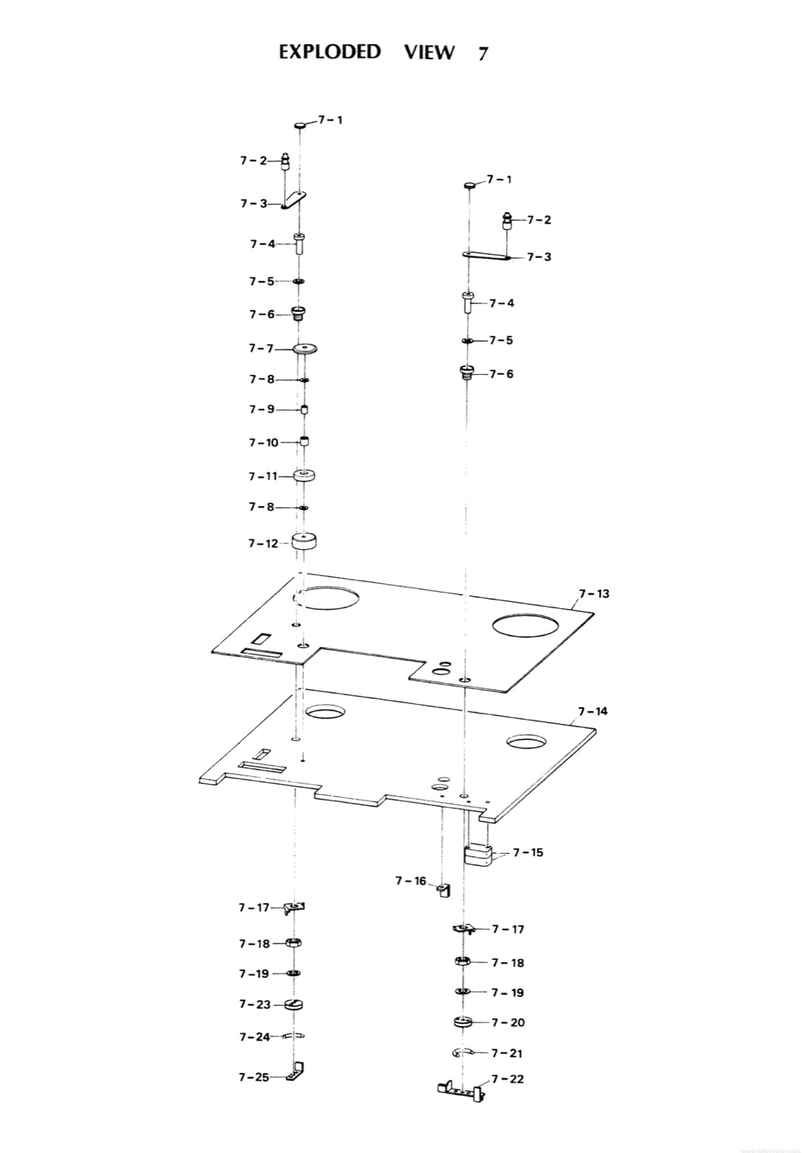
EXPLODED VIEW 7

PARTS LIST 8
Ref. No. | Description | Parts No. | New No.
8-1 | Meter Grille | AF-207-005 | PZ4A007
8-2 | Knob B | NB-31-014 | KN1012
8-3 | Spacer | TY-100-038 | PZ1B011
8-4 | Knob A | NB-31-013 | KN1011
8-5 | Spacer | TY-100-013 | KZ6C015
8-6 | Variable Resistor Escutcheon | TY-100-010 | PZ4A006
8-7 | Push Button B | NB-19-4094B | KN2026
8-8 | Push Button A | NB-19-4094A | KN2025
8-9 | Amplifier Display Panel | AF-230-003 | A101601
8-10 | Lamp Cover | TY-900-024A.B(A:Red,B:Green) | LU9002
8-11 | Lamp Assembly | PL-19-005 | LU2003
8-12 | VU Meter | MT-11-023 | ME11003
8-14 | Blind | TY-900-029 | PZ1B010
8-15 | Blind | TY-900-031 | PZ1B012
8-16 | Amplifier Mounting Base | AF-230-004 | A101602
8-17 | Record out & Playback Equalizer Amplifier Assembly | PA-286A | PB-11O
8-18 | MIC Amplifier Assembly | PA-287A | PB-11P
 | Test Oscillator & Line out Amplifier Assembly | PA-285 | PB-11N
8-19 | Variable Resistor | VR-19-EWF-A0AM25A24 | RV224001
8-20 | Terminal | LP-09-STT-1L5NR | CN901011
8-21 | Remort Connector [sic] | CN-09-OSAB12F N/N | CN212050
8-22 | Stereo Jack | CN-09-LJ-109 | CN603009
8-23 | Slide Switch C | SW-39-SL242B4 | WH340013
8-24 | Slide Switch A | SW-39-SL242B4 | WH340011
8-25 | Stereo Jack | CN-09-LJ-110-1-2 | CN602010
8-26 | Spacer | TO-230-009 | KZ6C023
8-27 | Rear Panel | AF-230-007 | A101609
8-28 | Rear Hame Plate [sic] | AF-230-009 | A101610
8-29 | Connector Supporter | AF-204-11 | A101610
8-30 | Connector | CN-09-XLR-3-31 | CN103046
8-31 | Connector | CN-09-XLR-3-32 | CN103045
8-32 | Fuse Holder | FS-89-SN-2052 | FH1-022
8-33 | IC Power Supply | IC-09-SI-3250E | ISI3240E
8-34 | SUB Power Supply PCB Assembly | PA-307 | PB-61C
8-35 | Dummy Plug | CN-01-QS-SP12M N/N | CN212049
8-36 | Earth Terminal | LP-09-T-10 | CN901040
8-37 | Fuse | FS-19-2A | FH7A020
8-38 | Cord Stopper | RB-19-BU-3270 | PZ1G002
8-39 | Power Cord | TY-559 | PZ9D017
Site note: Ref. No. 8-13 is called out in EXPLODED VIEW 8 but has no corresponding row printed in Parts List 8; the row after 8-18 prints a description and part number with no Ref. No. — both as in the original.
Site note: Ref. 8-10’s row is asterisked in the revision, the same way Ref. 6-27’s is: the New No. cell above (LU9002) is only for the “A:Red” variant. A footnote below the table, keyed by the same asterisk, gives the “B:Green” variant’s new number, transcribed verbatim: “* B:Green … LU9003”
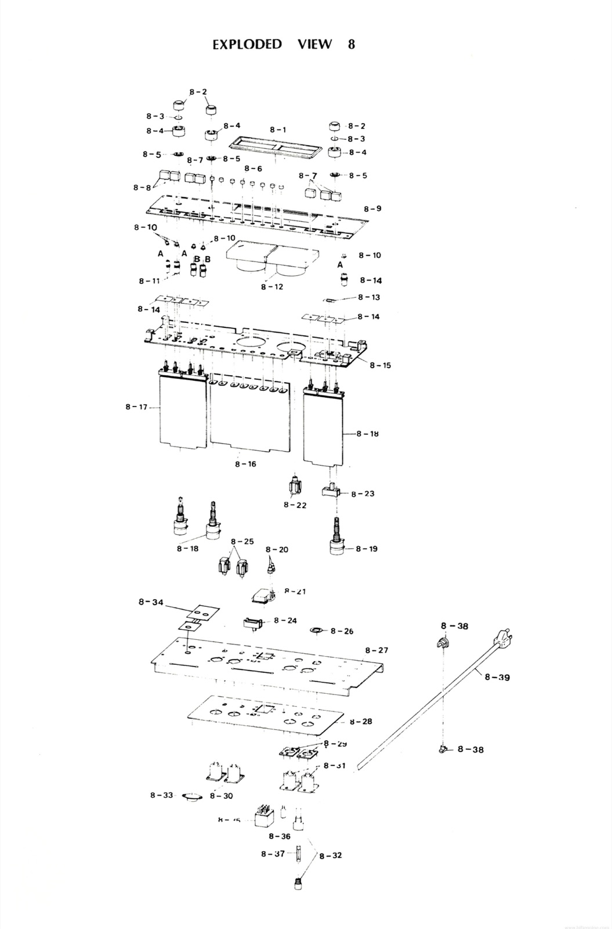
EXPLODED VIEW 8

PARTS LIST 9
Ref. No. | Description | Parts No. | New No.
9-1 | Top Packing | PC-133-002 | K700502
9-2 | Left Side Packing | PC-133-007 | K7005-A
9-3 | MX-5050 Profetional [sic] Assembly | ——-
9-4 | Right Side Packing | PC-133-008 | K7005-B
9-5 | Reel Clamper Packing Assembly | ——-
9-6 | Packing B | PC-133-003 | K700503
9-7 | Packing C | PC-133-004 | K700504
9-8 | Open Reel Box | ———–
9-9 | Packing Box | PC-133-001 | K700501
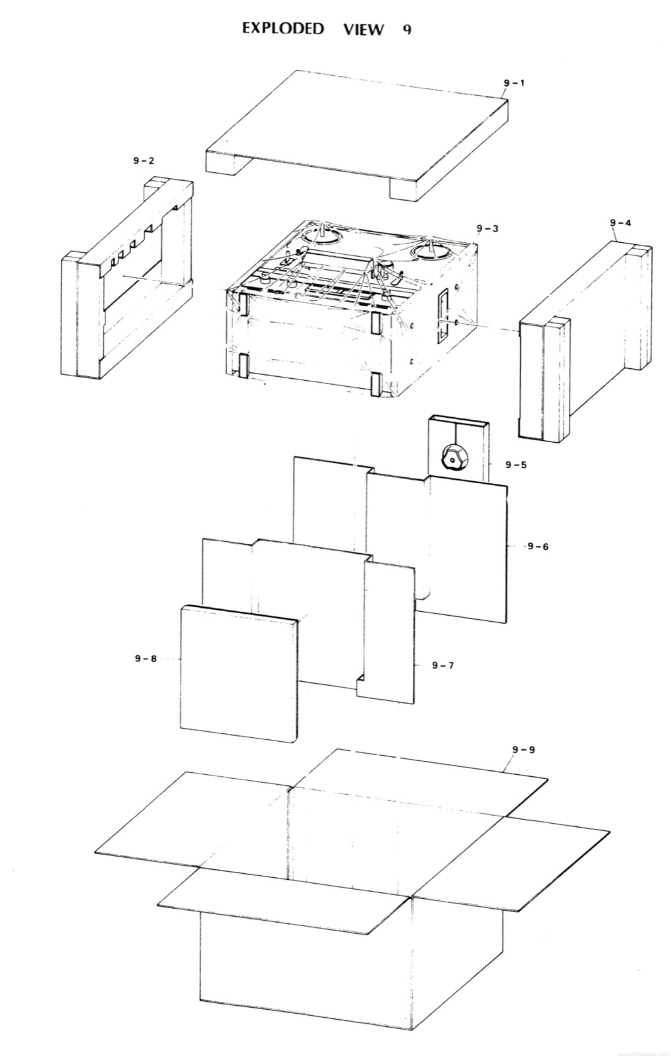
EXPLODED VIEW 9

Schematics and Board Layouts
Site note: The remaining pages of the manual are schematic and layout sheets, reproduced here full-size — click any sheet to open it. Note what’s absent: the tape transport wiring diagram is not bound into this manual. The board-layout sheets say so themselves — “Refer to TAPE TRANSPORT ELECTRONICS (TD5050DA) WIRING DIAGRAM” — and that separate fold-out is the tape transport schematic hosted on the manuals page (https://otarimx5050.com/library/manuals/).
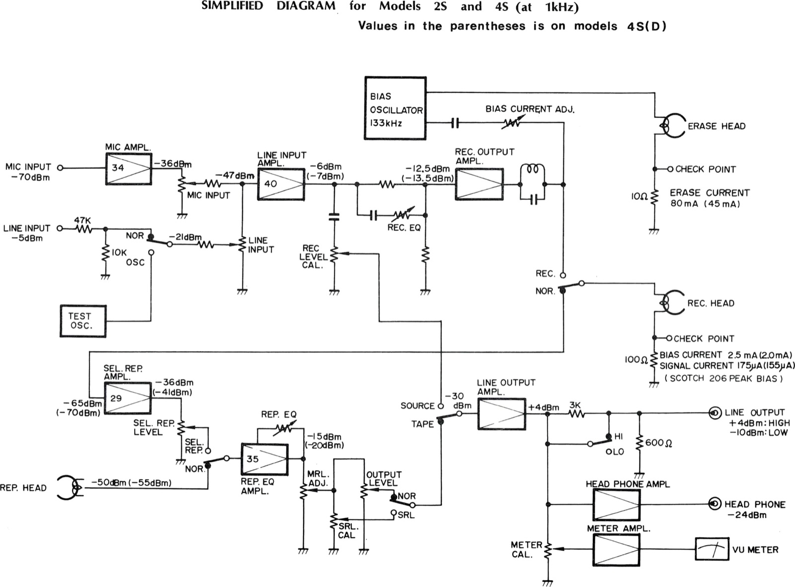
SIMPLIFIED DIAGRAM for Models 2S and 4S (at 1kHz)
Site note: The later-revision printing of this sheet adds an “old #” / “new #” header above the title, verbatim: old # (PA-287A), new # PB-11P.
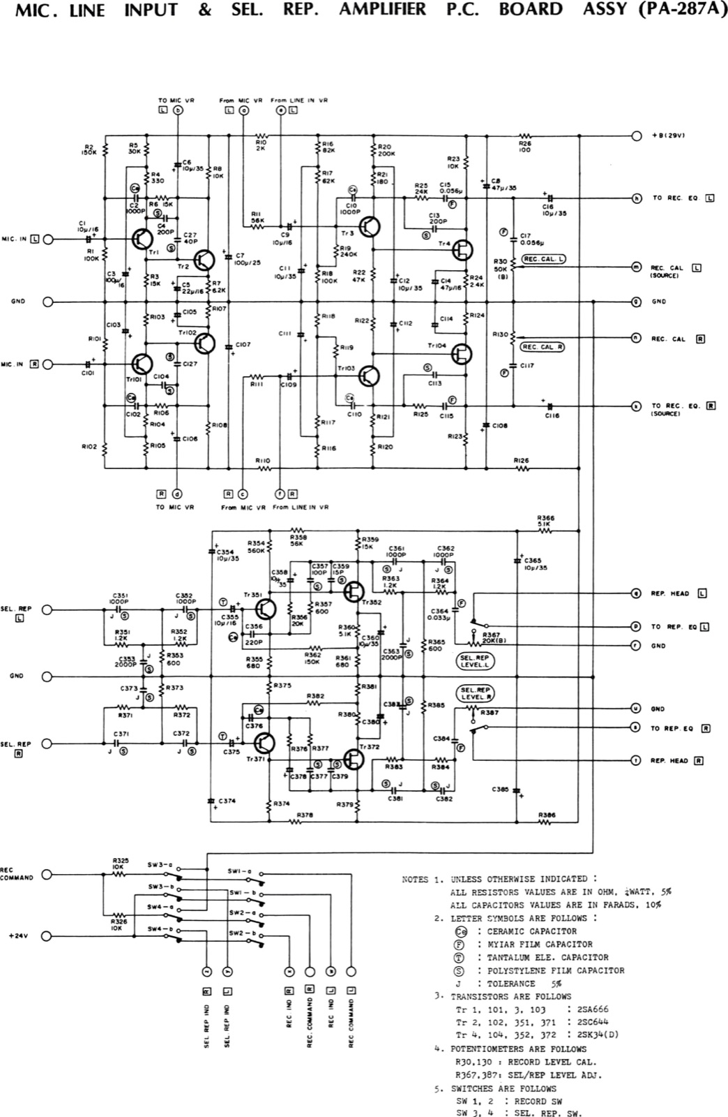
MIC. LINE INPUT & SEL. REP. AMPLIFIER P.C. BOARD ASSY (PA-287A)
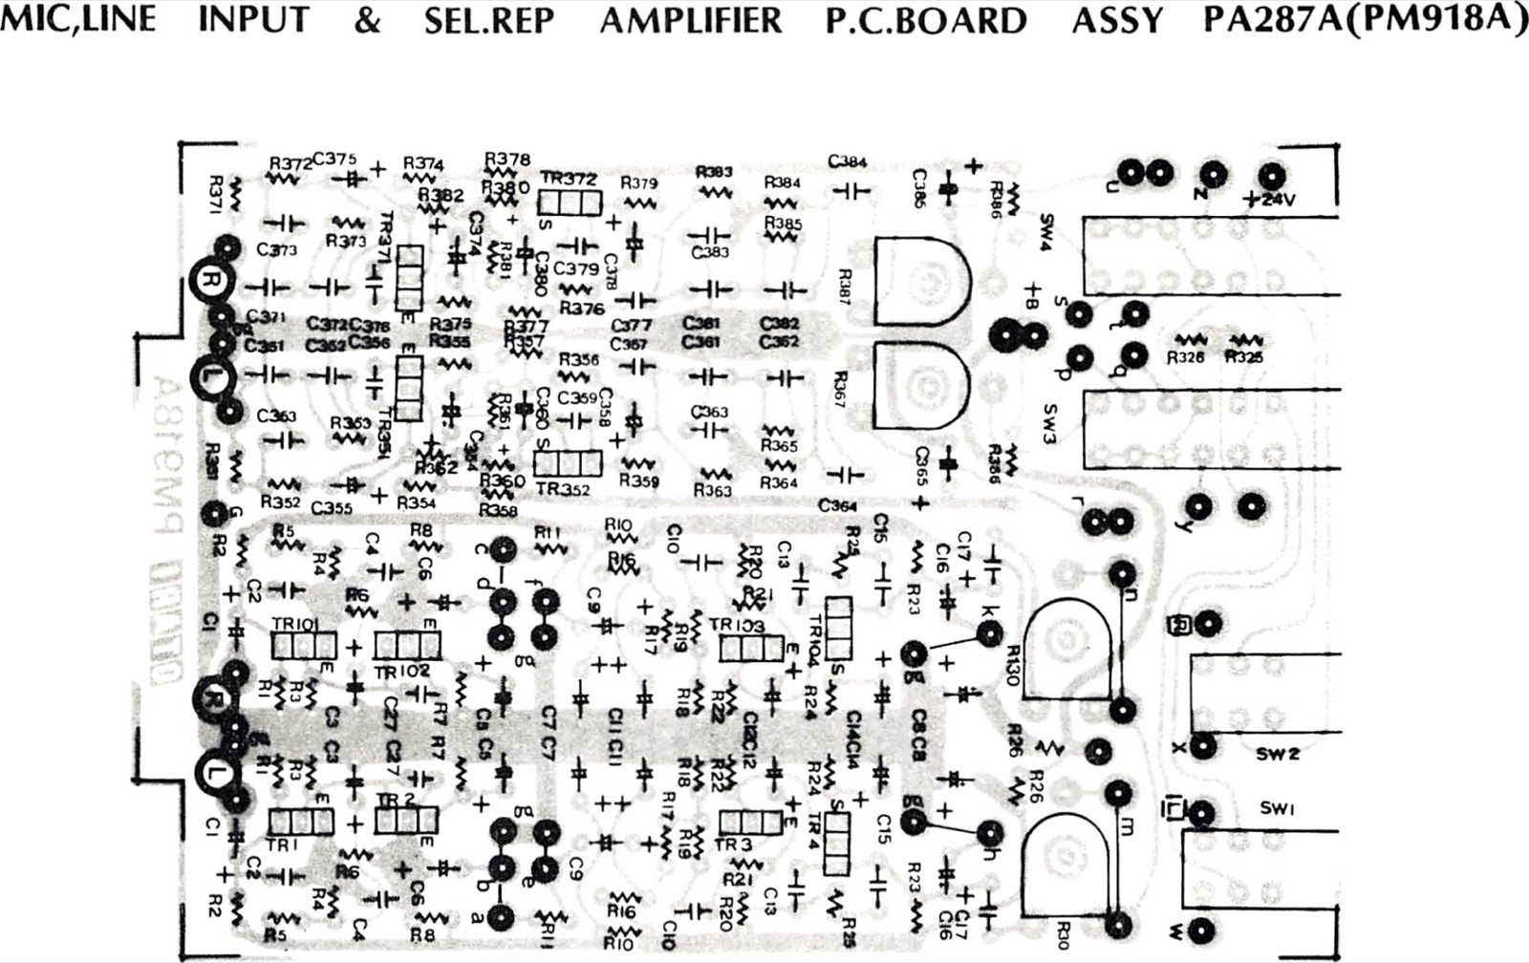
MIC,LINE INPUT & SEL.REP AMPLIFIER P.C.BOARD ASSY PA287A(PM918A)
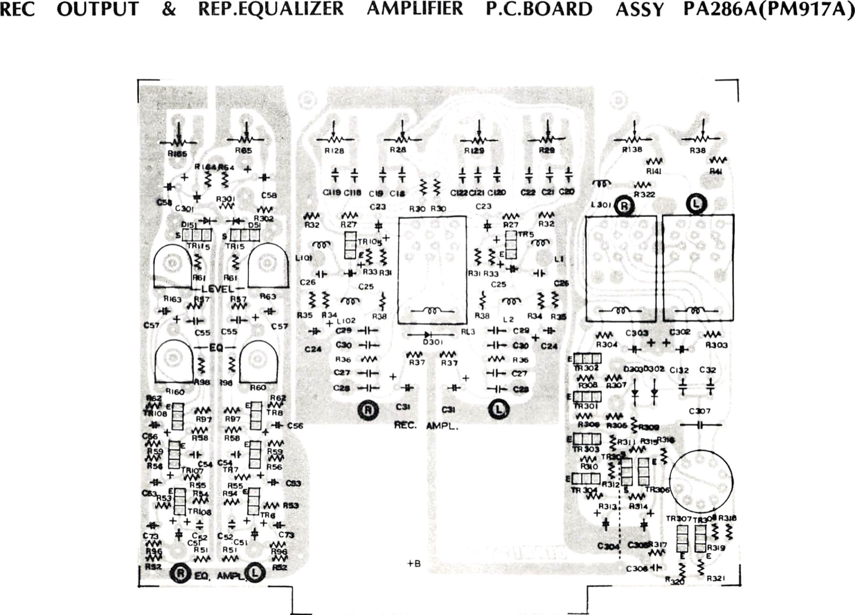
REC OUTPUT & REP.EQUALIZER AMPLIFIER P.C.BOARD ASSY PA286A(PM917A)
Site note: The later-revision printing of this sheet adds an “old#” / “new #” header above the title, verbatim: old# (PA-286A), new # PB-11O.
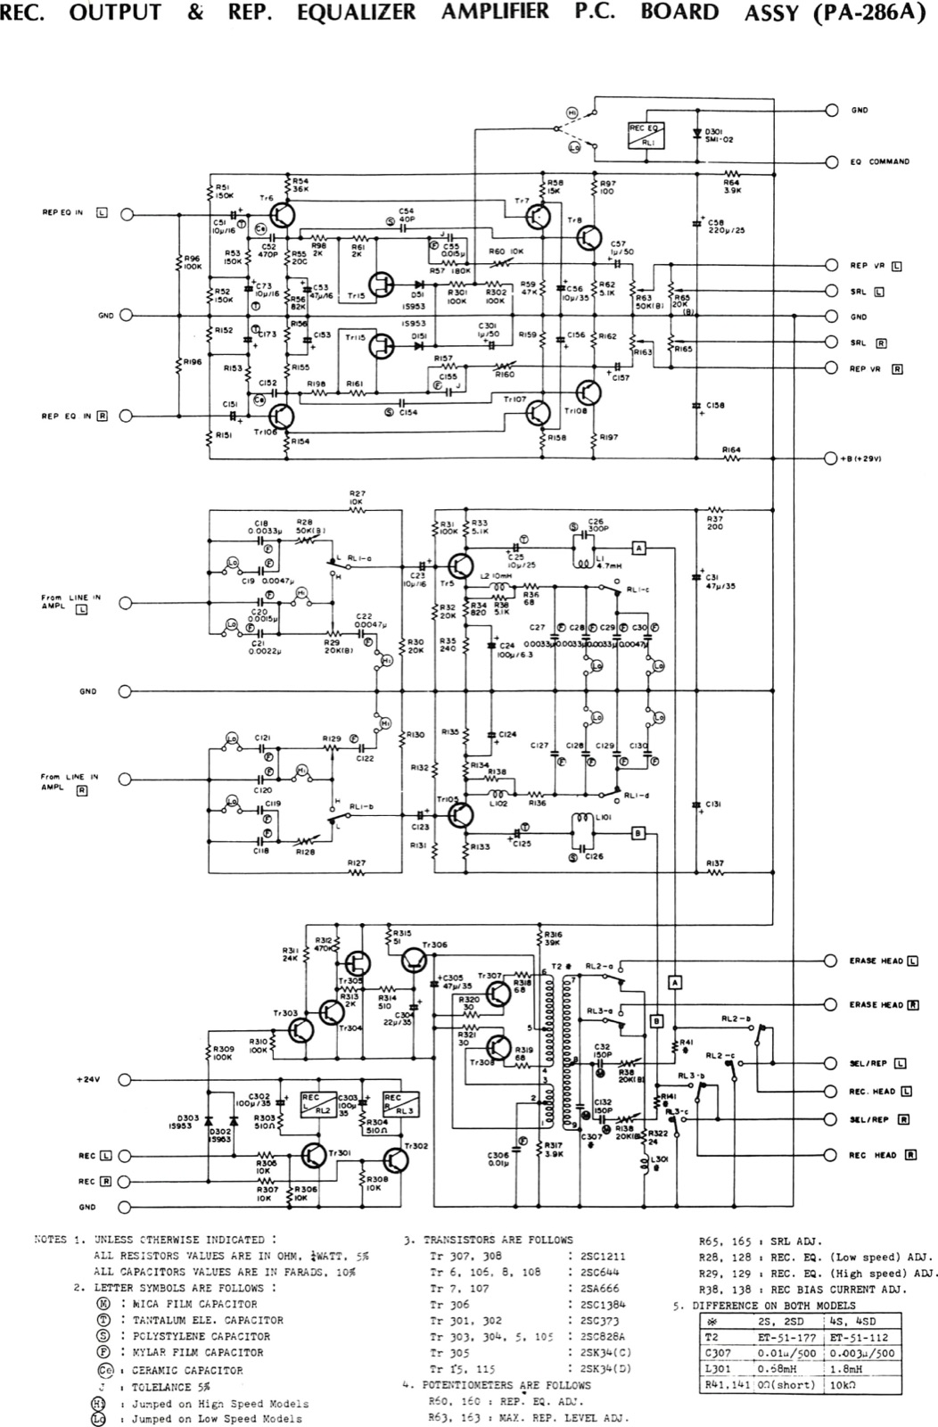
REC. OUTPUT & REP. EQUALIZER AMPLIFIER P.C. BOARD ASSY (PA-286A)
Site note: The later-revision printing of this sheet adds an “old #” / “new #” header above the title, verbatim: old # (PA-285), new # PB-11N.
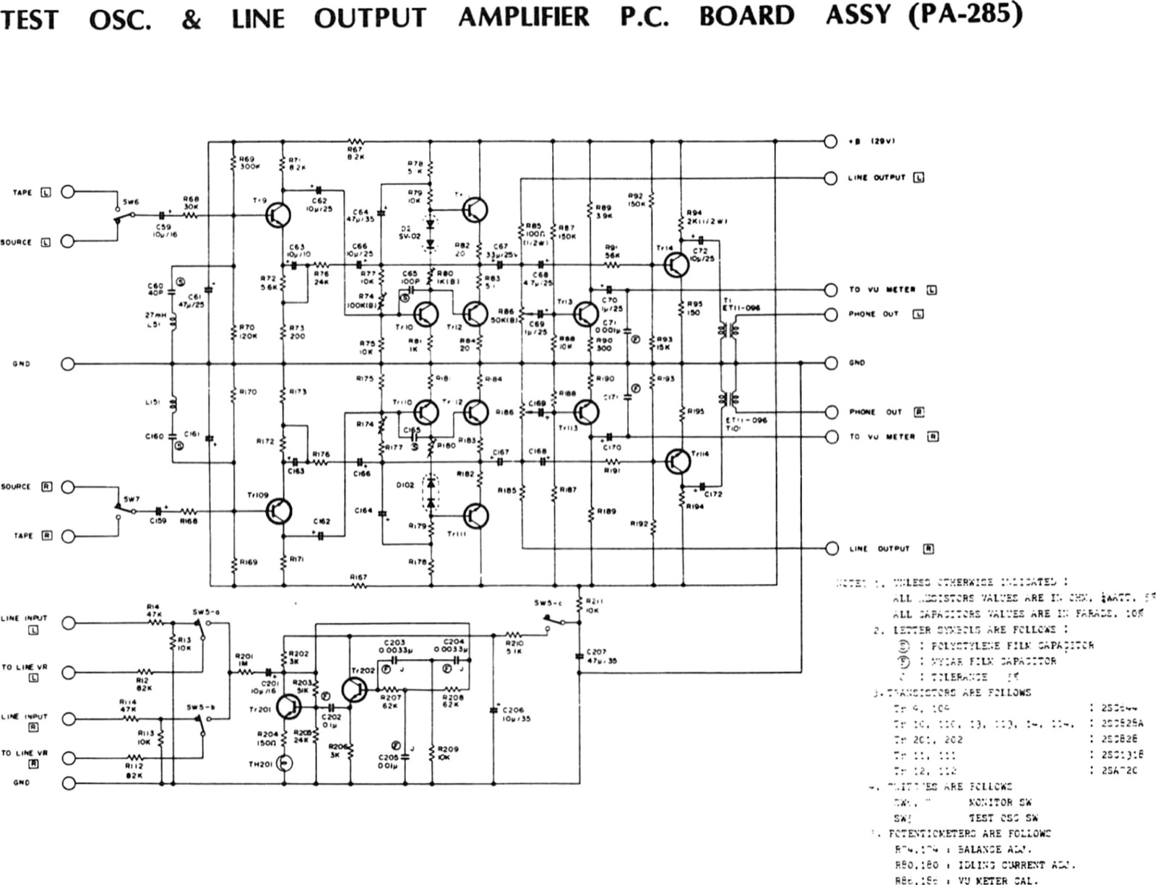
TEST OSC. & LINE OUTPUT AMPLIFIER P.C. BOARD ASSY (PA-285)
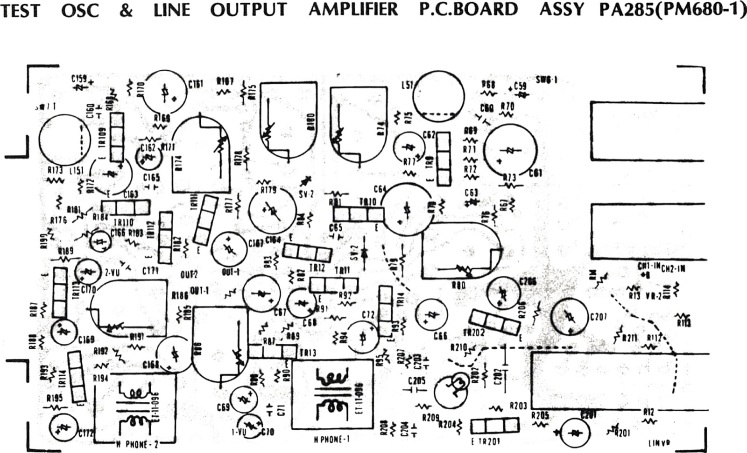
TEST OSC & LINE OUTPUT AMPLIFIER P.C.BOARD ASSY PA285(PM680-1)
Site note: The later-revision printing of this sheet adds an “old #” / “new #” header above the title, verbatim: old # PA-377 (PM-875A), new # PB-61E.
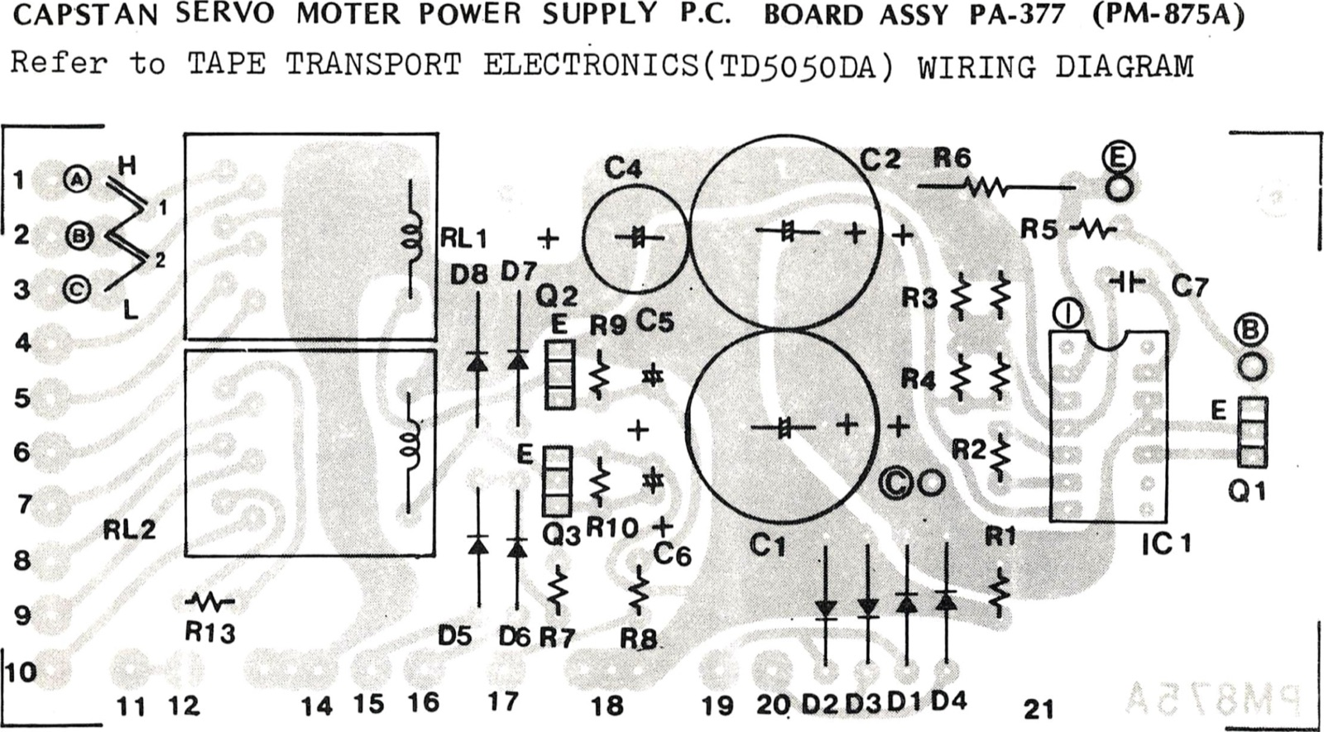 [sic]
Site note: The later-revision printing of this sheet adds an “old#” / “new #” header above the title, verbatim: old# PA426(PM796), new # PB-61D.
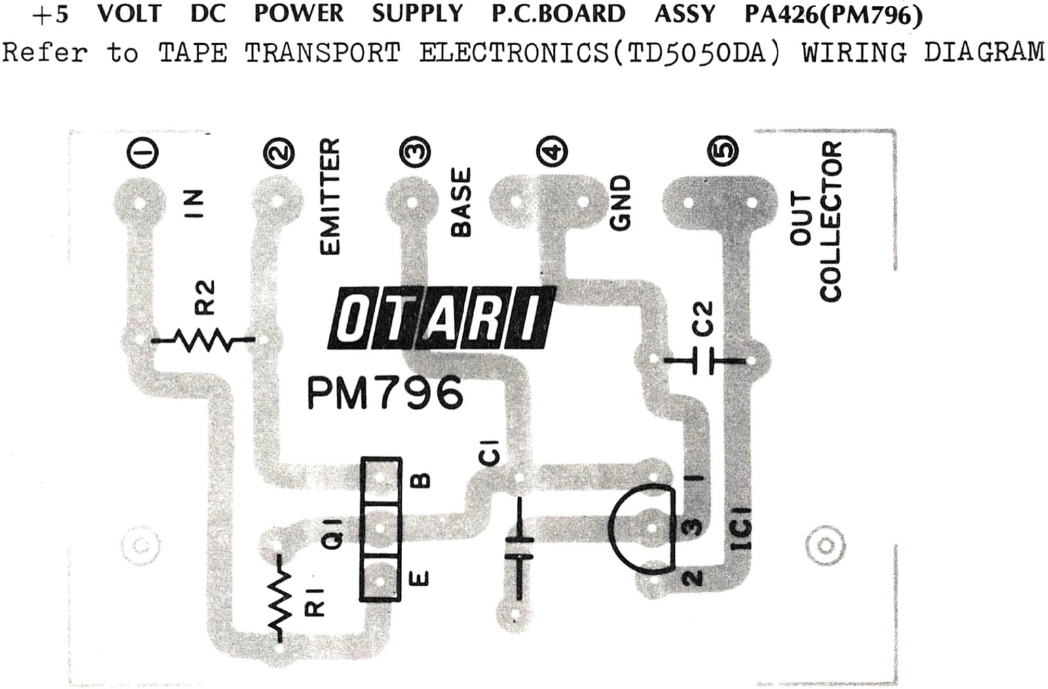
+5 VOLT DC POWER SUPPLY P.C.BOARD ASSY PA426(PM796)
Site note: The later-revision printing of this sheet adds an “old #” / “new #” header above the title, verbatim: old # PA284(PM679-2), new # PB-41D.
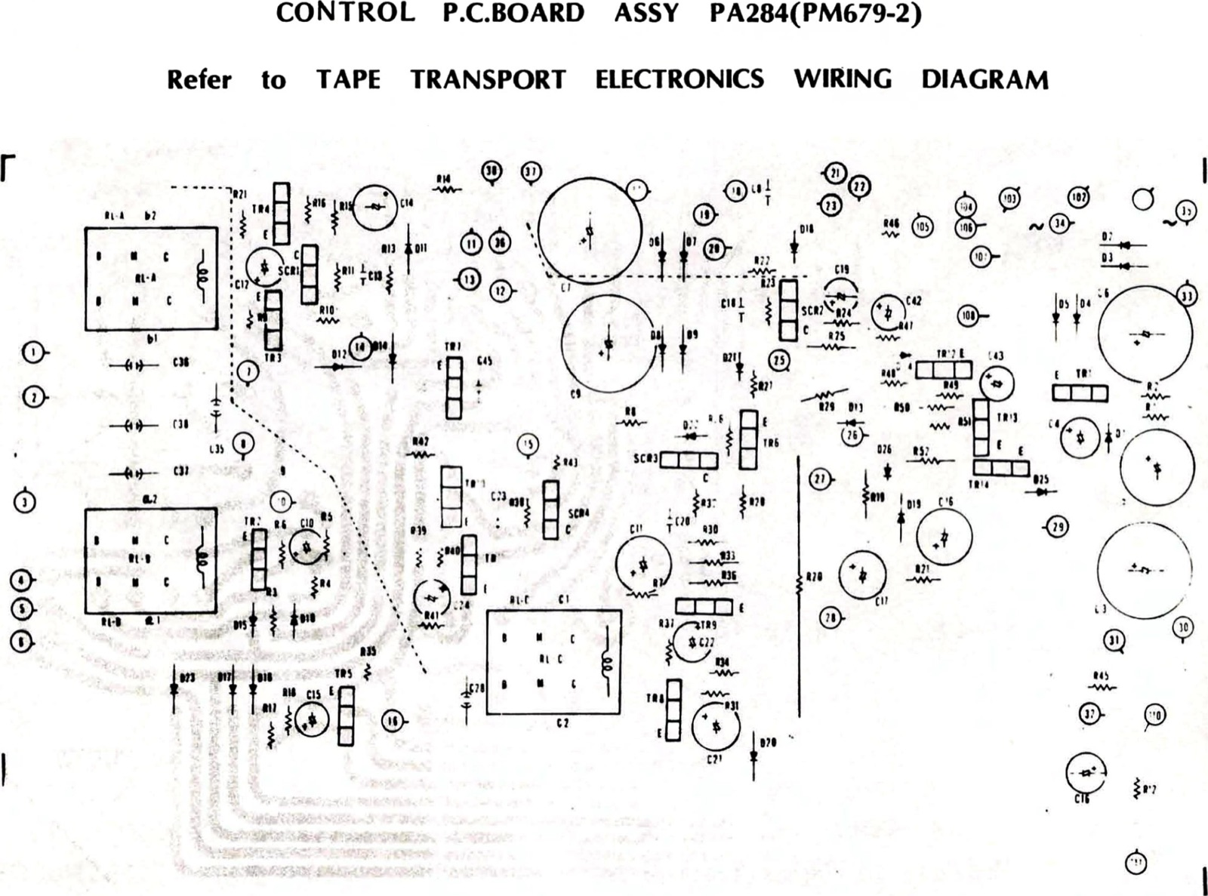
CONTROL P.C.BOARD ASSY PA284(PM679-2)

